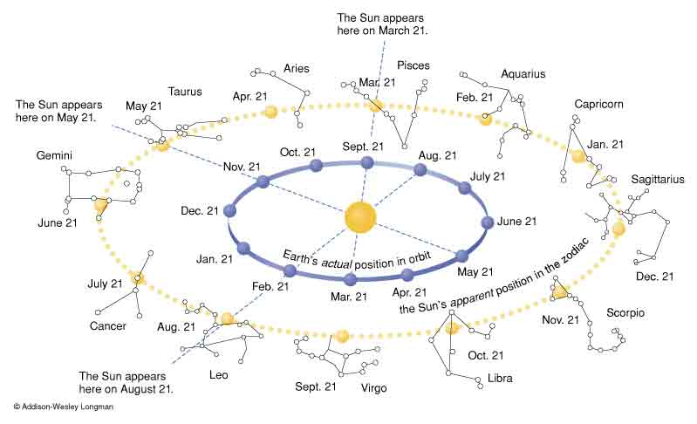
ZODIAC ON THE ECLIPTIC

