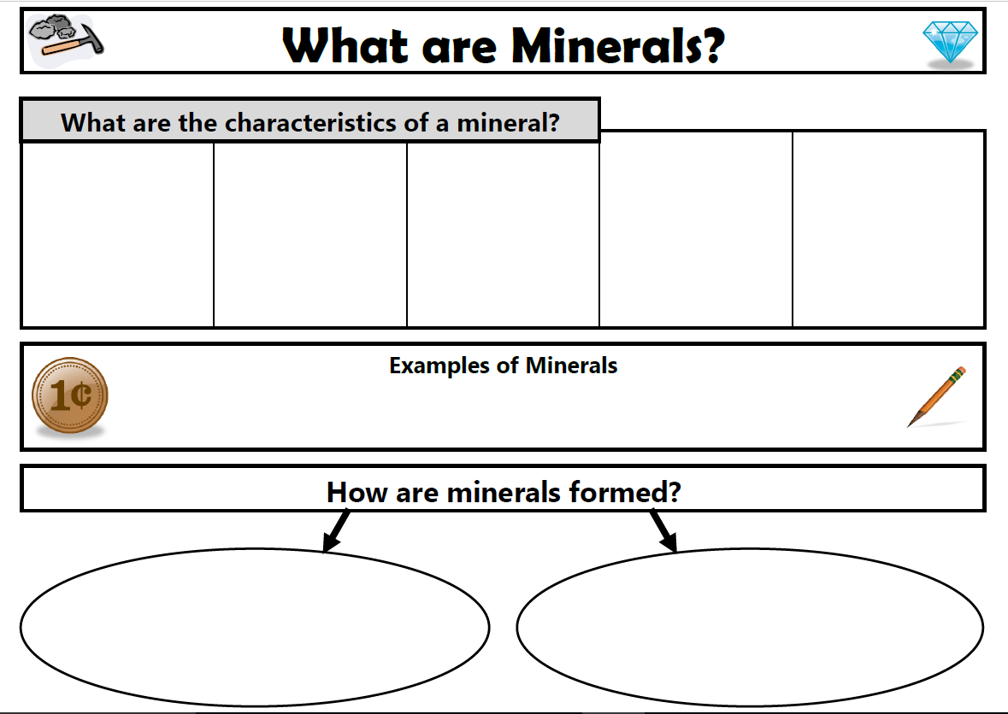

Of the almost __________ known minerals, only about 30 are common.

The most common are quartz, feldspar, mica, and calcite.

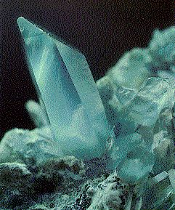 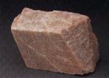 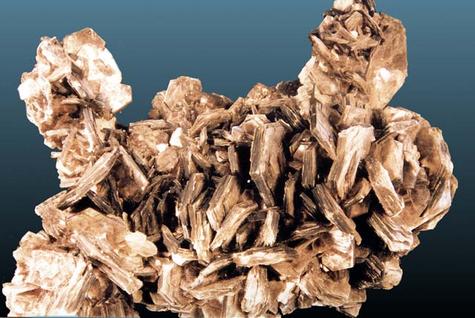

**Describe earth’s crust as it relates to minerals.**

* These minerals make up most of the rocks found in the ___________________.
* In fact, more than _______________ of all of the minerals are in the Earth’s Crust
* They are made up of compounds containing __________ and ___________, the two most abundant elements on Earth.

Earth’s overall crust contains over ______ of the family of minerals known as ________________!

**Where do Minerals Form?**

Minerals form in cooling ______________

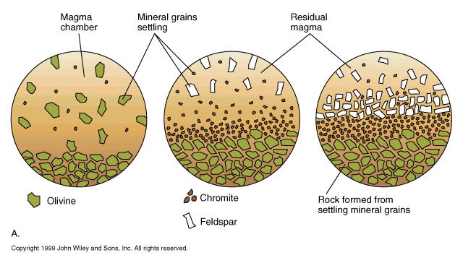

**How long does it take for minerals to form?**

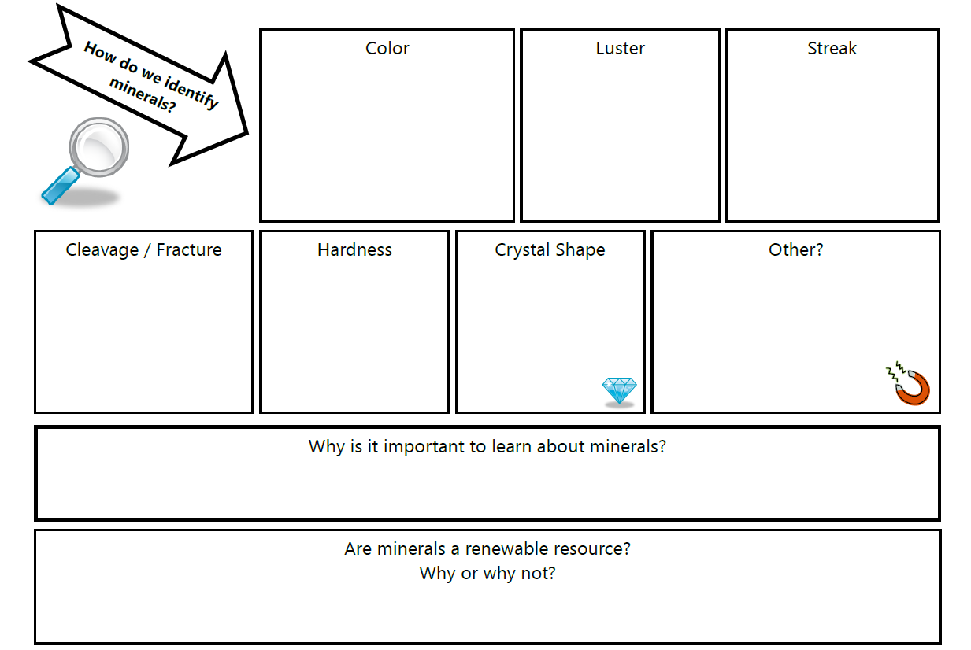

A useful property to identify minerals if the minerals have had the time and space to form ___________. Most mineral grains that are found in rocks, lack the room to grow.

* The cleavage of a mineral is its tendency to ___________ or to separate along ______ surfaces.
* Not all minerals show _______.
* Those that don’t break along cleavage surfaces are said to have _________________.
* The hardness of a mineral is its resistance to being ____________.
* _______ is the hardest of all minerals, and talc is the __________.
* Friedrich Mohs devised a hardness scale.

Density

* Each mineral has a _______________.
* Density is the _______ of a given space or in scientific terms the mass per unit of volume.
* Formula for density:

**Density = Mass/Volume**

* The color of its powder when rubbed on an _____________________.
* The _________ is often not the same color as the mineral.
* A minerals color may vary, but the streak rarely will!
* Refers to the way a mineral shines in ____________________.
* The mineral on the left has a ______________, the one on the right, a ___________________.
* Color is the most easily observed mineral property and the ______ useful!
* Some exceptions to the color rule would be ______________, which is always red, and ____________, which is _______.

