VIRTUAL OWL PELLET LAB
Pre-Lab Video
Watch the video linked below.
Dirty Jobs - Owl Pellets.avi | Mountainheightsacademy (vids.io)
Virtual Lab
Virtual Owl Pellet Dissection (kidwings.com)
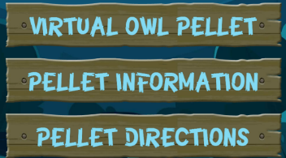
Go to the Pellet Information Section
Look to the menu on the left side of the screen.
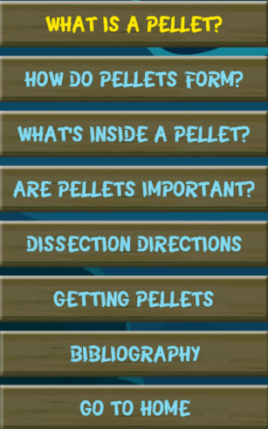
After answering the questions click here to return to the home page
Starting with the first tile answer the questions on your own paper.
- What is a pellet?
- How do pellets form?
- What’s inside a pellet?
- Are pellets important?

Click on the Pellet Directions tile and read through the steps to complete the virtual lab
After reading the directions, Go to the Virtual Owl Pellet Lab. Complete the Lab by selecting the bones within the pellet and place them into the correct location on the right side diagram. Continue selecting and placing the bones until all the bones have made a complete skeleton. Record the time that it takes you to complete the activity on your paper where you have answered the questions. Once completed turn in your paper to CTLS.

