Unit 2 Review Sheet: Nonrenewable & Renewable Energy
Review Questions On a separate paper, answer all parts of the following questions using complete sentences.

Definitions
- Define renewable energy
- Define nonrenewable energy
- Identify examples of commonly considered nonrenewable energy sources.
- Identify examples of renewable sources
- What are the benefits of using renewable energy sources?
- What are the general disadvantages of using renewable energy sources?
- What are the benefits of using nonrenewable sources?
- What are the general disadvantages of using nonrenewable sources?
- List at least three factors that influence the cost of a fuel or energy source.

Underground energy sources
- What is meant by the term “fossil fuels”?
- Which energy sources are typically considered fossil fuels?
- Explain the main hypotheses regarding how coal forms.
- Explain the main hypotheses regarding how oil and natural gas form.
- Why are these 3 fuel sources used widely around the world?
- List three advantages of using coal, oil, and natural gas as fuel.
- List three disadvantages of using coal, oil, and natural gas as fuel.

Above-ground energy sources
- What are the various types of solar energy absorption or storage?
- What sources can be used to produce biomass fuel?
- How is biomass fuel made from these sources?
- Compare and contrast how geothermal energy and tidal energy work.

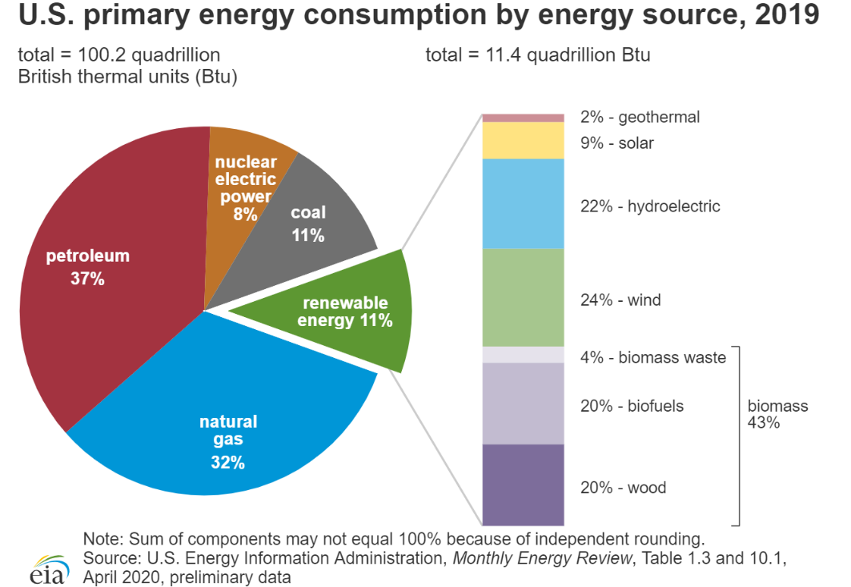
Energy Conservation
- Define and contrast energy efficiency with energy conservation.
- Identify three ways people can conserve energy
- Describe three ways to increase energy efficiency in a city.

Analyzing Data
- What are the top three energy sources in the U.S. in 2019?
- What are the top three renewable energy sources in the U.S. in 2019?
- Why are wood, biofuels, and biomass waste considered renewable energy sources?
- How much energy did the U.S. use in 2019 that is not publicly considered renewable?
- How much energy did the U.S. use in 2019 that is publicly considered renewable?

- A store uses one hundred 200Watt lightbulbs for 10 hours each day. If the store is open for 300 days a year, explain why they might be reluctant to switch to currently available renewable energy sources. Show your work and calculations to help explain your answer.
Energy source | Cost per kilowatt-hour
Coal | $0.07 (Ga cost)
Solar | $400.00
Wind | $0.15
Nuclear | $0.20
Natural gas | $0.07

Energy Sources: Pros and Cons
Fill out the table below
Energy Source | Define and explain how this energy source works | Pros/Advantages of using this source | Cons/Disadvantages of using this source
Coal
Petroleum (oil)
Natural Gas
Wind
Geothermal
Tidal
Hydroelectric
Nuclear
Solar
Tidal
OTEC

Energy Source | Define and explain how this energy source works | Pros/Advantages of using this source | Cons/Disadvantages of using this source
Biofuel
Hydrogen fuel (for transportation)

Hybrid vehicles

Electric vehicles

