Unit 1 Patterns in the Sky Fill in Notes Name _____________________ Block___
Coordinates: Altitude and Azimuth
Coordinate System
Coordinates

Terrestrial coordinates

Equator
Prime meridian

Angular Measurements
Degree = a circle’s divided into _______ degrees
minute of arc = ________ of a degree
second of arc = ______ of a minute (…. Or 1/3600 of a degree)
Hold finger out at arm’s length = ~___ degrees
Hold fist out at arm’s length = ~____ degrees
Moon and sun are only 0.5 ° (stays constant--if it looks bigger...it’s an illusion)

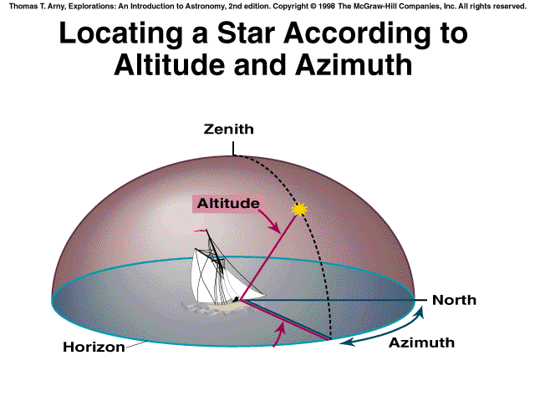
Horizon system

Zenith

Altitude

Azimuth

Problems...
- 1. Stars change position over the course of the night because of rotation of Earth—stars rise and set like the sun
- 2. Stars occupy different positions in the sky at different points on the earth (N vs. S hemispheres)

Rotation of the Earth
The Earth spins on its axis and rotates around once every ____ hours. This causes…
1. the Sun to rise and set.
2. stars to rise and set
Day vs Night
Rotation: _________________________________________________________________
-Example: earth rotates on its axis once a day
Revolution: ________________________________________________________________
-Example: earth revolves around the sun once a year.

The Seasons are caused by the fact that:
-Earth’s axis of rotation tipped by________ from the perpendicular to its orbit (causes the seasons).
-The Seasons are a result of ___________________ the sunlight is that strikes Earth.
-They are not related to Earth’s distance from the sun. In fact, Earth is slightly closer to the sun in (northern-hemisphere) winter than in summer.
-Northern summer = more __________ light, sun __________ in sky, daytime sunlight is __________
-Northern winter = less _______ light, sun __________ in sky, daytime sunlight is __________

What is an ecliptic?
Definition #1
_________________________________________________________________________________
Definition #2
__________________________________________________________________________________

How the path of the sun changes over the course of the year (this is at ____ degrees latitude)
Earth circles (______________) around the sun in _________ days, and the sun appears to circle the sky in the same period.
The sun, traveling ________ degrees around the ecliptic in 365.25 days, travels about ___ degree eastward each day…seasons

The Celestial Sphere
Celestial Sphere

North Celestial Pole

Polaris

Why use it?
- The Celestial sphere is an easier way to locate stars because they are __________ coordinates on this map

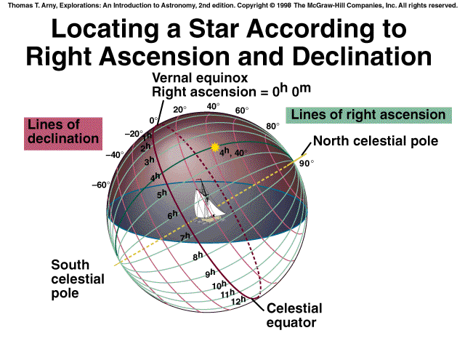
Right ascension (RA)

Declination (dec)

If you are standing at the North Pole, your view of the celestial sphere looks like this…

Diurnal Circles (daily “star trails”) from North Pole; Polaris at 90 degrees altitude

If you are standing at the equator, your view of the celestial sphere looks like this…
Diurnal Circles from Equator; Polaris at 0 degrees altitude

If you are standing in Atlanta, your view of the celestial sphere looks like this…

Diurnal Circles from Mid-Latitude
Circumpolar stars

Latitude and Polaris

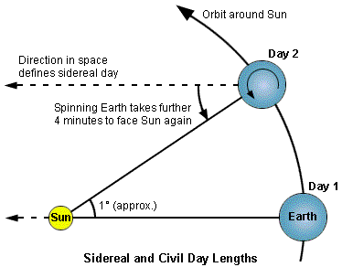
Sidereal Day
The time it takes a star to line back up with Earth 23 hours, 56 minutes, 4 seconds
(~_______ minutes shorter than a 24 hr day)
Therefore stars rise
~ _____________________________________________________________________
Mean Solar Day =

Precession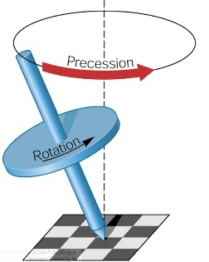 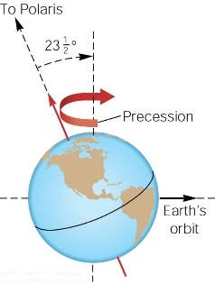
At left, gravity is pulling on a slanted top. Wobbling around the vertical.
The Sun’s gravity is doing the same to Earth.
The resulting “wobbling” of Earth’s axis of rotation around the vertical w.r.t. the Ecliptic takes about 26,000 years and is called __________________________.
As a result of precession, the celestial _______ ________ follows a circular pattern on the sky, once every _________________ years.
It will be closest to _______________ ~ A.D. 2100.
There is nothing peculiar about Polaris at all (neither particularly bright nor nearby etc.)
~ 12,000 years from now, it will be close to _______________ in the constellation Lyra.

The positions of the stars change over the course of the year because the Earth orbits the Sun…
Off-season constellations are “______” during the daytime
Notice that between June and August, the Sun is directly “in” Gemini
Notice that June to August, Sagittarius is prime viewing during summer nights
Positioning of the Planets
Notice that the planets lie along the ____________ because the solar system is in the same plane (a flat disc)
The planets are orbiting the sun almost exactly in the plane of the Ecliptic.
The Moon is orbiting Earth in almost the same plane (Ecliptic).
The Sun, Moon and planets can always be found in a Zodiac _____________________ on the ecliptic.
Planets "_____________" across the celestial sphere and through the stars in two ways:
1. _______________ Motion - normal eastward movement of planets
2. _______________ Motion - occasional westward movement of planets
Retrograde motion occurs when an inner planet passes by an outside planet and the outside planet appears to go “backwards” in the sky for a few weeks (this doesn’t happen in a night)
The movement is ________________—Mars does NOT really move like that in space. The position of mars shifts against the backdrop of distant stars.

Moon Phases
Phases of the moon occur because we see only a portion of the lit side of the moon from different angles
Half the moon is always lit and half the moon is always dark, but we might only see a portion of the lit side
Phases of the Moon are NOT because of the Moon going in and out of shadows
EVENING SKY OBSERVATION

MORNING SKY OBSERVATION

- The Moon orbits Earth in a sidereal period of ________________ days.
- The Moon’s synodic period (to reach the same lunar phase) is ____________ days
(~ 1 month).
Lunar Eclipses: Earth’s shadow falls across Moon
- partial shadow is the ________________, and a zone of full shadow is the _________
- If the entire surface of the moon enters the Umbra, the _________ eclipse is ___________.
Solar Eclipses: Moon’s shadow falls across Earth
- The sun appears approx. as large in the sky (same angular diameter ~ 0.5⁰) as the moon.
- When the moon passes in front of the sun, the moon can cover the sun completely, causing a ________ _________ eclipse.
- A _________ eclipse can only occur if the moon passes a node near _____ moon.
- A _________ eclipse can only occur if the moon passes a node near _____ moon.

