The Milky Way Galaxy Fill in Notes NAME_____________________________
A galaxy is a collection of ______, ______, and ________ bound together by ___________.
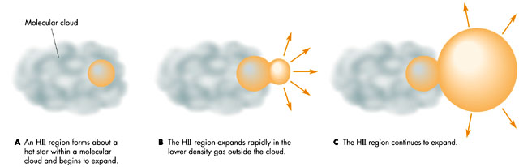
Our galaxy is filled with interstellar gas and dust, which makes it hard to see through our galaxy
- Light hits the dust and can produce
- 1. ________ ___________ (if dust blocks/scatters lots of light)
- 2. ________ ___________ (if dust is close to stars--reddish)
- 3. ________ ___________ (if dust is far from stars--bluish)
What can you see through dust?
- ________________ waves pass through easier
- Lets _______ ________ through gas and dust clouds (and 21 cm radiation)
- Previous experiments about size and shape of the Milky Way were off because they didn’t account for ________________ _____ and _________.
Where are we? How do we know?
- We initially look at distributions of ___________ _________ to see where they’re centered
- We look at ____ cm radiation to map the milky way
- Plot the ____________ ___________ locations (just x and y coordinates)
- After you plot them, mark a star (*) where you think the center of the galaxy is
(where is the center of the clusters?)

The Distribution of Globular Clusters in the Galaxy
- Sun is ___________ ___ from the center
- about ______ Globular Clusters in Milky Way
- globular clusters are _________ clusters of stars found in _____ around galaxy
- globular clusters contain _________, ________ stars
- Spiral arms contain _____________, ____________ stars
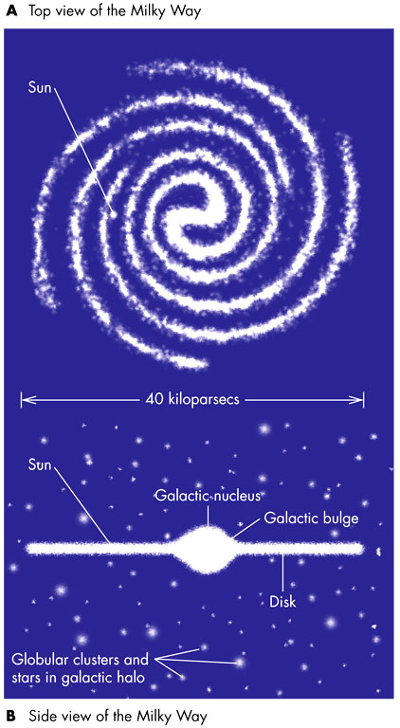

The Milky Way
- ___________ light years thick

- ____________light years across

- We are ______________ from the center

- Contains __________ billion stars

- Total mass = ________________solar masses

- _____________ structure

- Supermassive black hole of ___ __________ solar masses at center

- Missing Mass = _________ (dark matter)

- Q: What is dark matter?
- A:

- Q: How do we know there is dark matter?
- A:

