Stellar Evolution Name____________________________
Astronomy objectives sheet

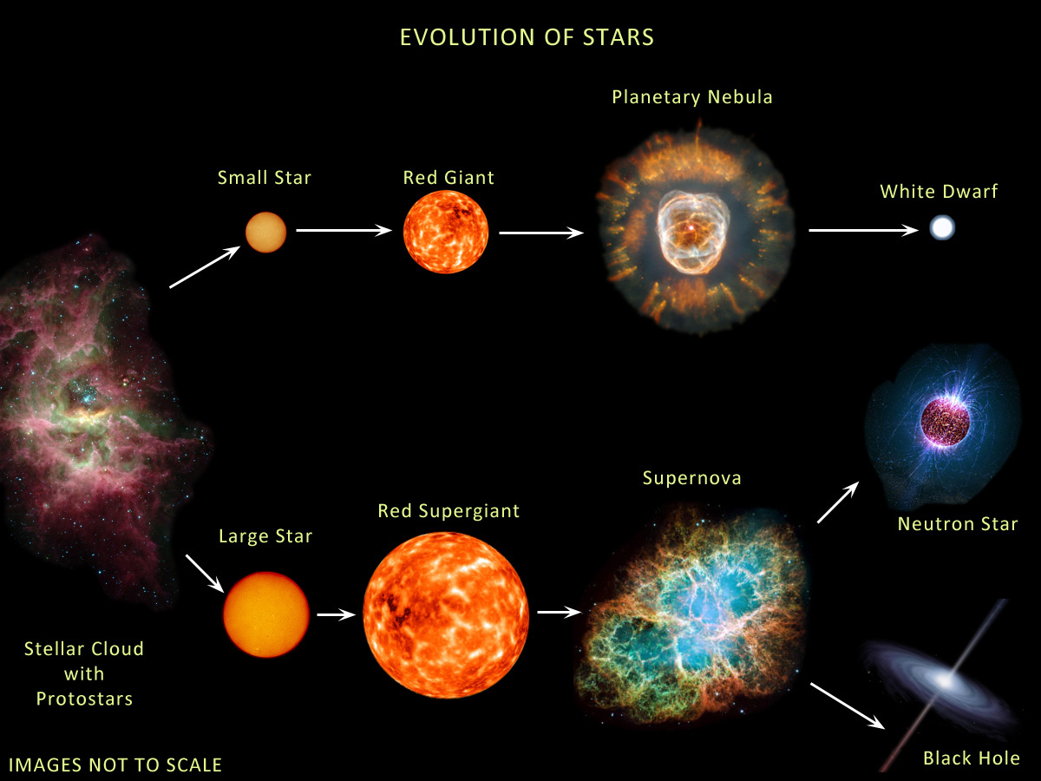
Astronomy Content Standards

SAST2. Students will describe the scientific view of the origin of the universe, the evolution of matter and the development of resulting celestial objects.
b. Describe the life cycle of a star and explain the role gravity and mass play in the brightness, life span, and end-stages of stars.
SAST5: Students will evaluate the significance of energy transfers and energy transformations in understanding the universe.
a. Relate nuclear fusion reactions and mass-energy equivalence to the life cycle of stars.
b. Explain the relationship between the energy produced by fusion in stars to the luminosity.
c. Analyze the energy relationships between the mass, power output, and life span of stars.
d. Describe energy transfers and transformations associated with the motion and interactions of celestial bodies (e.g. orbits, binary pulsars, meteors, black holes, and galaxy mergers).

Characteristics of science standards
SCSh1. Students will evaluate the importance of curiosity, honesty, openness, and skepticism in science.
SCSh2. Students will use standard safety practices for all classroom laboratory and field investigations.
SCSh3. Students will identify and investigate problems scientifically.
SCSh4. Students use tools and instruments for observing, measuring, and manipulating scientific equipment and materials.
SCSh5. Students will demonstrate the computation and estimation skills necessary for analyzing data and developing reasonable scientific explanations.
SCSh6. Students will communicate scientific investigations and information clearly.
SCSh7. Students analyze how scientific knowledge is developed.
SCSh8. Students will understand important features of the process of scientific inquiry.

Essential Questions
- By what processes does a cloud of gas become a star?
- How and why do stars change over the course of their lifetimes?
- How does the mass of a star affect nuclear fusion rates, power production, and lifetime?
- How does the mass of a star affect the eventual outcome of a star’s life cycle?
- How is the H-R diagram used as evidence of stellar evolution? How do stars evolve on the H-R diagram?

Textbook references: Foundations of Astronomy Chapters 11 through 14

Key Terms
nuclear fusion, hydrogen, helium, absolute visual magnitude, apparent magnitude, luminosity, Hertzsprung-Russell diagram (H-R diagram), main sequence, red giant, blue giant, red dwarf, white dwarf, brown dwarf, binary star system, supernova, neutrino, neutron star, pulsar, black hole, event horizon, singularity, gamma ray burst (hypernova)

Review Questions
- By what process does the sun generate its energy? Describe the reaction.
- What is hydrostatic equilibrium?
- Explain how stars form from clouds of gas and dust. What is this process known as?
- What is the difference between a main sequence star and a brown dwarf?
- What is the main relationship between mass and luminosity on the HR diagram?
- What do main sequence stars all have in common?
- How does our Sun’s temperature and size compare to that of other stars?
- Why does the lifetime of a star depend on its mass?
- Compare a blue giant to a red dwarf. What do they have in common? What is different between them?
- After the main sequence stage, what will our Sun evolve into next? What are the characteristics of this stage?
- In Red Giants, how is the nuclear fusion process different from main sequence stars?
- 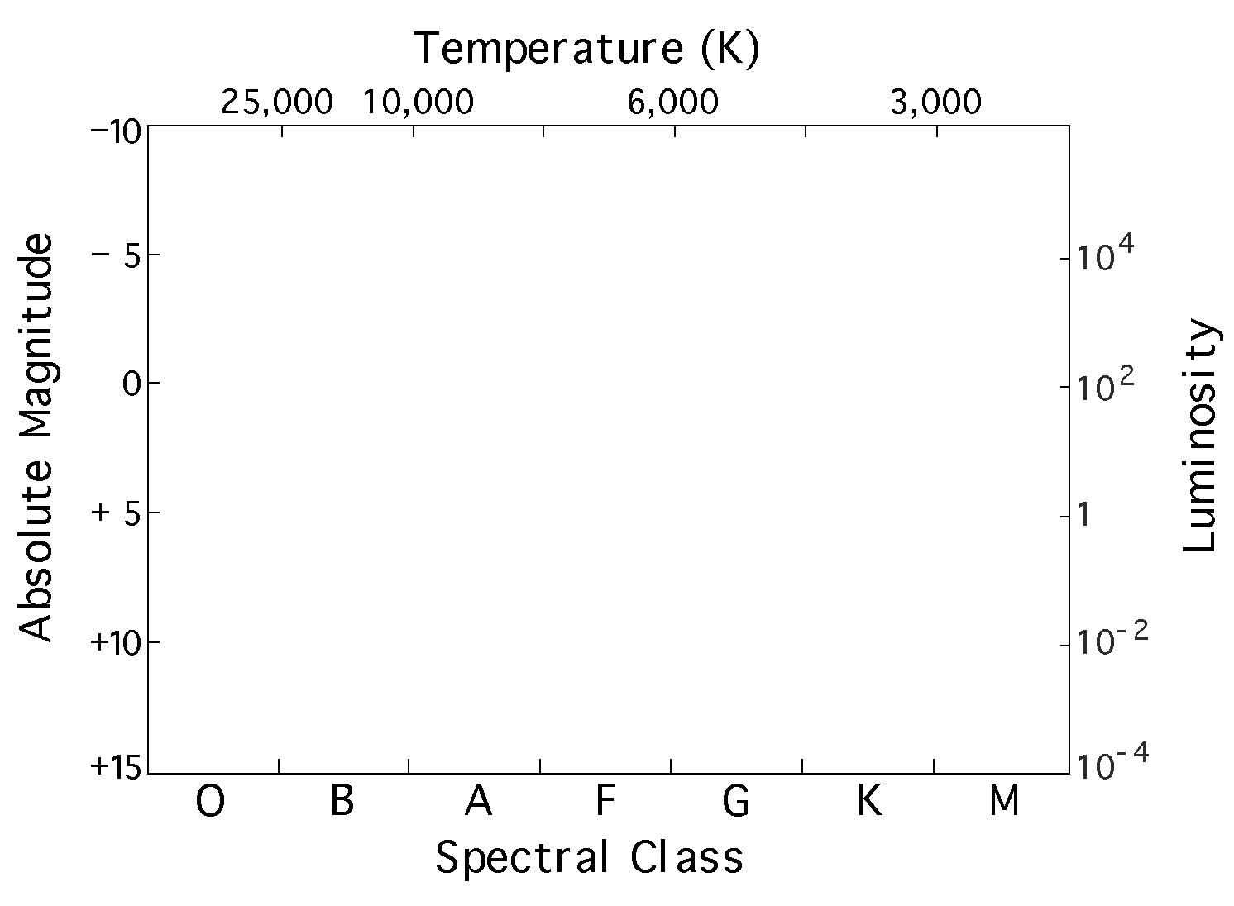Consider a star like our sun that is a main sequence star and then consider the same star as a red giant. Compare the core temperature of the star as a main sequence star to the core temperature as a Red Giant. Compare the surface temperature of the star as a main sequence star to the core temperature as a Red Giant.
- Why will a red dwarf not become a Red Giant?
- Which will evolve faster, a Blue Giant or a red dwarf? Explain why.
- What is the classification of our Sun right now?
- Sketch the Hertzsprung-Russell Diagram
(the H-R diagram) and label all the main sections.
- Describe the general characteristics of red dwarfs. Describe the general characteristics of white dwarfs. Describe the general characteristics of red giants. Describe the general characteristics of blue giants.
- What is the mass-luminosity relationship that we find for main sequence stars?
- Sketch out the evolutionary track of our Sun and label where it will go on the HR diagram (there are three distinct locations you should mark).
- When we say that a star moves from one spot on the HR diagram to another, does that mean that the star is moving that way in space? Explain.
- What is a brown dwarf? Why are there no main sequence stars that are less than 0.08 M?
- 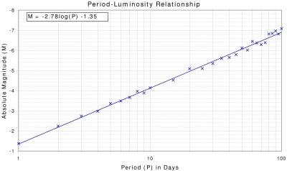In comparing two different star clusters, you notice that one appears redder and has mostly red stars in it, and the other appears bluer and has mostly blue stars in it. How do the ages of the two clusters compare?
- What is a planetary nebula?
- What supports the collapse of white dwarf stars? Are they burning anything? What will eventually happen to them?
- What is the Chandrasekhar limit for white dwarf stars?
- What is a Cepheid variable star? Why are Cepheid variables important to astronomers?
- In comparing two different Cepheids, you notice that star A has a period of 10 days, while star B has a period of 20 days. How do the luminosities of the two stars compare?
- High mass stars will eventually fuse nuclear fuels up to a certain element. What is that element?
- What happens to a high mass star after that element is formed in the core? What else comes out of this event?
- What is the difference between a Type Ia supernova and a Type II supernova?
- What is a neutron star?
- What is a pulsar? Sketch a label the parts of a pulsar.
- What is the light house model of a pulsar? Why do pulsars spin so fast?
- What do large masses do to spacetime?
- What is a black hole? Sketch and label the parts surrounding a black hole.
- If we can’t see the light coming from black holes, then how do we know they exist?
- What is the event horizon of a black hole? What is the singularity?
- What is a gamma ray burst (aka—a hypernova)?
- Your friend argues that our Sun will eventually explode one day in a supernova and become a black hole. How do you respond?
- Another friend argues that black holes are only theoretical and that they are not real objects. How do you respond?

