Stars and Classification Name____________________________
Astronomy objectives sheet

Astronomy Content Standards

SAST2. Students will describe the scientific view of the origin of the universe, the evolution of matter and the development of resulting celestial objects.
b. Describe the life cycle of a star and explain the role gravity and mass play in the brightness, life span, and end-stages of stars.
SAST5: Students will evaluate the significance of energy transfers and energy transformations in understanding the universe.
a. Relate nuclear fusion reactions and mass-energy equivalence to the life cycle of stars.
b. Explain the relationship between the energy produced by fusion in stars to the luminosity.
c. Analyze the energy relationships between the mass, power output, and life span of stars.
d. Describe energy transfers and transformations associated with the motion and interactions of celestial bodies (e.g. orbits, binary pulsars, meteors, black holes, and galaxy mergers).

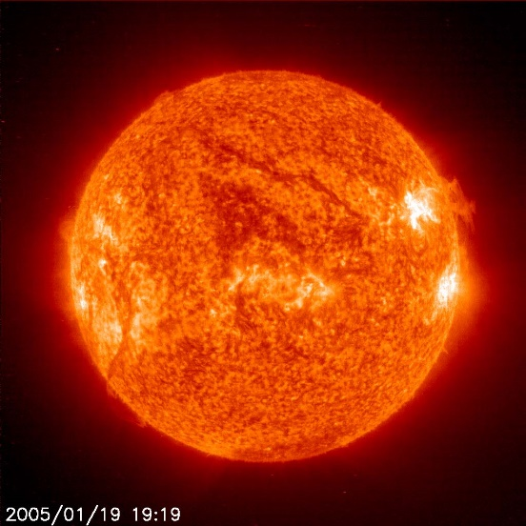

Characteristics of science standards
SCSh1. Students will evaluate the importance of curiosity, honesty, openness, and skepticism in science.
SCSh2. Students will use standard safety practices for all classroom laboratory and field investigations.
SCSh3. Students will identify and investigate problems scientifically.
SCSh4. Students use tools and instruments for observing, measuring, and manipulating scientific equipment and materials.
SCSh5. Students will demonstrate the computation and estimation skills necessary for analyzing data and developing reasonable scientific explanations.
SCSh6. Students will communicate scientific investigations and information clearly.
SCSh7. Students analyze how scientific knowledge is developed.
SCSh8. Students will understand important features of the process of scientific inquiry.

Essential Questions
- By what processes does a cloud of gas become a star?
- What effect does mass have on gravity, power output, and the luminosity of a star?
- How are nuclear fusion and luminosity of a star related?
- What are the general features of our sun and how does this compare to other stars?
- How do we classify stars?
- How are stars on the H-R diagram similar? How are stars on the H-R diagram different?

Textbook references: Foundations of Astronomy Chapter 8 and 9

Key Terms
nuclear fusion, hydrogen, helium, sunspot, core, radiative zone, convection zone, corona, chromospheres, photosphere, aurora, prominence, flare, granulation, parallax, parsec, light year, proper motion, absolute visual magnitude, apparent magnitude, luminosity, distance modulus, Hertzsprung-Russell diagram (H-R diagram), main sequence, red giant, blue giant, red dwarf, white dwarf, brown dwarf, binary star system

Review Questions
- Where is most of the mass in the solar system found? As a percentage, how much of the solar system is found here?
- What is the chemical composition of the Sun?
- What are the different layers of the Sun? Sketch them and briefly describe each layer.
- By what process does the sun generate its energy? Describe the reaction.
- In which layer of the Sun does nuclear fusion take place?
- Why does nuclear fusion require such high temperatures and pressures for the reaction to take place?
- What is hydrostatic equilibrium?
- Explain how the Sun came to be a star. What is this process known as?
- If the mass of the Sun went up, how would this affect the amount of pressure inside the core? How would this affect the nuclear fusion rate? How would this affect the luminosity of the Sun?
- What are sunspots? Why do they form?
- On average, how long does it take the sunspot cycle to go from maximum to maximum?
- Does the Sun rotate? How long does it take to go around at the equator? How long at the poles? How is it possible for the Sun to exhibit a differential rotation rate, while the Earth cannot?
- How does our Sun’s temperature and size compare to that of other stars?
- Explain how astronomers use emission lines and absorption lines (spectral lines) to identify the composition of a star.
- What is the classification scheme by which we classify stars?
- What is the general mnemonic device used to remember the classification of stars?
- Which classification of stars are the hottest? What are their characteristics?
- Which classification of stars are the coolest? What are their characteristics?
- What is the classification of our Sun?
- What other information can be learned about a star by analyzing the spectral lines?
- If a star’s spectral lines are redshifted, what does that tell us about the star?
- If a star’s spectral lines are blueshifted, what does that tell us about the star?
- Describe what stellar parallax is. What is it usually measured in?
- Why is parallax only measurable for nearby stars and not for the very distant stars?
- What is a parsec? How many light years are in a parsec?
- Use the distance formula to calculate the distance to a star that has a parallax of 0.08”. How far away is the star in parsecs? How far away is the star in light years?
- What is proper motion of stars?
- Why does a star’s parallax shift repeat itself from year to year, but a star’s proper motion shift will not?
- What is the apparent magnitude of a star? (this is also called visual magnitude)
- The Andromeda Galaxy has an apparent magnitude of 3.44. The star, Vega, has an apparent magnitude of 0.03. The star, Arcturus, has an apparent magnitude of -0.04. Which object appears the brightest in the sky at night.
- What is the absolute magnitude of a star?
- Rigel has an absolute magnitude of -6.7. Vega has an absolute magnitude of 0.6. Alpha Centauri has an absolute magnitude of 4.3. Which object is the most luminous?
- Explain why we cannot use brightness alone to determine how close a star is to Earth.

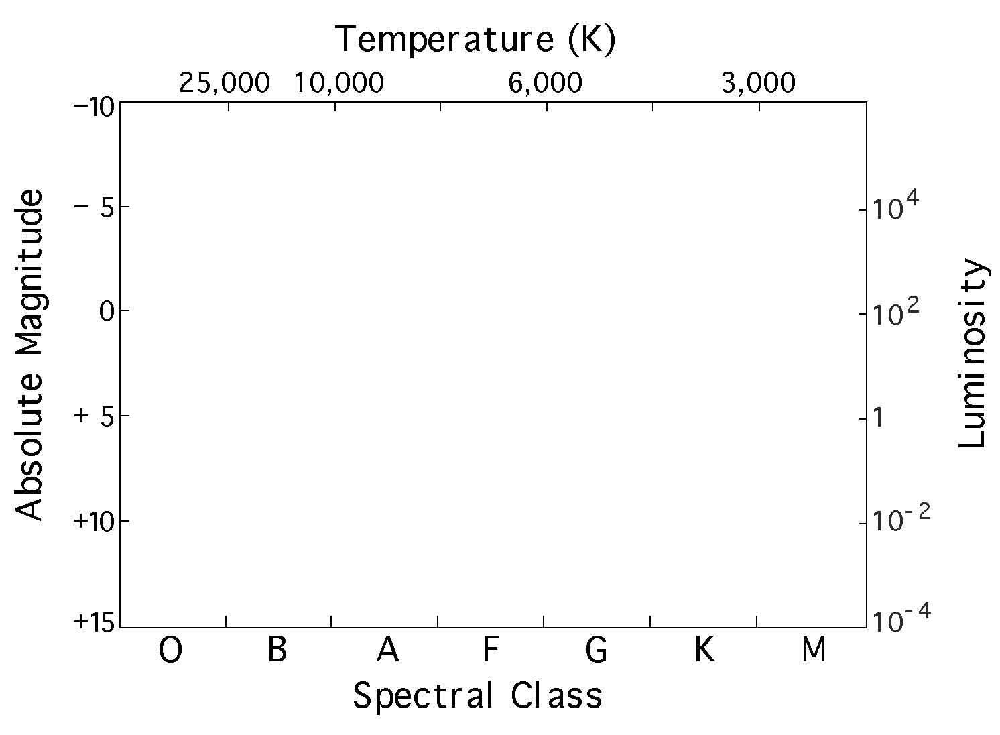

- Sketch the Hertzsprung-Russell Diagram
(the H-R diagram) and label all the main sections.
- Describe the general characteristics of red dwarfs.
- Describe the general characteristics of white dwarfs.
- Describe the general characteristics of red giants.
- Describe the general characteristics of blue giants.
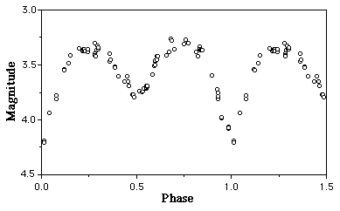
- What is the mass-luminosity relationship that we find for main sequence stars?
- Explain how this graph shows the light curve for an eclipsing binary star system. On the graph, when is the larger star eclipsed? On the graph, when is the smaller star eclipsed?

