The Solar System Name____________________________
Astronomy objectives sheet

Astronomy Content Standards

SAST2. Students will describe the scientific view of the origin of the universe, the evolution of matter and the development of resulting celestial objects.
a. Outline the main arguments and evidence in support of the standard cosmological model. (e.g. elements, solar systems, and universe)
c. Compare and contrast the major properties of the components of our solar system.
SAST4. Students analyze the dynamic nature of astronomy by comparing and contrasting evidence supporting current views of the universe with historical views.
a. Evaluate the impact that technological advances, as an agent of change, have had on our modern view of the solar system and universe.
b. Explain the relevance of experimental contributions of scientists to the advancement of the field of astronomy.

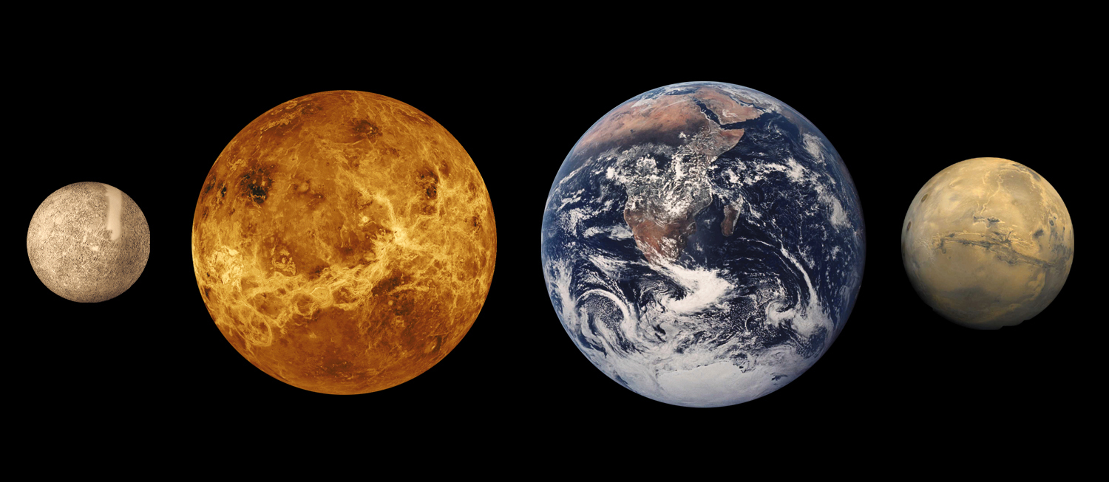

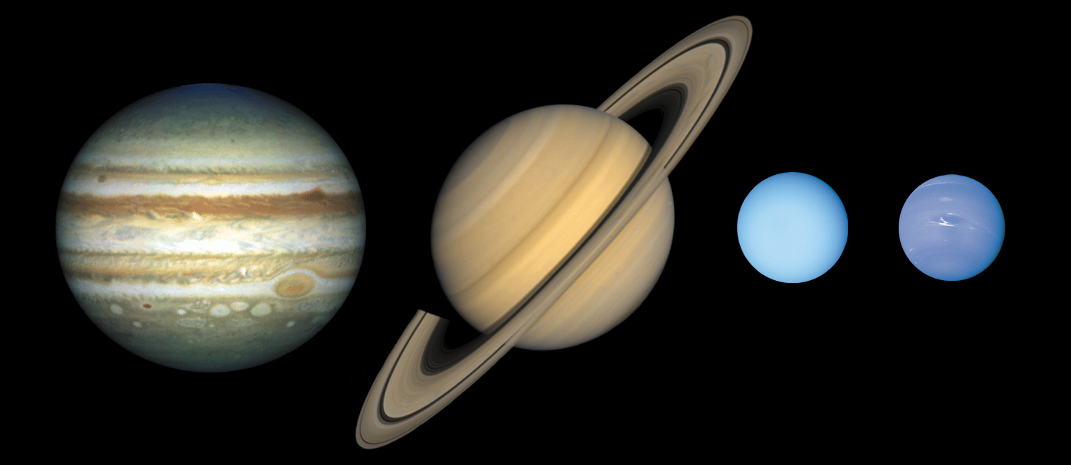

Characteristics of science standards
SCSh1. Students will evaluate the importance of curiosity, honesty, openness, and skepticism in science.
SCSh2. Students will use standard safety practices for all classroom laboratory and field investigations.
SCSh3. Students will identify and investigate problems scientifically.
SCSh4. Students use tools and instruments for observing, measuring, and manipulating scientific equipment and materials.
SCSh5. Students will demonstrate the computation and estimation skills necessary for analyzing data and developing reasonable scientific explanations.
SCSh6. Students will communicate scientific investigations and information clearly.
SCSh7. Students analyze how scientific knowledge is developed.
SCSh8. Students will understand important features of the process of scientific inquiry.

Essential Questions
- How do we know how the solar system formed?
- How are the terrestrial planets similar and different?
- How are the Jovian planets similar and different?
- Why is Pluto no longer classified as a planet?
- How are comets and asteroids similar and different?

Textbook references: Foundations of Astronomy Chapter 19-25

Key Terms
Terrestrial planet, Jovian planet, planetesimal, accretion, nebula, gravitational collapse, half-life, comet, asteroid, meteorite, meteoroid, meteor, crater, mare, collision-ejection theory (or Giant Impact theory), atmosphere, greenhouse effect, shield volcano, belt, zone, shepherd satellite, magnetosphere, dwarf planet, Kuiper Belt object, Oort cloud

Mercury
Mercury is most similar to what other solar system object? In what ways?
When Mercury cooled, what did it form?
What’s the large crater that’s left over from an asteroid impact?
Give are two major outcomes of Mercury not having an atmosphere?

Venus
Venus is most similar to what other solar system object? In what ways?
Why are the craters smoothed over?
Why is it so bright in the sky?
What are the major components of Venus’s atmosphere?
What are the results of having a thick atmosphere?

Earth
How much of Earth is covered by water? Is there water on other planets? Why is Earth unique?
What allows for the shifting crust of the Earth?
What gases make up Earth’s atmosphere? Why does Earth have the largest percentage of O₂ in its atmosphere compared to the other terrestrial planets?
What is the Greenhouse Effect?
Describe scientists’ concerns about the Greenhouse Effect and CO₂ emissions.
Describe the layering of Earth’s atmosphere. Where do weather changes take place (in which layer)?
Why does Earth have a magnetic field? What produces the aurora borealis?

The Moon
The Moon is most similar to what other solar system object? In what ways?
What are Maria? How were Maria formed?
How did the Moon form? What evidence is there for the Giant Impact Theory?
How old is the Moon?
Why is the Moon so heavily cratered? Which side of the Moon is more cratered?
How are Moon rocks different from Earth rocks?

Mars
How is Mars similar to Earth? How is it different?
Why is Mars red in color?
Is the surface temperature hotter or colder than Earth? Explain why.
What’s the large mountain on the surface of Mars? Why is it significant? How does it compare to Mount Everest on Earth?
What’s the large canyon on Mars? How does it compare to the Grand Canyon on Earth?
What structures are located at the poles of Mars? What are they made of?
Why does Mars change colors during the seasons?
What evidence is there that Mars once had water on it?
What are the moons Mars? Why are they non-spherical? Why is Earth’s moon more spherical?

Jupiter
What are the main gases that make up the atmosphere of Jupiter?
Why does Jupiter have a banded (or striped) appearance? Describe the difference between belts and zones.
Does Jupiter have rings? How are Jupiter’s rings different from Saturn?
What is the Great Red Spot? How does the Great Red Spot compare to hurricanes on Earth? How big is the Great Red Spot compared to Earth?
How many moons does Jupiter have? What are the 4 main moons of Jupiter? Main characteristics?
Saturn
Saturn is most similar to what other object in the solar system? In what ways?
What are the rings of Saturn made of?
Why are the rings of Saturn so bright in comparison to other planets with rings?
What is the composition of Saturn’s clouds? Why are the belts and zones not as distinct as Jupiter’s?
How are the rings separated and classified?
Why are there gaps and divisions in the ring structure of Saturn?

Uranus
Uranus is most similar to what other object in the solar system? In what ways?
How is the orientation of Uranus different from the other planets?
Describe the make-up of the atmosphere of Uranus. Why is Uranus blue?
What do the rings of Uranus look like?
How are they unique in comparison to the other planets?

Neptune
Neptune is most similar to what other object in the solar system? In what ways?
How is the appearance of Neptune similar to Uranus? How is the appearance different from that of Uranus?
Why does Neptune take on a bluish color? Why are there white streaks on Neptune?
What are the storms of Neptune? How does this compare to the Great Red Spot of Jupiter?
What drives the winds on the planet (…on any of the gaseous planets)?

Pluto
Describe the general surface and structure of Pluto.
Explain how Pluto is a “pattern-breaker” for the Jovian planets.
Why is Pluto’s orbit unique and different from the other planets (2 reasons)?
How many moons does Pluto have?
Is there a weight limit that a planet must reach in order to be considered a planet?
Why is Pluto no longer considered a planet?
What is the new classification of Pluto? Why does it best fit into this classification? What other objects are with Pluto in this classification?

Solar system debris (asteroids and comets)
Why do meteor showers occur?
What are the different types of meteorites?
What is the difference between a meteor and meteorite?
How big are most meteoroids that strike Earth’s atmosphere?
Explain why Earth has a surface that is much smoother than the Moon’s?
Draw and describe the structure of a comet. How is it like a “dirty snowball”?
When a comet approaches the sun, what happens?
Where are most asteroids found in the solar system?
Where are most comets found in the solar system?

General similarities and differences
How are the terrestrial planets similar?
How are the Jovian planets similar?

Formation of the solar system
Describe the scientific view of the origin of the solar system. What evidence is there that the solar system formed this way?

