STUDY GUIDE REVIEW UNIT 7 NAME______________________
- Based on interpretations of rock units and changes in fossil life forms, geologists have divided Earth’s history into manageable units that are represented by the ____.
- What is the currently accepted age of Earth?
- The largest expanse of time on the geologic time scale is the ____.
- Which of the following lists the divisions of the geologic time scale in order from longest to shortest?
- Which of the following is the study of tree rings to determine ages?
- Which of the following is bands of alternating light- and dark- colored sediments caused by glaciers?
- In what type of rocks would geologists most likely find evidence of past life forms?
- According to the principle of cross-cutting relationships, an intrusive rock body is ____.
- The dating process that places geologic events in proper sequence is referred to as a ____.
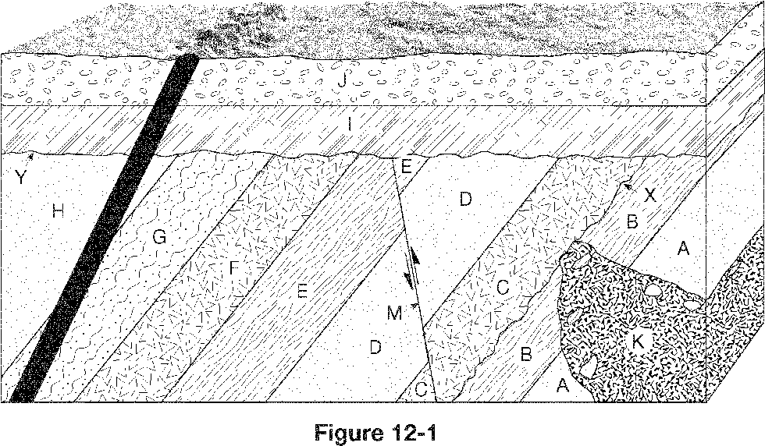
- Which of the following sequences correctly lists the geologic events in Figure 12-1 in order from oldest to youngest (oldest listed first)?
- What is the youngest feature shown in Figure 12-1?
- An unconformity is a(n) ____.
- What are fossils?
- In what type of rocks are most fossils found?
- The footprints of a dinosaur are an example of what type of fossil?
- The task of using fossils to match up rocks of similar ages in different areas is called ____.
- Which of the following must be true for a fossil organism to be useful as an index fossil?
- Index fossils allow geologists to ____.
- Radioactivity is produced when unstable nuclei ____.
- The time it takes for 50% of the nuclei in a radioactive sample to decay to its stable isotope is called ____.
- Atoms with the same atomic number but different mass numbers are called ____.
- Assume you began with 10 g of a radioactive parent isotope. How many grams of parent isotope will be present in the sample after 2 half-lives?
- Radiometric dating is possible because the rates of decay of radioactive isotopes ____.
- The radiometric dating of an igneous rock provides ____.
- Which two substances do geologists use in radiocarbon dating?
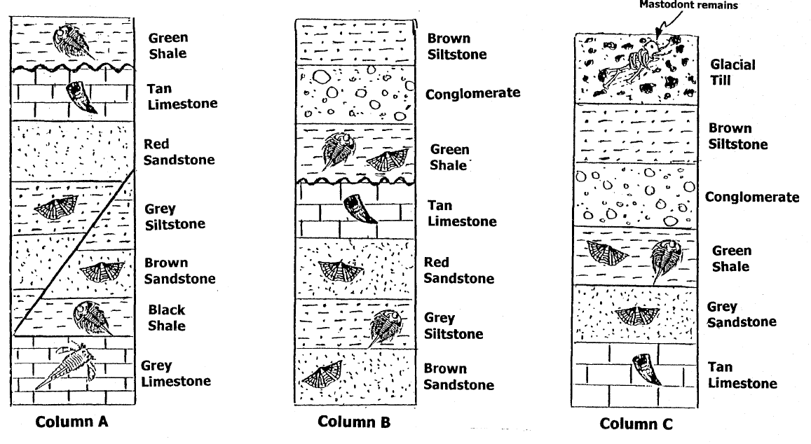
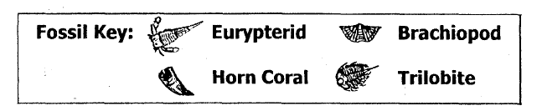

- Which fossil would be the best choice for being selected as as index fossil?
- What geologic feature do the Green Shale and Brown Sandstone best represent?
- At two locations there is an unconformity (buried erosional surface) which rock layer is missing at this place in the rock formation?
- Which geologic column contains the youngest rock layer?
- The fossils in the rock formation in column A indicate that this rock layer was once covered by what?

