Name _________________________________ Date ____________________ Block ___
Earth Systems Final Exam Study Guide
City | Latitude | Longitude
A | 39º96'N | 82º99'W
B | 39º77'N | 86º16'W
C | 27º34'N | 82º53'W
D | 40º06'N | 80º72'W
Use the table to answer questions.
- Order the cities in the table above from North to South.

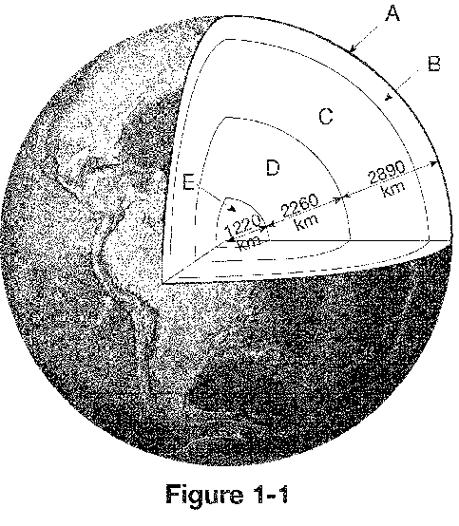
- Label each letter marked in Figure 1-1.
- The crust and uppermost mantle make up the rigid outer layer of Earth called the ____.
- The distance, measured in degrees, north and south of the equator is referred to as ____.
- What does a topographic map show?

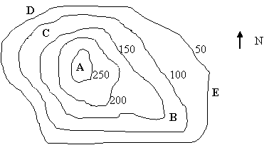
- How much of a rise in elevation exists from point D to point B?
- Which would be the easiest route to climb and why?
- What are the two sources of energy for the Earth system?

- What is the difference between weather and climate?
- The equator receives more energy from the sun year-round than other areas of Earth because…
- What is an air mass?
- An air mass that forms over the southwestern US and Mexico will have what 2 characteristics?
- What are the key features of cold fronts? (Hint: what kind of weather do they bring?)
- Put the steps of cloud formation in the correct order:
A | B | C | D
Moist air rises | Water droplets collect to form a visible cloud | Water condenses around a particle in the air (condensation nuclei) | The rising air begins to cool

- What is the greenhouse effect?
- Aside from tornados, rotating thunderstorms can also produce…
- What 3 substances cause chemical weathering?
- What type of land will experience the most erosion? (Hint: also consider slope)
- Define chemical weathering
- Water and ice cannot perform erosion without the force of …

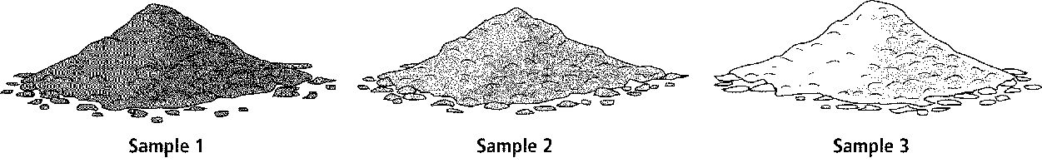

- What soil horizon would you most likely find sample 1?
- Karst topography often is full of these 3 features.
- Define frost wedging.
- What are 3 causes of mechanical weathering?
- Groundwater is found underground in the zone of ___.
- Rocks are split into three categories based on ____.
- If granite faces high temperatures and high pressures deep within Earth, what type of rock will be formed? (Assume that the granite did not melt.)
- A rock that forms when magma hardens beneath Earth’s surface is called ____.
- If lava cools faster, the crystals that form will be ____.
- What are the steps (in order) involved in sedimentary rock formation?
- Minerals are classified by ____.
- What are the building blocks of minerals?
- Which property is usually not useful in identifying minerals?
- What are the 5 characteristics of minerals?
- Moh’s scale is used to classify what property of minerals?
- The appearance or quality of light reflected from the surface of a mineral is called ____.
- The resistance of a mineral to being scratched is called ____.
- What is the uneven breakage of a mineral called?

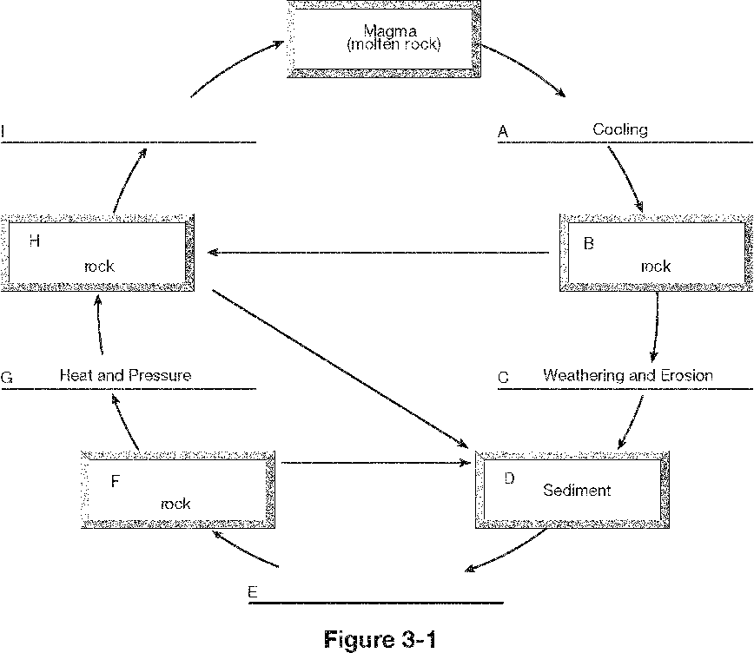
- In Figure 3-1, what type of rock should occur in the part of the rock cycle labeled B?
- In Figure 3-1, what process or processes would be occurring in the part of the rock cycle labeled E?
- In Figure 3-1, what type of rock should occur in the part of the rock cycle labeled F?
- The theory of plate tectonics helps scientists explain ____.
- According to the plate tectonics model, what layers form Earth’s rigid, mobile plates?
- Which of these factors affects the rate of weathering?
- In a well-developed soil profile, which horizon is the uppermost layer?
- A depositional feature that forms where a stream enters a lake or ocean is a(n) ____.
- Permeable rock layers or sediments that transmit groundwater freely are called ____.
- A cavern is an underground chamber formed by ____.
- A seismogram shows that P waves travel ____.
- The particles produced in volcanic eruptions are called ____.
- The most violent volcanic eruptions are associated with what type of volcano?
- A fault is ____.
- During an earthquake, how can the ground surface move?
- Overall, which seismic waves are the most destructive?
- The distance between a seismic station and the earthquake epicenter is determined from the ____.
- One piece of evidence that supports Wegener’s hypothesis of continental drift is that ____.
- A divergent boundary at two oceanic plates can create ____.
- What plays a major part in determining the type of volcano?
- Most of the Earth’s active volcanoes are located in the ____.
- An earthquake’s epicenter is ____.
- In what type of rock layer would geologists most likely find evidence of past life forms?
- An unconformity is a(n) ____.
- Uniformitarianism says that the geological processes that shape Earth’s features today ____.
- The principle of original horizontality says that ___ rocks are deposited in horizontal layers.

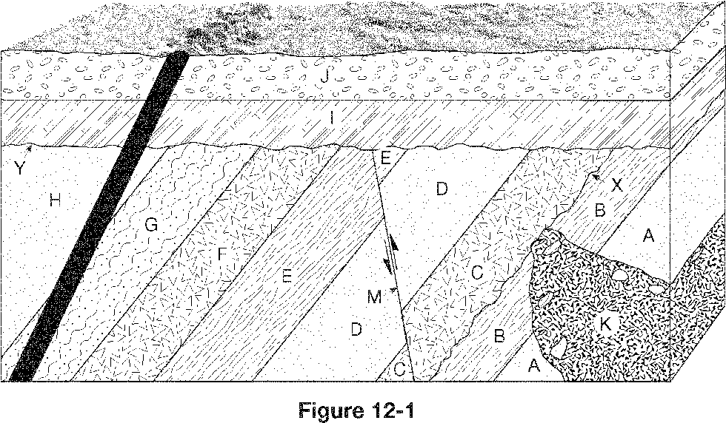
- What is the youngest feature shown in Figure 12-1?
- The footprints of a dinosaur are an example of what type of fossil?
- Which two substances do geologists use in radiocarbon dating?
- Assume you began with 10 atoms of a radioactive parent isotope. How many atoms of parent isotope will be present in the sample after 2 half-lives?
- Carbon-14 cannot be used to accurately date what types of things?
- In general, the law of superposition states that ____.
- What is the most abundant gas in the atmosphere?
- What is the lowest layer of the atmosphere?
- The ratio of air’s water-vapor content to its capacity to hold water vapor at that same temperature is the ____.
- Which of the following refers to the temperature to which air would have to be cooled to reach saturation?
- The force exerted by the weight of the air above is called ____.

