KEY ASTRONOMY FINAL EXAM REVIEW
- Zenith- straight up and above; horizon- where sky meets the land
- East to west- rise to the right and set to the left
- 34 degrees to the north celestial pole, directly above at the North Pole, not seen from equator
- Right ascension- like longitude (hours); declination- like latitude (degrees above and below the equator
- Imaginary sphere upon which all the stars are projected; imaginary line around the sky directly above the Earth’s equator
- Sidereal day-time it takes for stars to rise 24 hours 56 min 4sec; 4 minutes shorter than solar day
- Stars rise 4 minutes early every night 2 hours early in one month’s time
- Ecliptic- they orbit around the sun
- Retrograde motion- apparent backward(westward) motion of planets as seen against the background of stars. Earth’s rotation catches Mars and then passes it, Mars appears to fall back
- Rotation of the Earth in a tilted axis
- Depends on the season-location of the Earth to the Sun
- Polaris
- Trails of stars movement forming a path that is caused by Earth’s spinning
- Agriculture, astrology, religion, historical records
- Whether the solar system was geocentric or heliocentric
- Galileo-sun centered universe
- Near the sun
- Found the Milky Way; sunspots on the sun; Jupiter has 4 orbiting satellites; Venus had phases
- Kepler-planets move ellipses not circles; planets move faster when closer to the sun; slower and further away
- Mass attracts mass; more mass-closer, more gravity; Less mass-further away, less gravity
- Gamma Rays, X-Rays, Ultraviolet, Visible Light, Infrared, Microwaves, Radio Waves-High to Low
- Reflecting and Refracting
- Telescope
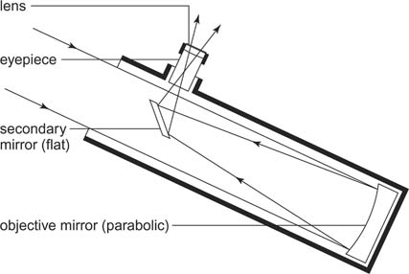

- Light gathering power 300-f/10; aperture -300mm, focal length -3,000mm
- Magnification 120 x; 300-f/10 = 3000/25 = 120x
- Decrease size of eyepiece
- Refracting- primary lens to eyepiece; reflecting- aperture to primary mirror
- CCD- Charge Coupled Device- detects light and faint objects in single exposure-read directly into a computer for analysis
- 1 / 16
- Terrestrial Planets- inner 4 planets; heavy metal cores, liquid mantle, solid rocky surface, temperature differences, liquid water, rocky
- Jovian Planets- 4 outer planets, small cores of heavy metals, large, ring systems
- Pluto’s orbit is elliptical not circular
- Small pieces of debris are burning up in the atmosphere
- Meteorite- debris large enough- does not burn- strikes the ground
- Comet- small, icy bodies that orbit the sun
- We only see portions of the lit side from different angles
- Lunar eclipse – Moon-Earth-Sun
Solar eclipse- Earth-Moon-Sun
- Nuclear fusion- hydrogen Helium energy, the core- high pressure and temperature
- Sunspots- hot gas that hits cool surface created by magnetic fields, sunspot cycle peaks approximately 10-11 years
- By temperature- O,B,A,F,G,K,M
- At higher temperatures atoms move faster, hydrogen becomes ionized
- Dark absorption lines – cooler gas absorbs light
- Composition
- Gravity; nuclear fusion; balance between pressure of gases and gravity
- Apparent magnitude- brightness-lower the number, the brighter the star
- Absolute magnitude- luminosity- lower the number, the more luminous the star
- Apparent angular size of the ellipse that a nearby star appears to trace against the background stars. 1/.742 = 1.35 pc ; 44 light year
- Helium and hydrogen
- Temperature and luminosity
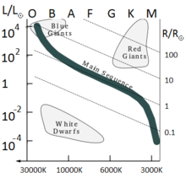
- HR Diagram

- Luminosity
- Sun red giant planetary nebula white dwarf
- Hot stars have a shorter life span

- HR Diagram
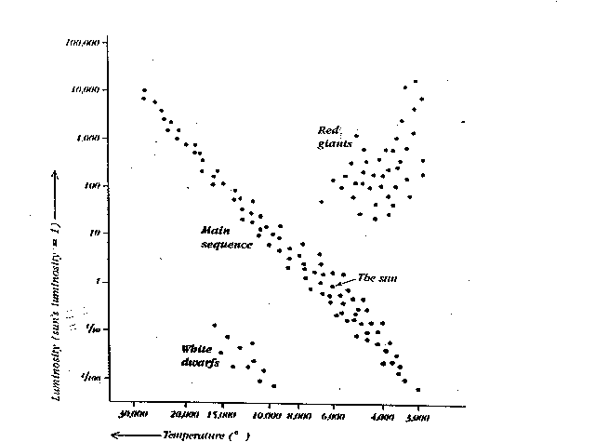

- Helium fuses into heavier elements
- Serve as distance markers (when two far away to see parallax)
- Mass
- Blue giants
- High mass stars- light and radiation, neutrinos, elements heavier than iron
- Stars run out of fuel, core collapses, core converts to mostly neutrons, explodes- after red giant phases
- Pulsar- neutron star that spins rapidly- emits radio waves (synchrotron radiation)
- Black hole- a very dense star that continues to collapse, detected by: accretion disk, galactic jets, x-rays, companion star orbiting
- Hypernova- explosion produced when a high mass star collapses into a black hole
- Interstellar Cloud Protostar Massive Star Red Giant Super Nova Blackhole neutron star

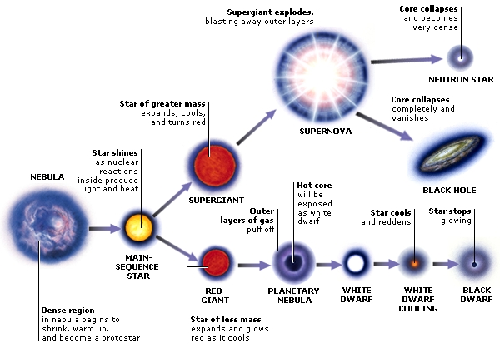

- Red giant – Betelgeuse; blue giant – Rigel; pulsar- crab pulsar; Blackhole- center of the universe; main sequence star – Sun
- Milky Way Galaxy
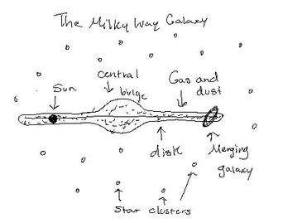

- Milky Way – spiral
- Interstellar dust; 21cm infrared waves
- Elliptical, spiral, barred spiral, irregular
- Initial conditions under which the galaxy was formed
- Cosmology- the study of how the universe began, is not and how it will be in the future
- Theory of how the universe began
  - Galaxies are receding away
  - Cosmic background radiation
  - Majority of universe is hydrogen and helium
  - Left over neutrinos
- The further away the faster the galaxy is receding
- Dependent on density; low density- the universe keeps expanding; high density- the universe expanding and collapse; Dark energy is the current cause of that force.
- Exoplanet- planets outside our solar system that could hold Habitable planet. Look for water as a signature.
- Atmosphere “water” food supply regulated heat

