Rock and Mineral Study Guide KEY NAME__________________________
- Which of the following is not true about rocks?
- Rocks are composed of only one mineral.
- Rocks do not contain any nonmineral matter.
- Coal is not considered a true rock.
- Most rocks are a mixture of minerals.
- Which of the following are considered to be a rocks?
- coal
- pumice
- sandstone
- lava
- What are the three types of rocks? Igneous, sedimentary, metamorphic

- Rocks are split into three categories based on what? How they form

- If granite faces high temperatures and high pressures deep within Earth, what type of rock will be formed? (Assume that the granite did not melt.) metamorphic

- What energy source drives the processes that form igneous and metamorphic rocks?
Earth’s interior
- A rock that forms when magma hardens beneath Earth’s surface is called an
Intrusive Igneous Rock.
- Fill in the chart below:
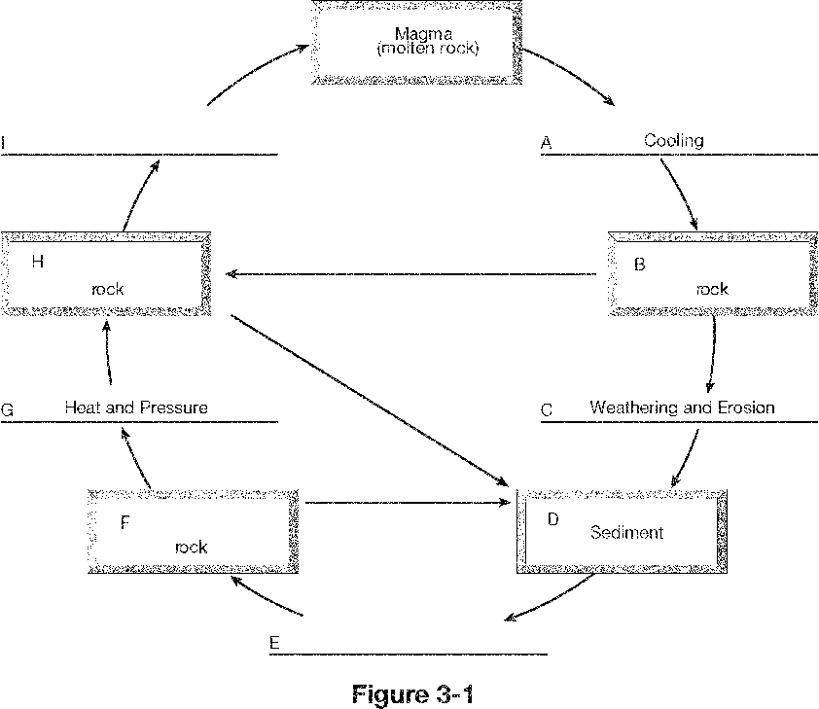
B. Igneous
E. Compaction and Cementation
F. Sedimentary
H. Metamorphic
I. Melting
- Lava that cools so quickly that there are no visible crystals makes rocks with a Glassy texture.
- If lava cools faster, the crystals that form smaller cystals.
- A conglomerate is a rock that forms because of Compaction and Cementation
- What is the correct order of the processes involved in sedimentary rock formation?
Weathering, Erosion, Deposition, Compaction, Cementation
- What type of sedimentary rock is formed from weathered particles of rocks and minerals?
Sedimentary
- Fossils are only found in what type of rocks? Sedimentary

- In which of the following settings would a metamorphic rock not form?
  - At the surface of the ocean floor
  - deep below Earth’s surface
  - a desert
  - on the slopes of an active volcano
- Which of the following are agents that helps form metamorphic rocks?
  - A nearby mass of magma
  - Pressure of the layers above
  - running water
  - a hydrothermal vent
- A metamorphic rock can be classified according to its what?
Texture and Composition
- Which of the following are one of the eight most common elements in Earth’s continental crust?
  - carbon
  - oxygen
  - silicon
  - aluminum
- The most abundant element in Earth’s continental crust (by weight) is Oxygen.
- What are the building blocks of minerals? Elements
- Which of the following are characteristics of minerals?
  - crystalline structure
  - definite chemical composition
  - formed by inorganic processes
  - liquid
- Minerals form from bodies of water due to the process of evaporation.
- The process of mineral formation from magma is called crystallization.
- Minerals are classified into mineral groups based on their composition.
- The most common mineral group in Earth’s crust is the oxides.
- What property is generally the least useful in identifying minerals? color
- The appearance or quality of light reflected from the surface of a mineral is called luster.
- The resistance of a mineral to being scratched is called hardness.
- The color a mineral leaves on a white tile of unglazed porcelain is called streak.
- Moh’s scale is used to classify what property of minerals? hardness
- The tendency of minerals to break along smooth flat surfaces is called cleavage.
- What is the density of a mineral? Ratio of mass to its volume
- What determines the properties of a mineral? Composition and structure

