REVIEW STUDY GUIDE FOR UNIT 6
- Describe the earth’s crust.
- What is the earth’s core is made from?
- What causes the earth’s inner core to be solid?
- What rock type makes up the continental crust?
- Describe Wegener’s hypothesis of continental drift.
- What was Pangaea?
- Describe evidence that supports Wegener’s hypothesis.
- What is a tectonic plate?
- Define a transform fault boundary.
- What is a rift valley?
- What is a convergent boundary?
- Where is new ocean crust formed?
- What type of boundary do we find in an area of sea-floor spreading?
- What is a subduction zone?
- What type of plate boundary are volcanic arch islands formed?
- What is a fault?
- What is an earthquakes epicenter?
- What type of movement occurs on the ground surface because of the earthquake?
- What fault line is responsible for the 1906 San Francisco earthquake?
- What seismic wave moves the fastest?
- Which seismic waves are the most destructive?
- In order to determine an earthquakes’ epicenter, a scientist will need _____?
- Using your travel-time graph to answer the following:
  - What is the distance between seismic station and the epicenter, if the first S wave arrives 4 minutes after the first P wave?
  - When does the first P wave arrive if the earthquake epicenter is 2500 km from the seismic station?
  - How much time is there between the first P wave and S wave if the seismic station is 2000 kilometers from the epicenter?
- An earthquake’s magnitude is a measure of _______?
- What instrument measures an earthquake?
- What is an earthquake’s intensity?
- What is the Richter magnitude?
- List 3 things that affect the amount of destruction caused by an earthquake?
- What is a tsunami?
- What layer of the earth will an S waves not travel through?
- What is the most abundant gas associated with volcanic activity?
- What plays a major part in determining the form of a volcano?
- The most violent volcanic eruptions are associated with what type of volcano?
- Structures that form from cooling and hardening of magma beneath the Earth’s surface is known as ____?
- List 3 factors that affect the melting point of rock.
- A magma’s viscosity is directly related what factor?
- List 3 factors that determine whether a volcano remains quiet or erupt violently.
- Particles produced in a volcanic eruption are known as _______.
- The area on Earth where there is a large concentration of volcanoes is known as ________.
- What is a caldera?

LABEL THE PARTS OF EARTH IN THE DIAGRAM BELOW:
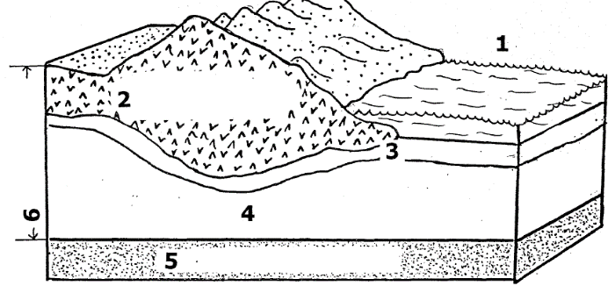

LABEL EACH PART OF THE DIAGRAM BELOW
