Earth Systems Weather and Atmosphere Test Review NAME________________________
Answer each review question on a separate sheet of paper.
- What type of energy passes from the Sun to the Earth?
- What is the difference between weather and climate?
- Why does the area around the equator receive more energy from the sun year round than any other areas of the Earth?
- A large volume of air with the same humidity and temperature as its source region is known as what?
- What are the characteristics of an air mass that forms over the southwest US and Mexico?
- Weather Station Models:
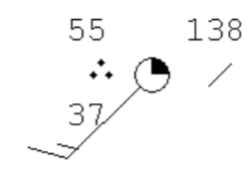
- What is the cloud cover?
- What is the temperature?
- What is the wind speed?
- What is the wind direction?
- What is the barometric pressure?
- What is the dew point?
- Answer the following questions using the map below:

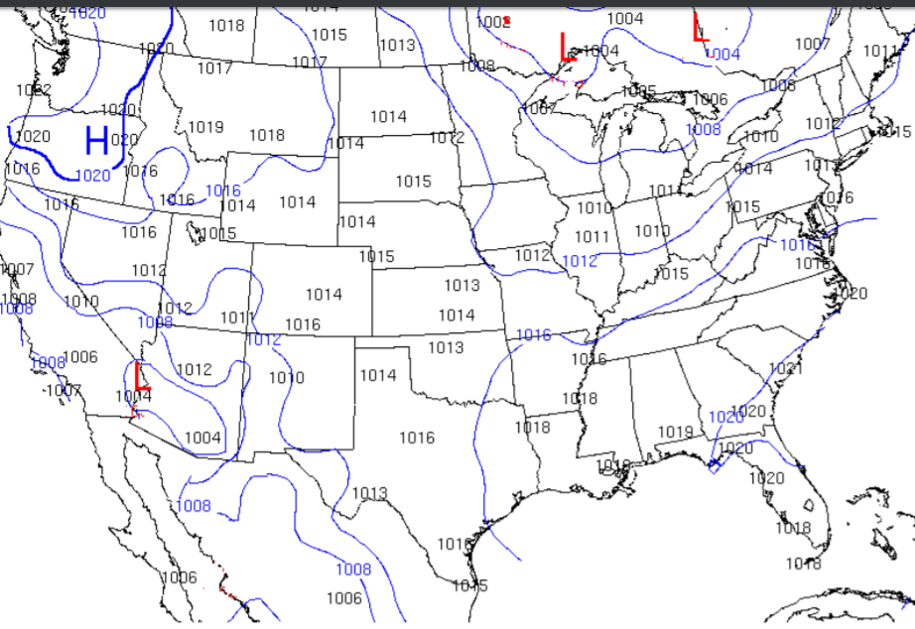

- What do the numbers represent on the map above?
- What do the curved lines on the map represent?
- What is the air pressure in lower Alabama?
- What type of weather is associated with High-pressure systems?
- What type of weather is associated with Low-pressure systems?
- High altitude wind found in a narrow band of air that moves very fast is known as the ____________________.
- How does a weather front form?
- Describe a cold front. (Name 3)
- Describe the motion of a high-pressure system that forms over the US.
- Why do we experience curving winds on Earth?
- How does air pressure differ on top of a mountain compared to air pressure at sea level?
- What causes fog?
- When the relative humidity is provided on the daily weather report, what information does this represent?
- Describe the steps of cloud formation in order.
- What is orographic lifting?
- When does rain happen?
- What causes thunder?
- Describe the greenhouse effect.
- Describe Tropical cyclones such as hurricanes in terms of temperature and pressure.
- What is a storm surge?
- Why do hurricanes form over the equator?
- The earliest stage of storms that could possibly form hurricanes is known as ___________.
- What is the Saffir-Simpon scale?
- What factor can cause hurricanes to weaken?
- What is a tornado?
- What is the Enhanced Fujita Scale (EF) and how is it used?
- Even though we do not understand how tornadoes form, what processes are needed to produce them?
- Rotating thunderstorms can produce tornadoes what else can they produce?
- What is the final stage of a thunderstorm?
- What are the steps involved in the formation of hail?

