Radioactive Dating Game Lab
http://phet.colorado.edu/simulations/sims.php?sim=Radioactive_Dating_Game

Purpose: You will use the radioactive decay rate and original-daughter element ratios of carbon-14 and uranium-238 to determine the ages of different objects.

Procedure:
Decay Rate
- Play around with the simulation for a few minutes.
- Click on the tab for Decay Rates. Check Carbon-14
- Click on the bucket and add some nuclei to the simulation, observe what happens
- What do the red dots represent? ________________________________
- What do the blue dots represent?_________________________________
- Use the stop and play buttons to control how fast the decay occurs.
- Explain what the pie graph looks like at one half life.

- Explain what the pie graph looks like at 2 half lives, then 3 half lives.

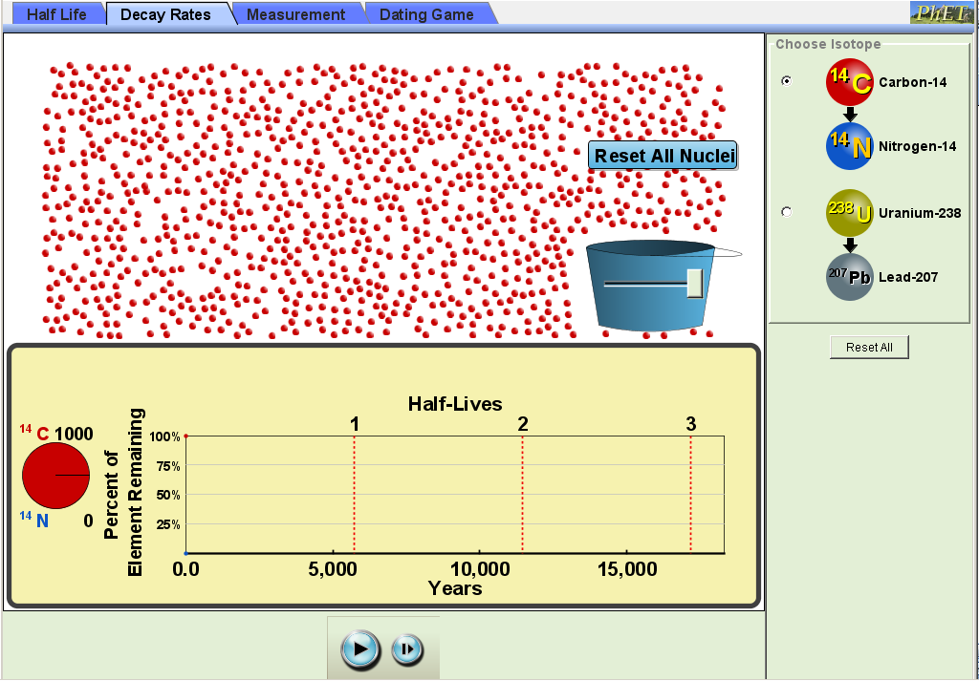
- What happens to the Carbon-14 by the end of the simulation?

- Load PhET Radioactive Dating Game
Bucket Slider
- Click on tab for Decay Rates
- Select Carbon-14. Using the graph, the estimated half-life for C-14 is _________ years.
- Move the bucket slider all the way to the right. This will place 1000 C-14 atoms onto the screen.
Step
button
Start/Stop
button
  - Click on the Start/Stop to stop the C-14 decay. Click on Reset All Nuclei
  - Click on the Start/Stop to start the C-14 decay. Stop the decay as you get close to one half-life.
  - Use the Step button to stop decay at one half-life.
    - After 1 half-life, how many C-14 atoms of the 1000 original remain? _______
  - Use the Start/Stop and Step buttons to reach two half-lives. After two half-lives, how many C-14 atoms remain? ________
    - What fraction of C-14 atoms present at 1 half-life remain after 2 half-lives? _______
  - Use the Start/Stop and Step buttons to reach three half-lives. After three half-lives, how many C-14 atoms remain? ________
    - What fraction of C-14 atoms present at 2 half-life remain after 3 half-lives? _______

  - Repeat Steps (a) to (e) with uranium-238.
    - Estimated half-life for U-238 is _________ years.
    - After 1 half-life, how many U-238 atoms of the 1000 original remain? _______
    - What fraction of U-238 atoms present at 1 half-life remain after 2 half-lives? _______
    - What fraction of U-238 atoms present at 2 half-life remain after 3 half-lives? _______
  - Based on the results of 4a to 4f, explain the meaning of the word “half-life” in one sentence.

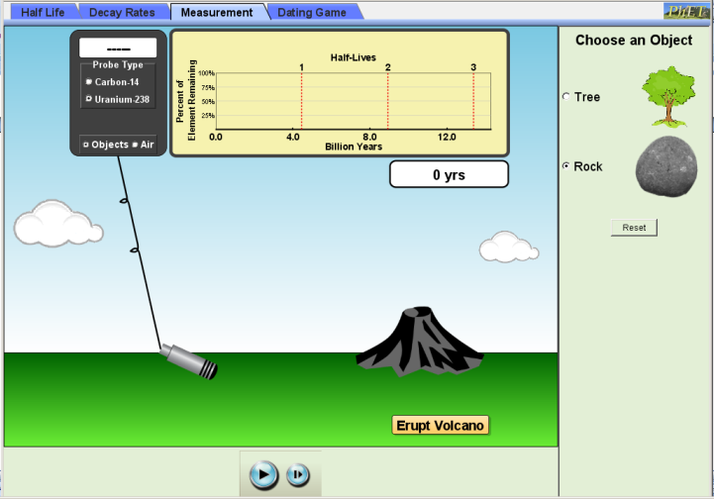
- Click on the Measurement tab.
- Under Probe Type, select Uranium-238 and Objects. Under Choose an Object, select Rock.
- Click on Erupt Volcano. Let the simulation run until you reach 1 half-life. What % of the original uranium remains? _________. How many years did this take? ____________
- Under Probe Type, select Carbon-14 and Objects. Under Choose an Object, select Tree.
- Click on Plant Tree. Let the simulation run until you reach 1 half-life. What % of the original carbon remains? _________. How many years did this take? ____________
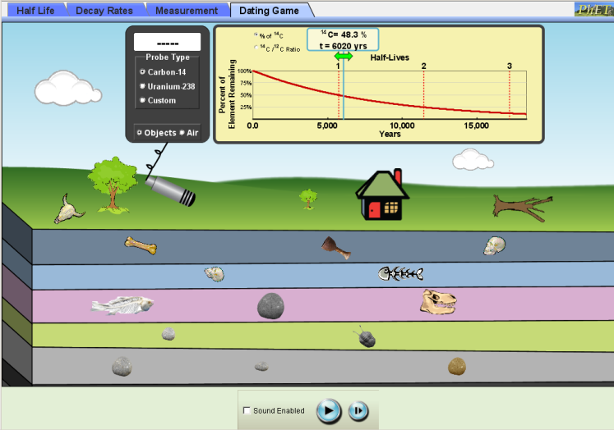
- Explain why uranium-238 is used to measure the age of rocks while carbon-14 is used to measure the age of the tree trunk?
- Click on Dating Game tab. There are objects on the surface and in the five layers beneath the surface. There are both rocks and fossils in each layer.
- Select the Carbon-14 detector. Move the Geiger counter to each fossil and record the % of original in the table below
- On the ½ life graph, move the green arrow right or left until the % of original matches the reading on the detector. Record your estimated age for each fossil in the table
- Repeat Steps 12 and 13 using the Uranium2-38 detector to estimate the rock ages. For fossils with no remaining C-14 signal, use the rock ages to estimate fossil ages in the same layer.
- Summarize how C-14 and U-238 dating together can be used to determine fossil ages.

Table: Radiometric Ages for Various Objects

Object | Measured using C-14 or U-238? | % of Original | Guessed Age | Measured Age
Animal Skull
Living Tree
Distant Living Tree
House
Dead Tree
Bone
Wooden Cup
1st human skull
2nd human skull
Fish Bones
Fish Fossil 1
Rock 1
Dinosaur Skull
Rock 2
Trilobite
Rock 3
Rock 4
Rock 5

