**Binary Ionic Compounds Review**



**Writing Formulas**

1. Write the symbol for the cation and charge



Cations (+) metal ion



A roman numeral after a metal denotes the its charge



1. Write the symbol for the anion and charge

Anions (-) nonmetal ion



1. Check the oxidation numbers (charge) of each ion

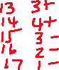

1. Use the Criss-Cross Method to determine subscripts
2. Reduce subscripts to the lowest ratio



**Naming Compounds**

1. Write the name of cation, (metal as it appears on the Periodic Table)



1. If the metal can hold more than one charge then place a roman numeral after its name to denote charge



1. Write the name of anion (nonmetal with an -ide ending)



**Ionic Characteristics**

Contains Ions



Metal to Nonmetal

Smallest unit “Formula Unit”

High melting & boiling points

Brittle solids at room temperature

Conducts electricity when molten

**Let’s Review the crisscross method**

Now lets use the crisscross method. In the crisscross method you take the number for the charge on an ion (ignore the positive and negative) and you make it the other atoms subscript.



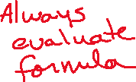

Now let’s look at **Calcium Chloride**







Now let’s look at **Aluminum Chloride**



Let’s take a look at **Magnesium Oxide**



In a case like this where you have two ions that have the same number for an oxidation state you want to find the least common multiple of the numbers. Always reduce the compound to its simplest form when dealing with ionic compounds.

**Aluminum Oxide**





**MATH CHECK:**

So, let’s check if this method has still generated a compound with a net 0 charge. To do this all we need to do is add up all the positive charges and add that to the sum of all the negative charges.

2 Al+3 = +3 + +3 = +6

3 O2- = -2 + -2 + -2 = -6

+6 + -6 = 0 neutral compound

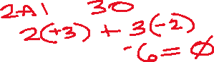

Therefore, the compound’s formula is correct.



What would the formula for Pb4+ and O2- be?





Remember: Always reduce to the least common multiple.



**MATH CHECK:**

So, let’s check if this method has still generated a compound with a net 0 charge. To do this all we need to do is add up all the positive charges and add that to the sum of all the negative charges.

1 Pb+4 = +4



2 O2- = -2 + -2 = -4

+4 + -4 = 0 neutral compound



Therefore, the compound’s formula is correct.



**Binary Ionic Compounds TYPE II (D Block metals + P Block Nonmetals)**



Where are the D Block elements?



What do we know about the oxidation (charges) of the D Block elements?

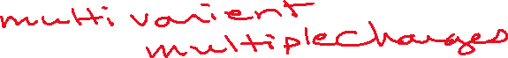

**Exceptions to the multi-charge D Block elements:**



**FORMULA WRITING:**

**Step 1:** You are given the name of the compound. You must evaluate what is given.

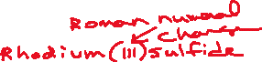

1. Where is the first element found on the Periodic Table?
2. Where is the second element found on the Periodic Table?



**Step 2:** Write the symbols:

1. Cation



1. Anion



**Step 3:** Criss Cross the Charges.

Remember:

1. The charges go away when you crisscross the oxidation numbers.
2. The numbers become subscripts
3. Reduce the subscript numbers to their lowest value.

**Examples:**



**Palladium (II) iodide Platinum (IV) telluride Vanadium (V) selenide**

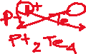

**Zinc chloride Manganese (VII) phosphate Silver arsenide**



**NAMING COMPOUNDS WITH D BLOCK METALS:**

Format for the naming of Binary Compounds using Transition Metals:

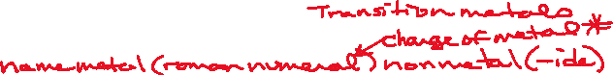

Given the formula for a compound.



**Step 1:** Identify

1. The first element, where is it on the Periodic Table?



1. The second element, where is it on the Periodic Table?



**Step 2:** Write



1. The name of the metal as it appears on the periodic table
2. If the transition metal has multiple charges put in parentheses ( ) in between the metal and nonmetal.



1. The name of the nonmetal as it appears on the periodic table



**Step 3:** Determine the charge on the metal. The number that you calculate will be the charge which is



written as a Roman Numeral and placed into the parentheses just like a middle initial in

name.



**ROMAN NUMERALS:**



1 = I 2= II 3= III 4= IV 5= V 6= VI 7= VII

**EXAMPLES:**

**CuF2 CrO Cr2O3**



**CuBr Os2S3 OsS**