**IONIC BONDING WITH S + P BLOCK ELEMENTS**

**Ions formed by a group on the Periodic Table**

**Group 1 Form 1+ ion**



**Group 2 Form 2+ ion**

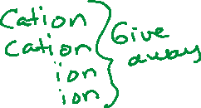

**Group 13 or 3A Form 3+ ion**



**Group 14 or 4A Form 4+ or 4- ion**



**Group 15 or 5A Form 3- ion**



**Group 16 or 6A Form 2- ion**

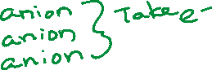

**Group 17 or 7A Form 1- ion**



**Ionic Bonds What are They?**



**What is a BINARY IONIC BOND?**



**How do we write the NAME for an IONIC COMPOUND?**

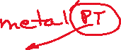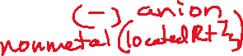

**NONMETALS**



**Carbon Arsenic**



**Nitrogen Selenium**



**Oxygen Bromine**



**Fluorine Tellurium**

**Silicon Iodine**

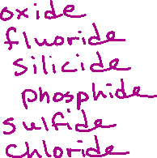

**Phosphorus Astatine**



**Sulfur**

**Chlorine**

**EXAMPLES:**



**Na2S**



**Al2O3**



**NaCl**

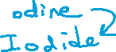

**RbI**



**ZnBr2**

**AgCl**

**BN**

**BaF2**

**Sr3N2**

**MgCl2**

**WRITING IONIC FORMULAS**

The name of the compound is given, and you are told to write the formula.

**Step 1**: Identify the first element in the name. Where is it on the periodic table? If it is to the left of the stairstep it is a metal. Metals form cations, the positive charged ion. The positive charges are written first.



**Step 2**: Identify the second element. Where is it on the periodic table? If it is to the right of the stairstep then it is a nonmetal. Nonmetals form anions, the negative charged ion. The negative charges are written second in an ionic bond.



**Step 3**: Write the symbol and charge for the cation then write the symbol and charge for the anion.



**Step 4:** Before we do anything with the number on the charges, we need to look at their values. If the numbers are the same, then they cancel each other out and we just write the symbols for the cation and anions together. If the numbers are not the same, we must look to see if they can be reduced. If they can be reduced, we need to this before we go through the crisscross method. Doing the reduction before we crisscross will help reduce errors.



**Step 5:** Once we have evaluated and reduced, then we are ready to crisscross our numbers. When we crisscross the numbers, the charges are dropped, and the numbers are now written in subscript. (The numbers switch partners.) The charges are for the ions not the compounds. We will not have charges showing in our final compound. (Remember that the numbers and signs in superscript show the ion charge and once we crisscross the numbers and write them in subscript, they are now ratios)

**EXAMPLES:**

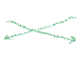**Hydrogen Fluoride**



**Hydrogen Selenide**



**Hydrogen Phosphide**

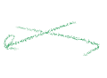**Calcium Chloride**



**Calcium Selenide**



**Calcium Phosphide**



**Indium Chloride**

**Indium Selenide**

**Indium Phosphide**

