NOTES: HOW TO COUNT ATOMS
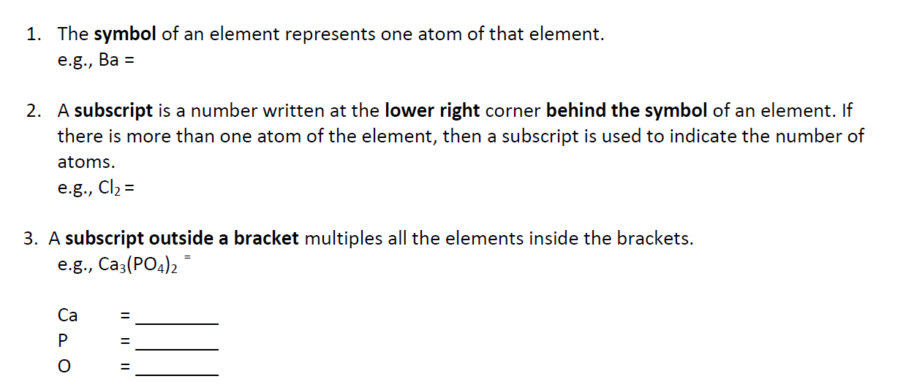

4. 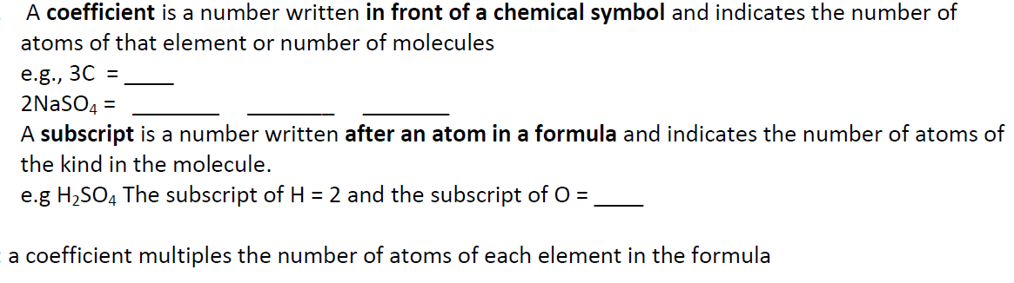
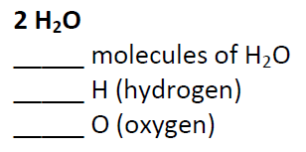
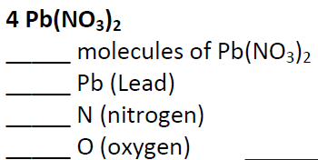

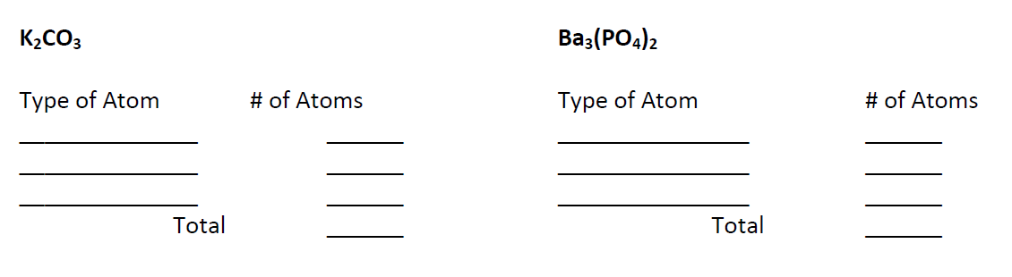

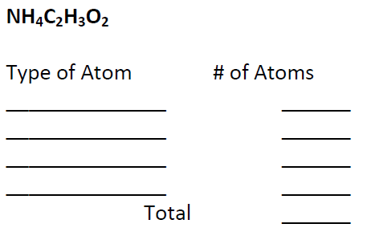

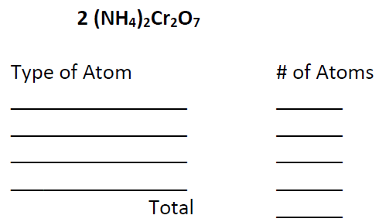

3Cs₂SO₃ # of molecules______
# of elements ______

Name of element: # of atoms:
____________________ ______
____________________ ______
____________________ ______

Total # of atoms ______

The #3 is a _________________________
(coefficient or subscript)

