Mini-Maps and Weather Station Models CITY_________________________________ NAME______________________
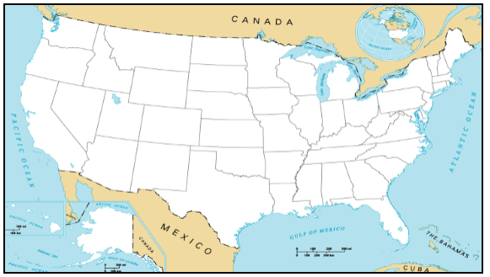
Weather Station Model DATE__________

Weather Station Model DATE_________

