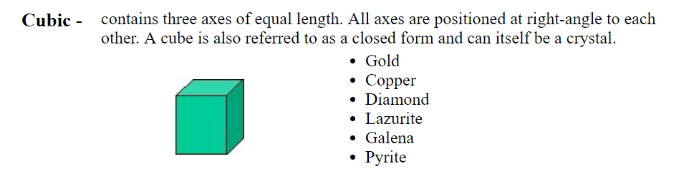
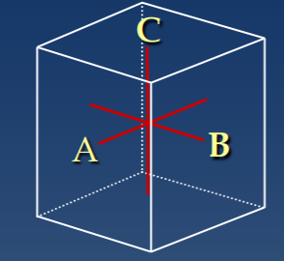

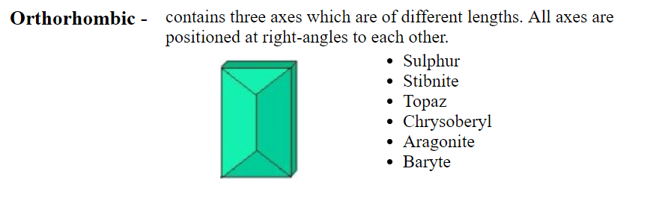

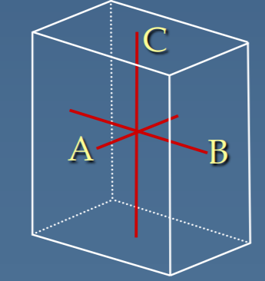

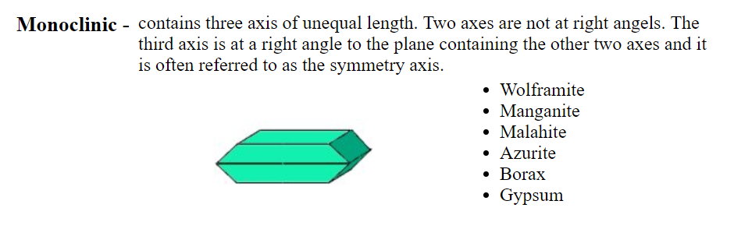

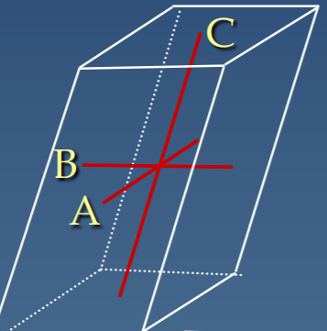

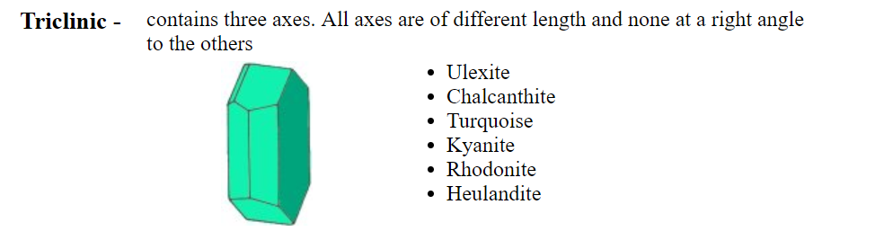

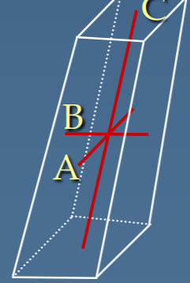
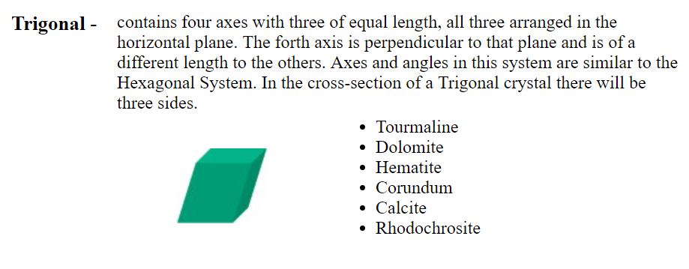

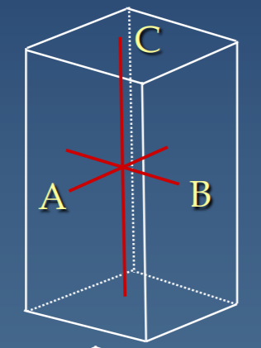
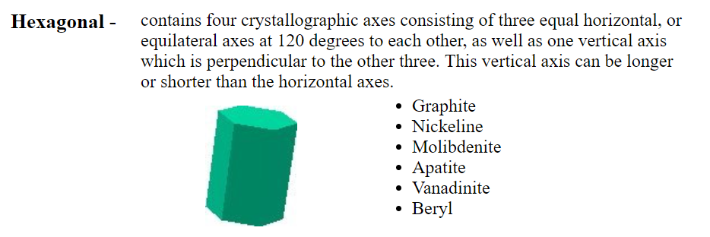

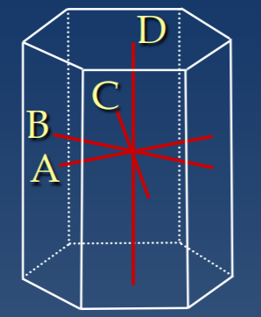

MINERAL GROWTH 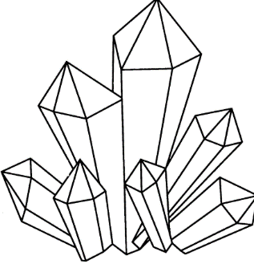
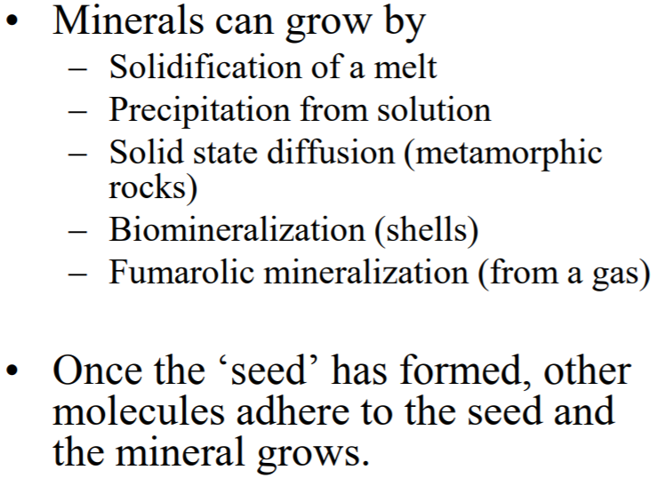

Special Mineral Characteristics
Transparency- How much light passes through
Tenacity- how the particles of the minerals are held together
Odor
Taste
Magnetic
Striations- layers or bands

MINERAL COMPOSITION
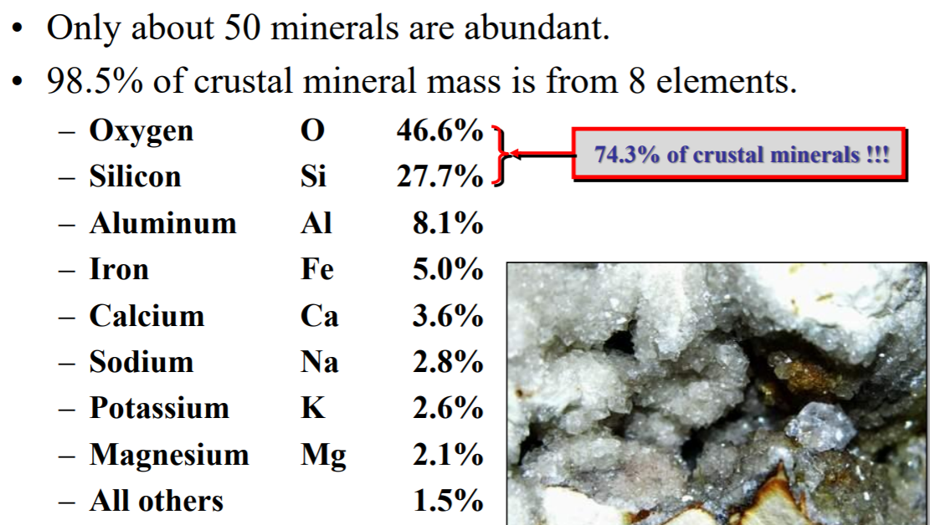

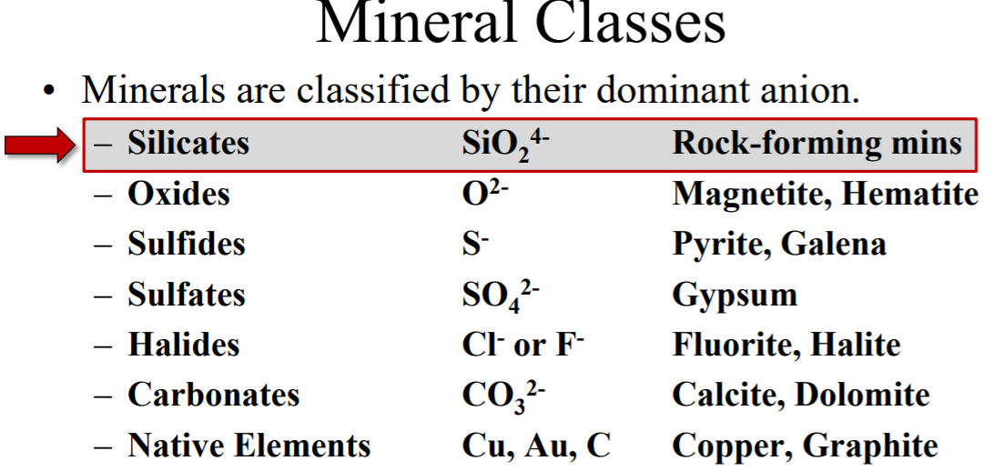

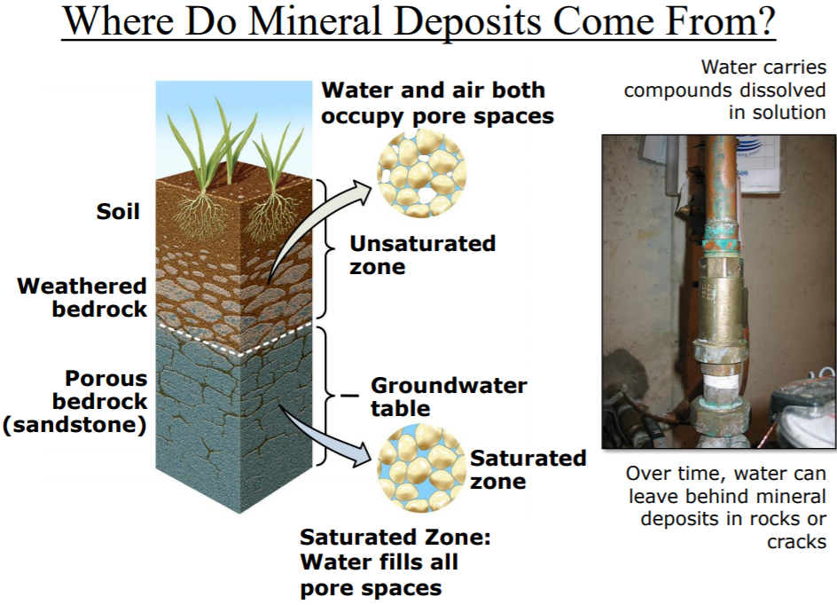
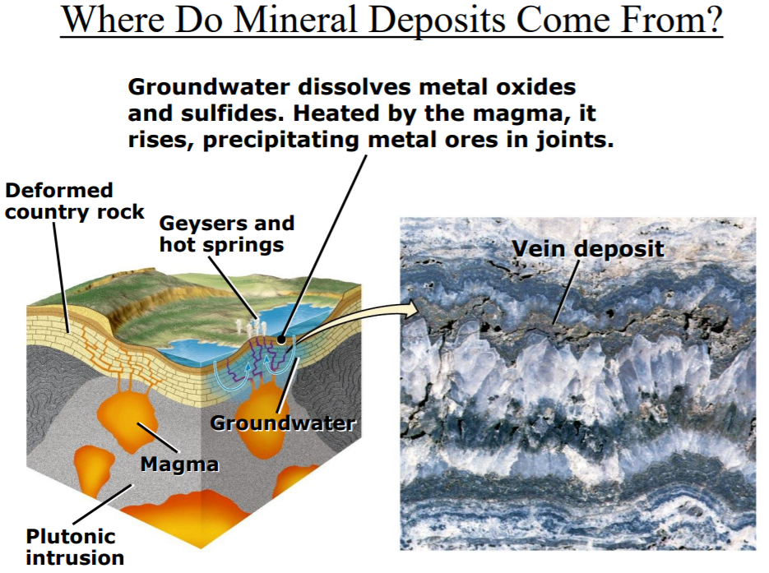
CUT AND ASSEMBLE

A mineral, by definition, has a crystal shape. These shapes fall into one of six basic groups, although there are many variations within these groups. (In fact, some of these variations may look to us very unlike anything else in the group.) The defining characteristic that determines which group a crystal belongs in is the geometric angles between the atoms in the crystal. The shapes shown below are the simplest shapes in each category.

