Intro to Ecology Note Taking Page
The Organization of Life
Section 1

Defining an Ecosystem
- __________________________________ are communities of organisms and their abiotic environment.
- Examples are an ___________________________________________________.
- Ecosystems do not have clear boundaries.
- Things move from one ecosystem to another.
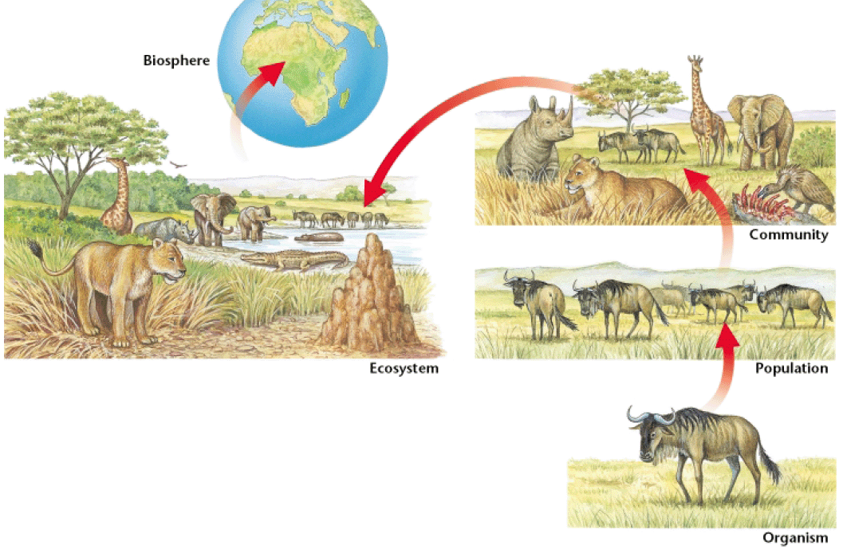
- Pollen can blow from a forest into a field, soil can wash from a mountain into a lake, and birds migrate from state to state.

The Components of an Ecosystem
- In order to survive, ecosystems need five basic components:
  - _________________________________
  - _________________________________
  - _________________________________
  - _________________________________
  - _________________________________
- Plants and rocks are components of the land ecosystems, while most of the energy of an ecosystem comes from the ___________________________.
- If one part of the ecosystem is destroyed or changes, the entire system will be affected.
Biotic and Abiotic Factors
- ____________________________________________ are environmental factors that are associated with or results from the ______________________________________________________, which includes plants, animals, dead organisms, and the waste products of organisms.
- _______________________________________________ are environmental factors that are _______________________________________________ with the activities of living organisms which includes air, water, rocks, and temperature.
- Scientists can organize these living and nonliving things into various levels.
Organisms
- _____________________________________ are living things that can carry out life processes independently.
- You are an organism, as is an ant, and ivy plant, and each of the many bacteria living in your intestines.
- Every organism is a member of a species.
- _____________________________________ are groups of organisms that are closely related can mate to produce fertile offspring.

Populations
- Members of a species may not all live in the same place.
- Field mice in Maine will not interact with field mice in Texas. However, each organism lives as part of a population.
- _____________________________________ are groups of organisms of the same species that live in a specific geographical area and interbreed.
- For example, all the field mice in a cornfield make up a population of field mice.
Populations
- An important characteristic of a population is that its members _________________________________________________________________ rather than with members of other populations
- For example, bison will usually mate with another member of the same herd, just as other flowers in the same field will usually pollinate wildflowers.
Communities
- __________________________________________ are groups of various species that live in the same habitat and interact with each other.
- __________________________________________ is part of a community.
- The most obvious difference between communities is the __________________________________________ they have.
- Land communities are often dominated by a few species of plants. These plants then determine what other organisms can live in that community.

Habitat
- ______________________________________ are places where an organism usually lives.
- Every habitat has specific characteristics that the organisms that live there need to survive. If any of these factors change, the habitat changes.
- Organisms tend to be very _________________________________ to their natural habitats.
- In fact, animals and plants usually cannot survive for long periods away from their natural habitat.
BIOME
- Large _____________ of ecosystems that share the same __________.
- Examples:

BIOSPHERE
- Relatively thin layer of Earth and its ________________ that supports life.
- All of the ______________ make up the biosphere.

BIODIVERSITY
- ______________________- measure of the number of _____________species there are as well as how common each species is.
- Ecosystems _________________ more with more __________________.

NICHE
- Niche- an organism’s role in the ________________ (like a job)
- It includes the way an organism _______________ with its environment. (ex: How it gets food, how it finds shelter, when it reproduces, how many offspring it has)

GENERALIST
- Generalists- species with broad __________, they can tolerate many conditions and use many resources (ex cats, deer, roaches)

SPECIALIST
- Specialists- Species that have narrow ________________, they can only tolerate certain conditions. (ex. Koala and Panda)

SYMBIOSIS- close ________________________ between any 2 living organisms
Remember: Sym = _______________________
Bio = ____________________
- _____________________- two species cooperating, they both benefit (+ and +)
- ex. bees and flowers, hippos and fish
COMMENSALISM
- one species benefits from another, the other species is not ___________ (+ and no affect)
- ex. Sea anemones and clown fish
  - Barnacles and whales
PARASITISM
- -one species benefits from another, the other species is _____________ (+ and -), detriment = harm
- dogs and ticks, humans and tape worms

COMPETITION
competition- organisms that are in the same ________ and are therefore struggling for a resource (- and -)
There are 2 types
- Interspecific- between 2 _____________ species
Ex: lions and hyenas or pine trees and oak trees
- Intraspecific- between ____________ species
Ex: 2 male elephants fighting for female

PREDATION
- predation- one species, the _______________, hunting and eating another, the _______
- leopards and gazelles, spider and fly

