HR DIAGRAM SUMMARY NOTES
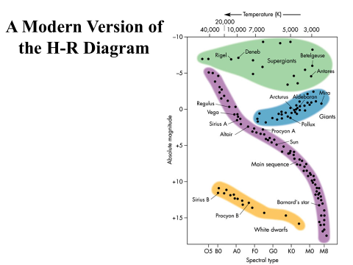
GENERAL INFO:
- ____________________________________________________________________________________________________________________________________________________________
- ____________________________________________________________________________________________________________________________________________________________
- ____________________________________________________________________________________________________________________________________________________________

BLUE GIANTS:
- ____________________________________________________________________________________________________________________________________________________________
- ____________________________________________________________________________________________________________________________________________________________
- ____________________________________________________________________________________________________________________________________________________________

RED DWARFS:
- ____________________________________________________________________________________________________________________________________________________________
- ____________________________________________________________________________________________________________________________________________________________
- ____________________________________________________________________________________________________________________________________________________________

WHITE DWARFS:
- ____________________________________________________________________________________________________________________________________________________________
- ____________________________________________________________________________________________________________________________________________________________
- ____________________________________________________________________________________________________________________________________________________________

RED GIANTS:
- ____________________________________________________________________________________________________________________________________________________________
- ____________________________________________________________________________________________________________________________________________________________
- ____________________________________________________________________________________________________________________________________________________________

RED SUPERGIANTS:
- ____________________________________________________________________________________________________________________________________________________________
- ____________________________________________________________________________________________________________________________________________________________

