Assignment #2 EARTHQUAKE FILL IN NOTES FOR WAVES NAME_____________________
- What is a wave?

- Draw and Label Picture of a WAVE.
wavelength
amplitude
crest (ridge)
trough
frequency

- List the 7 types of waves given.

- Seismic Wave Information:
- Waves that travel _____________________________________________________
- Classifications:
  - Body Waves
    - ____________, travel through the interior of the Earth
    - ______________ (primary)
    - _______________(secondary)
  - Surface Waves
    - _____________, travel along the surface of the Earth
    - Cause more ____________________
    - Similar to ______________________
    - _________ waves
    - _________ waves

- Primary Waves:
- _____________ cause the ground to have vibrations along or ___________ to the direction of the wave
  - _________The first type of seismic wave to arrive at a point away from the epicenter
  - Can travel through ________________________
  - Typical speeds:
    - In air: __________________
    - In water: ________________
    - In granite: _______________

- Secondary Waves:
- ______________ cause the motion of the ground to be perpendicular to the direction of the wave
  - Can only travel through ______________________
  - Speed is about ___________ of a P-wave in a material
  - ___________________ at a point away from the epicenter

- Love Waves:
- _______________ cause ___________________ shifting of the Earth during earthquakes
  - Move ________ than P-waves and S-waves, but ______ than Rayleigh waves
  - Named for _______________, the man who predicted this type of seismic wave in 1911

- Rayleigh Waves
- ______________ waves cause a _______________ motion—like ocean waves
  - _______________ of the seismic waves (travel at around ______________)
  - Produced by the ____________ of P- and S-waves at the Earth’s _________
  - Can be used to characterize the Earth’s interior and ___________________

- Intensity depends on:
  - ______________ of earthquake
  - ______________ to the earthquake
  - ______________ of the earthquake
  - ______________structure of the crust
  - The _____________ decreases with increasing _________ of the earthquake and with distance traveled.

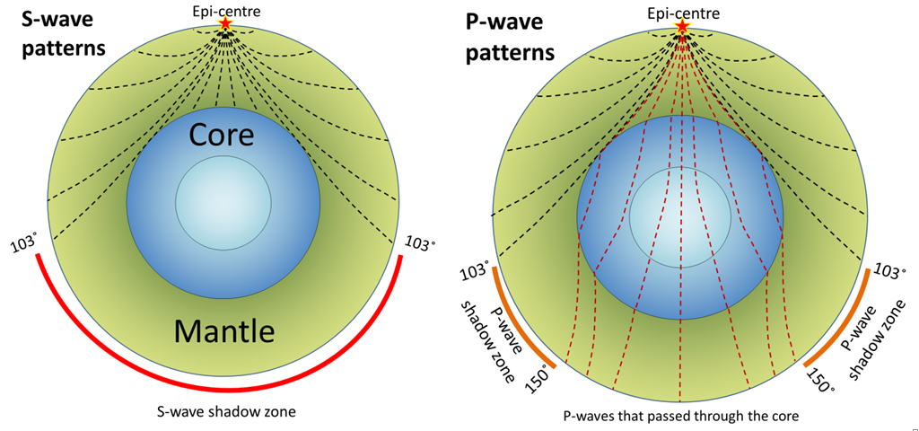

https://earthquake.usgs.gov/earthquakes/map/
- Go to the above link and find the last 10 earthquakes reported in the United States. List their location, magnitude and date.

