Earth Systems Weather and Atmosphere Test Review NAME_________KEY________
Answer each review question on a separate sheet of paper.
- What type of energy passes from the Sun to the Earth? Solar Radiation
- What is the difference between weather and climate? Weather is a short-time condition of an area, but climate is a long-term average weather for that area.
- Why does the area around the equator receive more energy from the sun year round than any other areas of the Earth? The equator is always angled toward the Sun.
- A large volume of air with the same humidity and temperature as its source region is known as what? An air mass
- What are the characteristics of an air mass that forms over the southwest US and Mexico? Hot and Dry
- Weather Station Models:
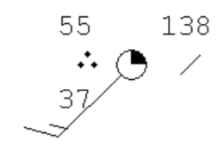
- What is the cloud cover? 25%
- What is the temperature? 55ºF
- What is the wind speed? 15 kts
- What is the wind direction? SW
- What is the barometric pressure? 138 mb
- What is the dew point? 37ºF
- Answer the following questions using the map below:

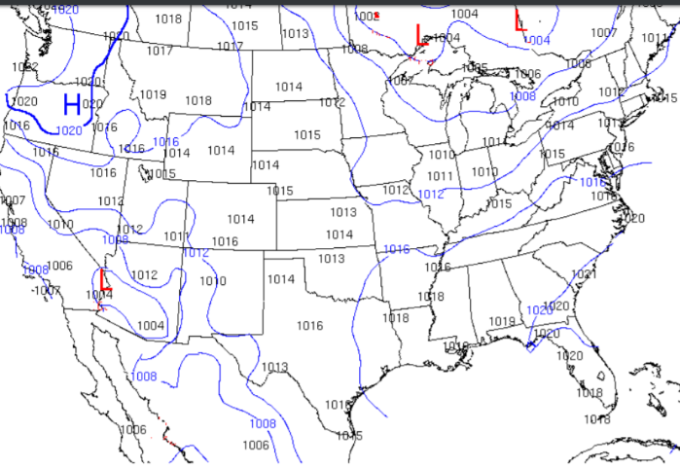

- What do the numbers represent on the map above? Barometric Pressure
- What do the curved lines on the map represent? Isobars
- What is the air pressure in lower Alabama? 1019 mb
- What type of weather is associated with High-pressure systems? Clear Skies
- What type of weather is associated with Low-pressure systems? Storms
- High altitude wind found in a narrow band of air that moves very fast is known as the Jet Stream.
- How does a weather front form? When two air masses collide
- Describe a cold front. (Name 3) Pushes warm air upward, Higher density, cloud formation and precipitation
- Describe the motion of a high-pressure system that forms over the US. Air rises and moves counter-clockwise
- Why do we experience curving winds on Earth? The Coriolis Effect
- How does air pressure differ on top of a mountain compared to air pressure at sea level? Air pressure is less at the top of a mountain because less atmosphere is pushing sown. Air pressure is less on top of a mountain because the air is thinner.
- What causes fog? The air is cooler at the surface causes condensation and warm air is on top of the cooler layer.
- When the relative humidity is provided on the daily weather report, what information does this represent? The percentage of saturation of the air by water.
- Describe the steps of cloud formation in order. Moist air rises, Rising air cools, Water condenses around a particle of air (condensation nuclei), Water droplets form a visible cloud
- What is orographic lifting? When an air mass comes in contact with a mountain and causes it to be pushed upward.
- When does rain happen? Water droplets gets too heavy to stay within the cloud.
- What causes thunder? The rapid heating and expansion of the air caused by lightning.
- Describe the greenhouse effect. The gases in the atmosphere trap heat between the Earth and the clouds.
- Describe Tropical cyclones such as hurricanes in terms of temperature and pressure. The air temperature warm and the pressure is low.
- What is a storm surge? A large wall of water pushes toward the shore.
- Why do hurricanes form over the equator? The warm ocean water is needed to grow hurricanes.
- The earliest stage of storms that could possibly form hurricanes is known as Tropical Storms.
- What is the Saffir-Simpon scale? The rating of a hurricane based on the wind speed.
- What factor can cause hurricanes to weaken? Crossing land masses and cold ocean waters
- What is a tornado? A mass of rotating wind around a low-pressure system.
- What is the Enhanced Fujita Scale (EF) and how is it used? The rating scale to judge the strength of a tornado by its wind speed and the damage that was caused.
- Even though we do not understand how tornadoes form, what processes are needed to produce them? Lifting of air around a low-pressure system.
- Rotating thunderstorms can produce tornadoes what else can they produce? Strong winds, Hail and flash flooding
- What is the final stage of a thunderstorm? The Dissipating Stage
- What are the steps involved in the formation of hail? Precipitation in the form of water droplets that are caught in strong updrafts within a thunderstorm. The water droplets move upward into cooler air causing them to freeze. As the frozen droplets fall back down into warmer parts of the cloud they melt and are pushed upward again causing outer layer freezing. This up and down motion of melting and freezing causes the hail to increase in size when it eventually falls from the clouds to the ground.

