DISTANCES IN SPACE ACTIVITY NAME____________________________
Equipment: Ruler, Meter stick, butcher paper
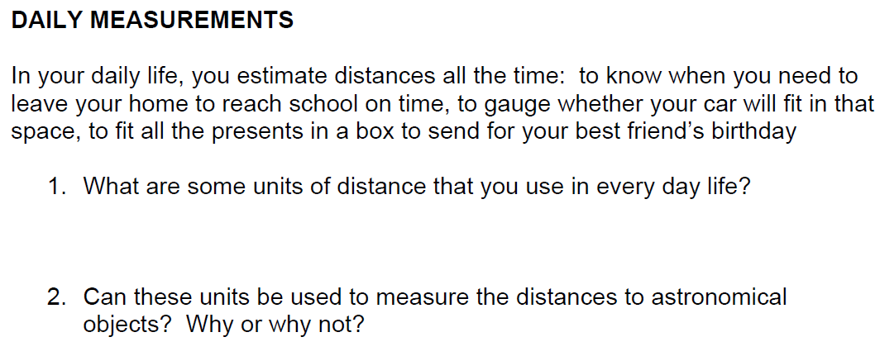
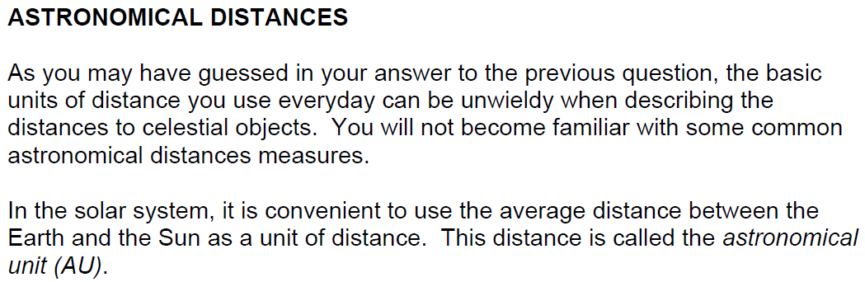
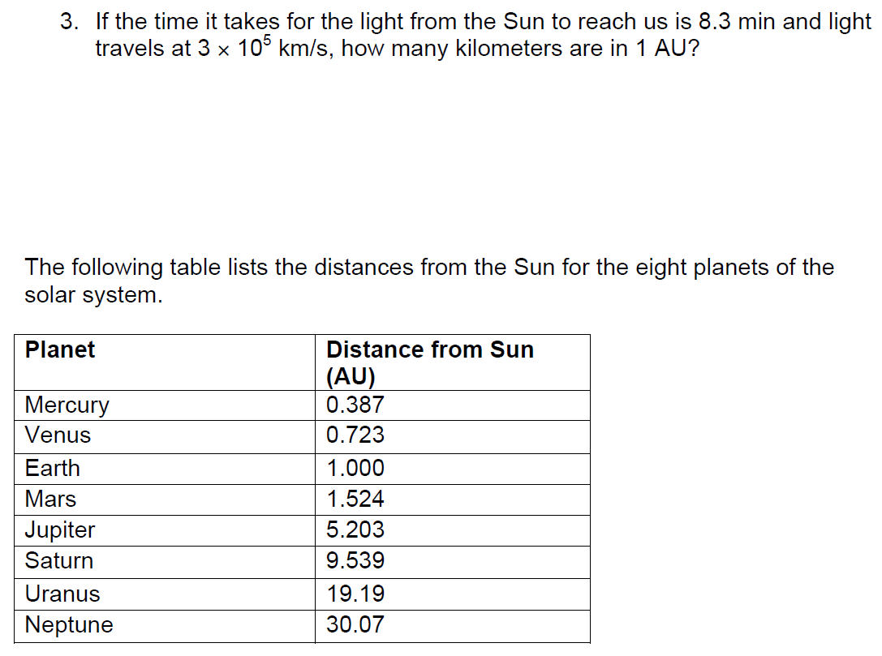
Activity:
- You will use the scale of 1AU = 1cm to make your drawing.
- You will draw a circle to scale for each planet on a piece of butcher paper.
- You will use a different color for each planet. The circles will overlap each other.
- After you complete your drawing answer the follow-up questions.

