Cornell Notes  Topic: The Sun  ___________________  Essential Question:  Questions/Main Ideas: | Name: ___________________________________Block: ________  Notes:
The Sun | 1.
 | 2.
Radius and Mass
Sun Properties | Distance
 | Diameter
 | Mass
 | Temperature
 | Core Temp.
 | Solar Energy
 | Sun’s Make-up
Solar Interior  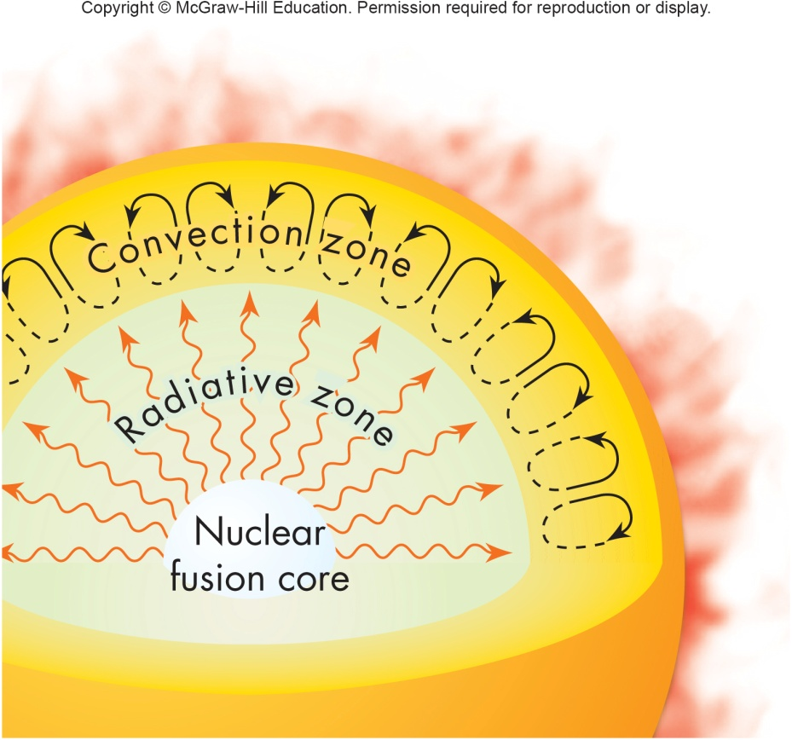 | The Photosphere:
Temperature and Density
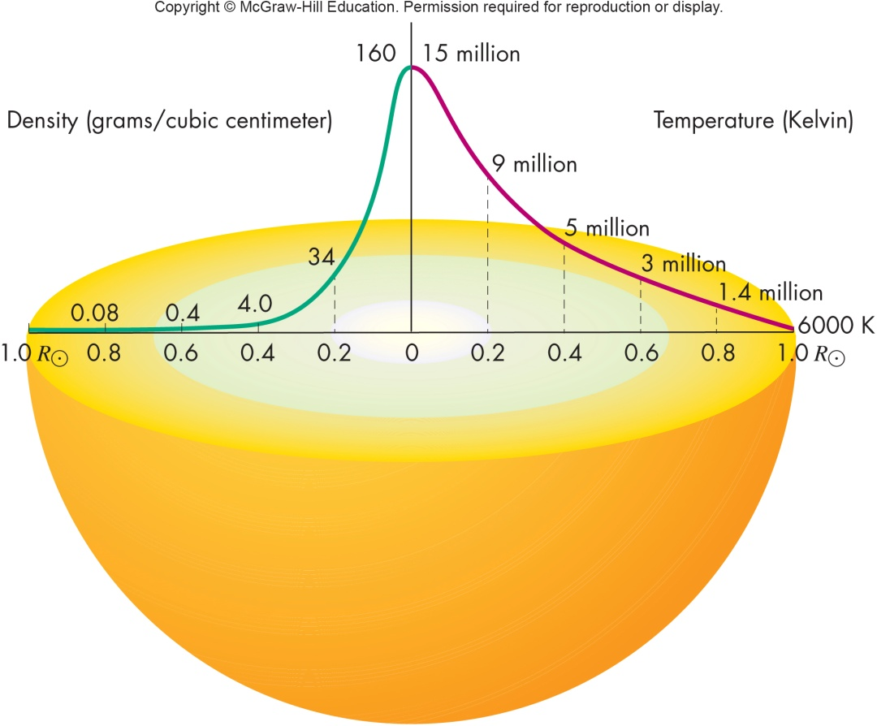
Radiative Zone  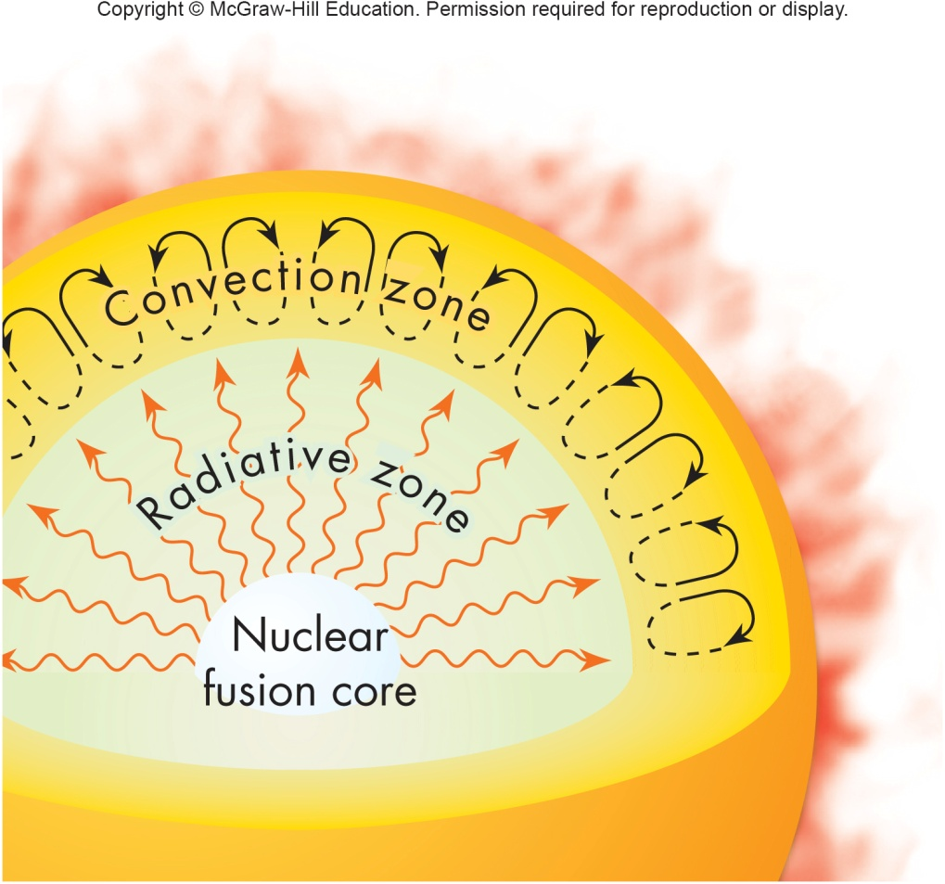 | 1.  2.
Very Old Light
The Convection Zone
Granulation

The Sun Atmosphere

The Temperature Profile | 1.
 | 2.
 | 3.
The Chromosphere | 1.
 | 2.
 | 3.
The Corona | 1.
 | 2.
 | 3.
How the Sun Works  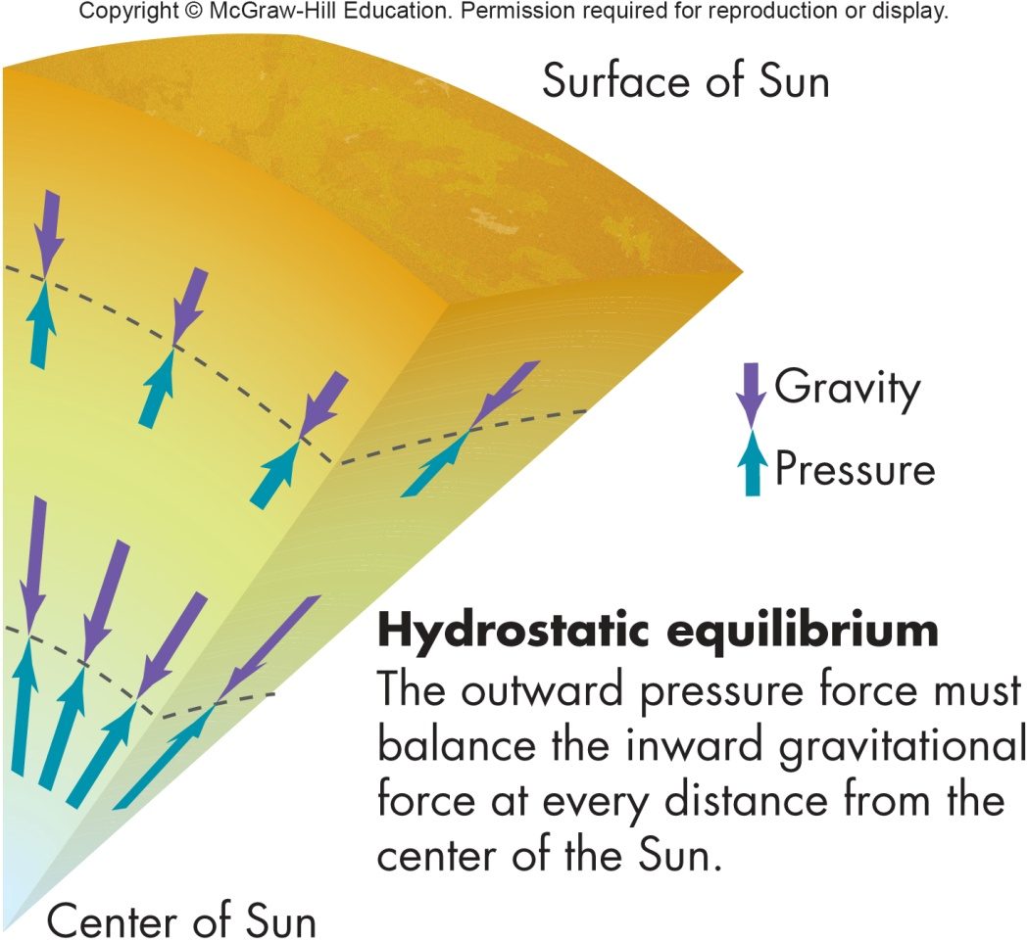 | 1.  2.  3.
Pressure in the Sun  1.  2. | 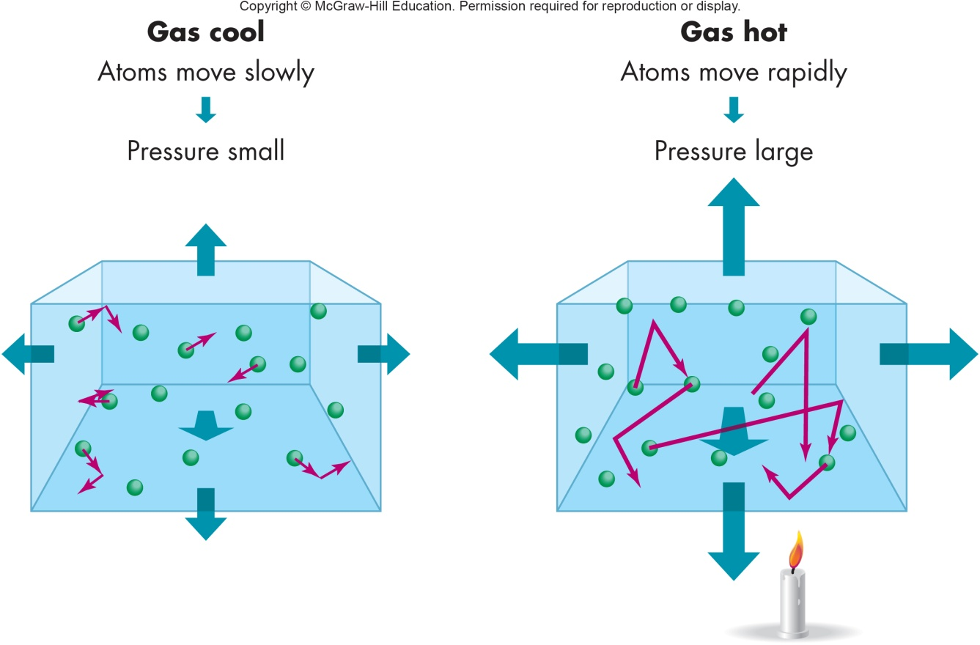
Powering the Sun
Nuclear Fusion
Solar Seismology | 1.
 | 2.
 | 3.
Solar Magnetic Activity
Sunspots | 1.
 | 2.
 | 3.
 | 4.
Origin of Sunspots | 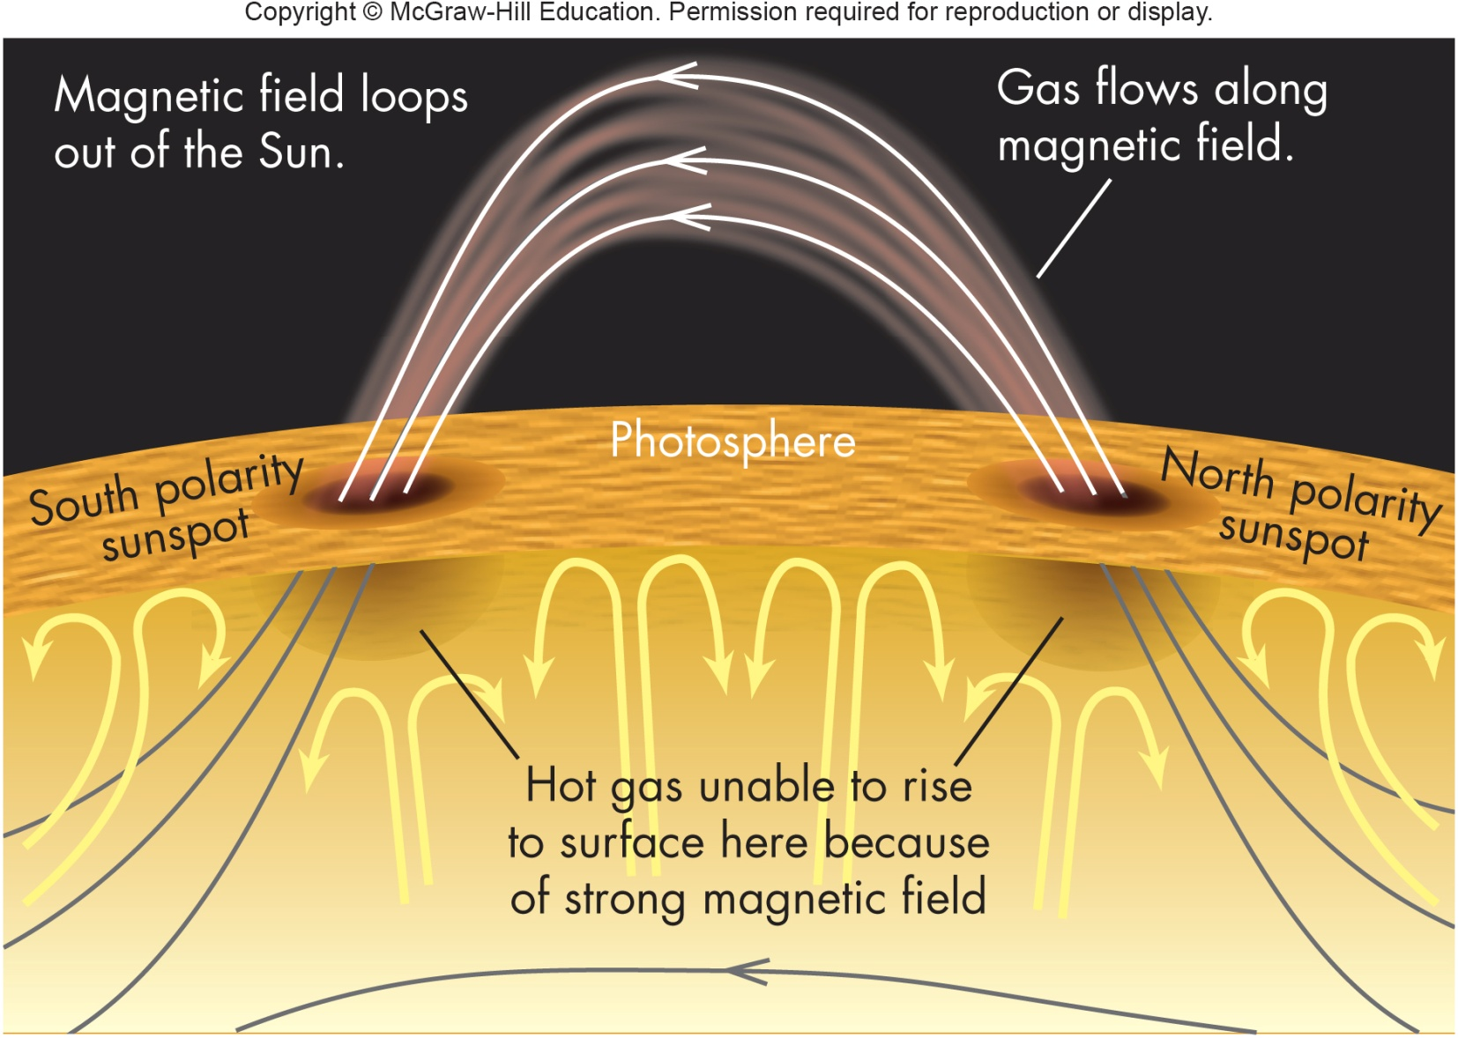
Prominences
Solar Flares | 1.
 | 2.
Source of Flares | 1.
 | 2.
Coronal Mass Ejections
Impact of Solar Flares
The Solar Winds | 1.
 | 2.
 | 3.
 | 4.
The Solar Cycle | 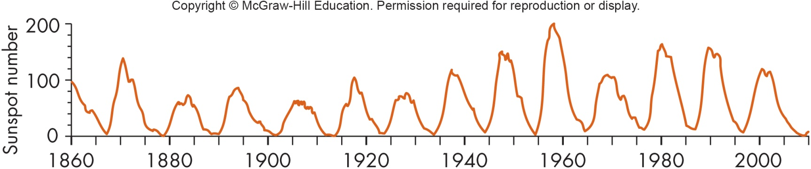  1.  2.  3.
Differential Rotation
Cause of Solar Cycle | 1.
 | 2.
 | 3.
Changes in Solar Cycle | 1.
 | 2.
 | 3.
Solar Cycle and Climate | 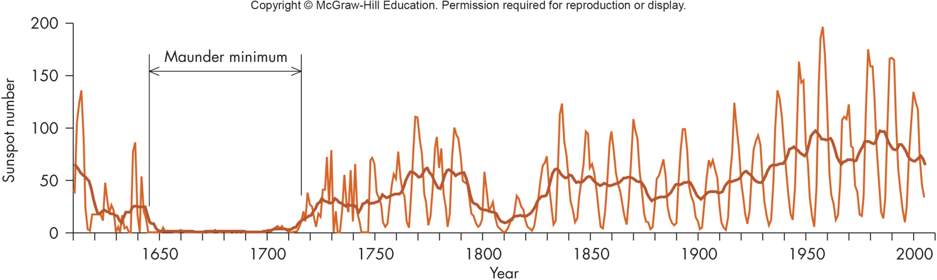
 | 1.
 | 2.
 | 3.
Summary:

