Cornell Notes  Topic: Terrestrial Planets: The Inner Planets  Essential Question: How are the terrestrial planets similar and how are they different?  Questions/Main Ideas: | Name: ___________________________________Block: ________  Date: ____________________________  Notes:
The Terrestrial Planets | 1.
 | 2.
 | 3.
Mercury
Venus
Mars
Earth
Terrestrial Planet Overview | 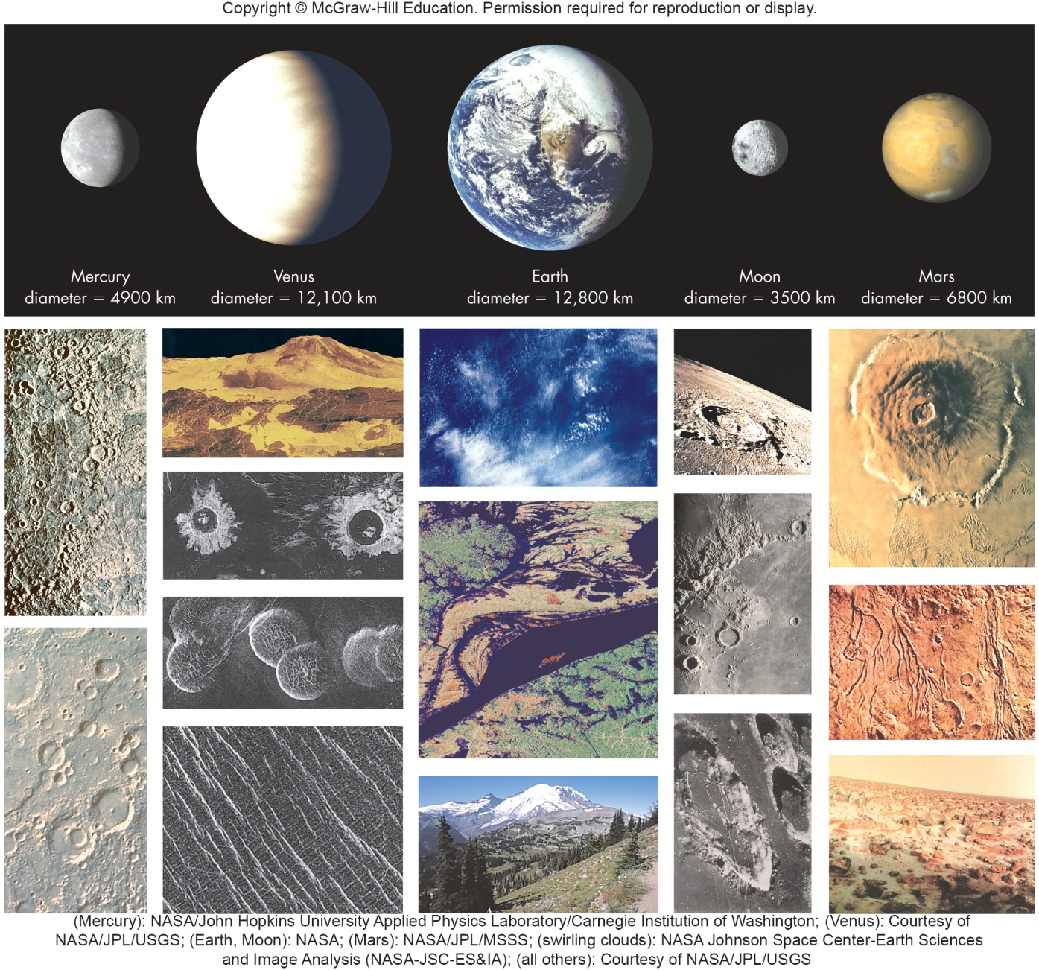
Mercury | 1.
 | 2.
 | 3.
Surface Features | 1.
 | 2.
Scarps | 1.
 | 2.
Caloris Basin | 1.
 | 2
3.
4.
Chaotic Terrain
Topo Map of Mercury
Mercury Temperature | 1.
 | 2.
Mercury Atmosphere | 1.
 | 2.
 | 3.
Ice on Mercury | 1.
 | 2.
 | 3.
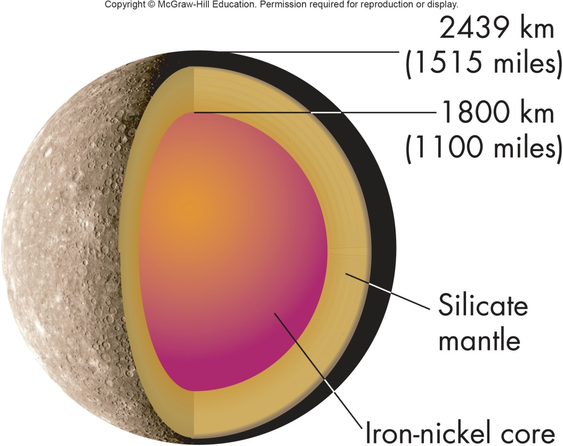 | Mercury Interior
Mercury’s Magnetic Field | 1.  2.
Mercury’s Rotation | 1.
 | 2.
Resonance | 1.
 | 2.
 | 3.
Venus | 1.
 | 2.
Venus Atmosphere
Clouds of H2SO4
Polar Vortex | 1.
 | 2.
 | 3.
 | 4.
Atmospheric Pressure | 1.
 | 2.
 | 3.
Greenhouse Effect | 1.
 | 2.
 | 3.
Surface of Venus
Ishtar and Aphrodite
Surface Features | 1.
 | 2.
 | 3.
 | 4.
Active Surface | 1.
 | 2.
Young Surface | 1.
 | 2.
Venus not a Twin | 1.
 | 2.
 | 3.
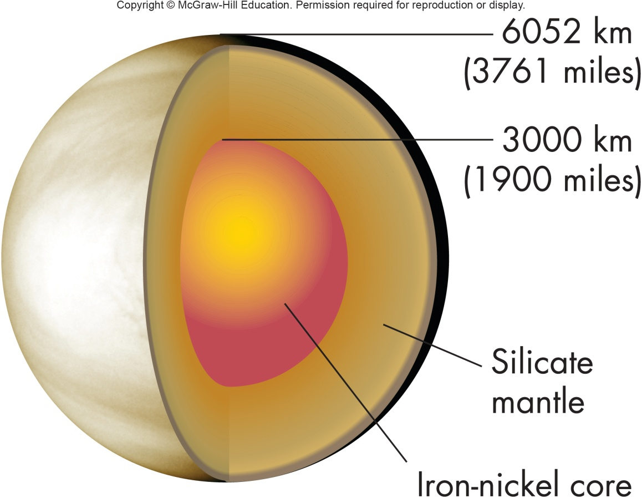 | Venus Interior  1.  2.  3.
Venus Rotation | 1.
 | 2.
 | 3.
 | 4.
Mars | 1.
 | 2.
More Like Earth | 1.
 | 2.
 | 3.
Vallis Marineris | 1.
 | 2.
Tharsis Bulge | 1.
 | 2.
 | 3.
 | 4.
Largest Mountain | 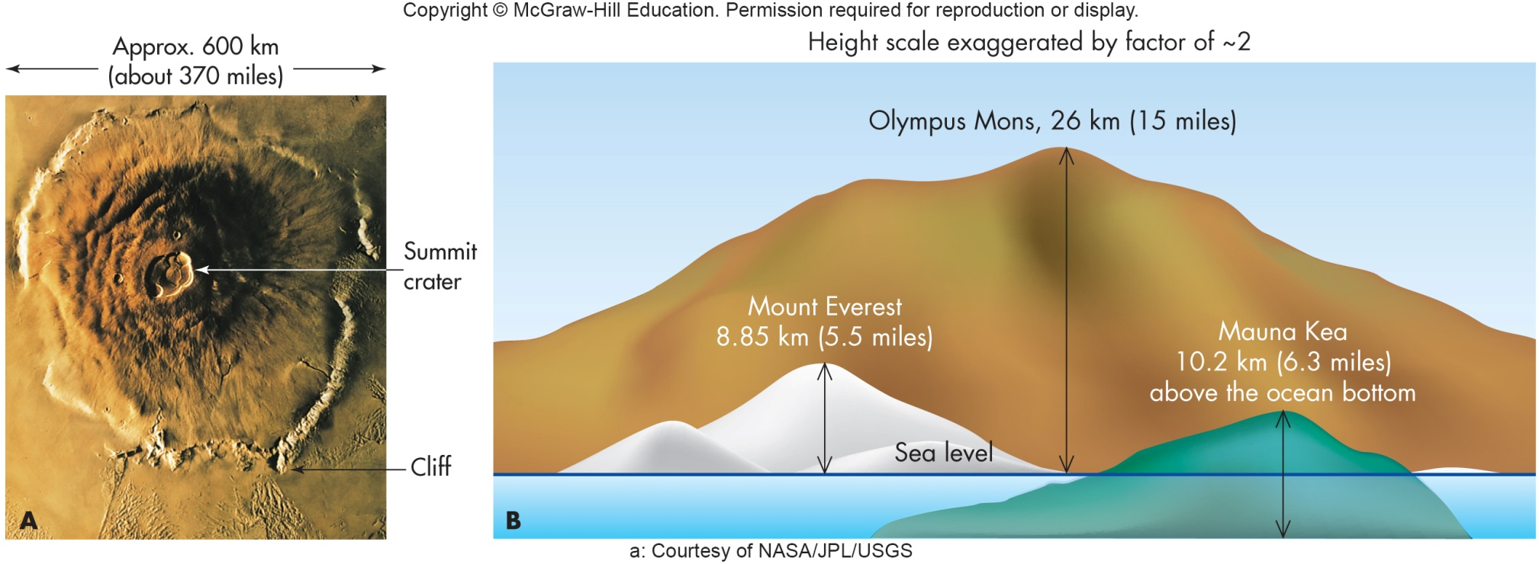
S. Polar Ice Cap | 1.
 | 2.
 | 3.
N. Polar Ice Cap
Dune Fields
Water on Mars | 1.
 | 2.
 | 3.
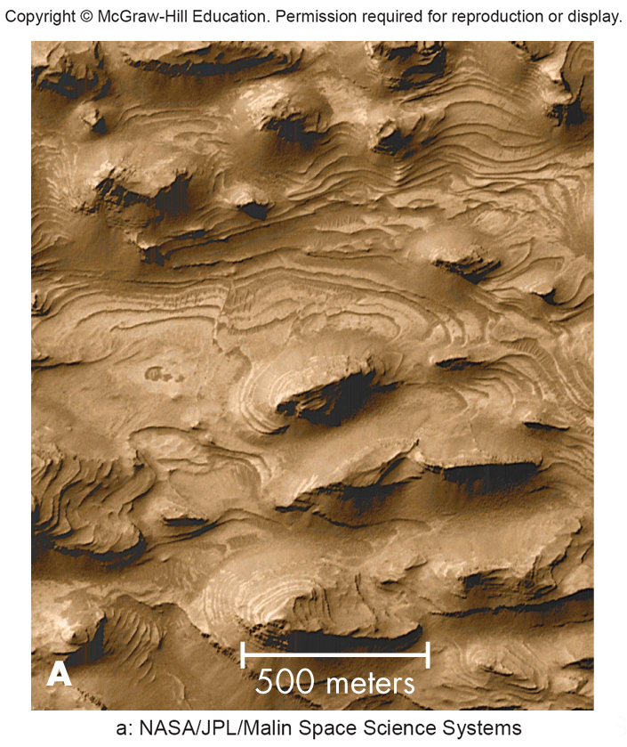 | Lake Sediments
Present Day Water
Sketch Image to show where water is located
Curiosity Rover | 1.
 | 2.
 | 3.
Mars Atmosphere | 1.
 | 2.
 | 3.
Mars Temperature | 1.
 | 2.
 | 3.
 | 4.
Martian Wind | 1.
 | 2.
 | 3.
No Rain | 1.
 | 2.
 | 3.
 | 4.
Ancient Atmosphere | 1.
 | 2.
 | 3.
Where did the atm. go? | 1.
 | 2.
Martian Interior | 1.
 | 2.
 | 3.
 | 4.
Martian Moons | 1.
 | 2.
 | 3.
Life on Mars | 1.
 | 2.
 | 3.
Martin Fossils? | 1.
 | 2.
 | 3.
Why are Terrestrial Planets Different? | In the Summary Section draw the comparative chart.
Role of Mass and Radius | 1.
 | 2.
 | 3.
 | 4.
Role of Internal Activity | 1.
 | 2.
 | 3.
Role of Sunlight | 1.
 | 2.
 | 3.
 | 4.
Role of Water | 1.
 | 2.
 | 3.
 | 4.
Role of Bio Processes | 1.
 | 2.
 | 3.
 | 4.
 | 5.
 | 6.
 | 7.
Summary:

