Cornell Notes  Topic: Telescopes  ___________________  Essential Question:  Questions/Main Ideas: | Name: ___________________________________Block: ________  Date: ____________________________  Notes:
Tools of the Trade: Telescope

Powers of a Telescope
Collecting Power

Focusing Power

Resolving Power

Light Gathering Power
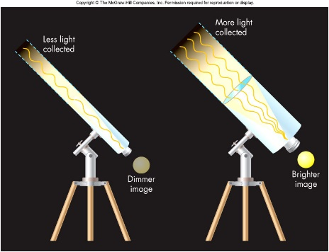

Focusing Power

Refraction
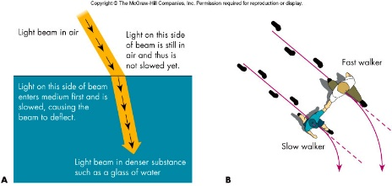

Refracting Telescope

Disadvantage of Refracting Telescope

Reflecting Telescope

Mirrors of Reflecting Telescope

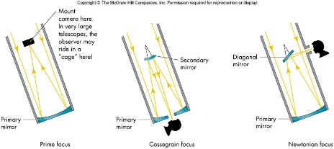

Resolving Power

Resolving Power and Aperture

Increasing Aperture

Interferometer

Detecting the Light

Charge-Coupled Device (CCD)

Non-Visible Wavelengths

Radio Observatories

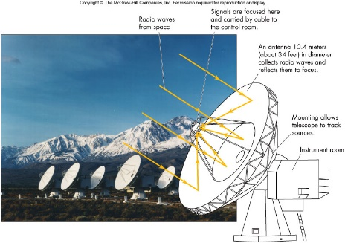

Atmospheric Window

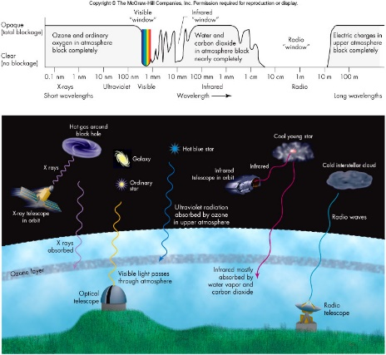

Space vs Earth Based Observations

Scintillation

Atmospheric Blurring

Summary:

