Cornell Notes  Topic: Stellar Properties and classification__________  Essential Question: How do we measure distances in space?  What are the major properties of stars that astronomers use to classify them? How do we use the HR diagram to classify stars?  Questions/Main Ideas: | Name: ___________________________________Block: ________  Date: ____________________________  Notes:
Triangulation | 1.
 | 2.
 | 3.
Calculating Distance using Parallax
 | 1.
 | 2.
 | 3.
The Parsec (Parallax-second) | 1.
 | 2.
 | 3.
 | 4.
Example: Distance to Sirius

Light: The Astro Tool | 1.
 | 2.
 | 3.
Temperature | 1.
 | 2.
Luminosity | 1.
 | 2.
 | 3.
 | 4.
 | 5.
 | 6.
Brightness
Inferring Luminosity
The Standard Candle Method | 1.
 | 2.
 | 3.
Method of Standard Candles

The Magnitude Scale | 1.
 | 2.
 | 3.
 | 4.
Magnitude Differences | 1.
 | 2.
 | 3.
 | 4.
Absolute Magnitude | 1.
 | 2.
 | 3.
Stefen Boltzman Law | 1.
 | 2.
 | 3.
Finding Luminosity

Stellar Radii | 1.
 | 2.
 | 3.
Spectra of Stars | 1.
 | 2.
 | 3.
Early Classification | 1.
Modern Classification | 1.
Spectral Types | 1.
 | 2.
 | 3.
Spectral Classification | 1.
 | 2.
 | 3.
New Spectral Types | 1.
 | 2.
 | 3.
Stellar Motion
Binary Stars | 1.
 | 2.
 | 3.
 | 4.
 | 5.
Stellar Transits
Summary of Stellar Properties | Distance
 | Temperature
 | Luminosity
 | Composition
 | Radius
 | Mass
 | Radial Velocity
Hertzberg Russel Diagram | 1.
 | 2.
 | 3.
Main Sequence | 1.
 | 2.
Understanding HR Diagram | 1.
 | 2.
 | 3.
 | 4.
 | 5.
 | 6.
Giants and Dwarfs | 1.
 | 2.
 | 3.
Mass and Density | 1.
 | 2.
Mass-Luminosity | 1.
 | 2.
 | 3.
Classes of Stars | 1.
 | 2.
Summary of HR | 1
 | 2.
 | 3.
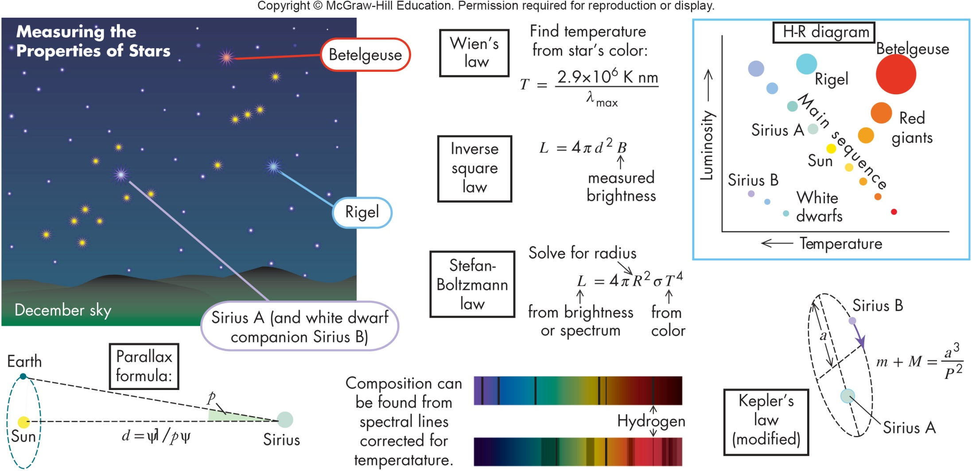
Summary:

