Cornell Notes  Topic: LIGHT  ___________________  Essential Question:  Questions/Main Ideas: | Name: ___________________________________Block: ________  Date: ____________________________  Notes:
Light the Astronomer’s Tool

Properties of Light

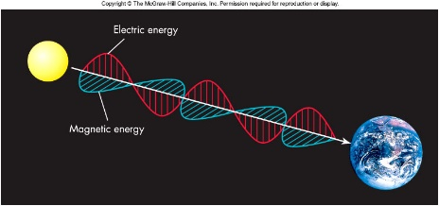

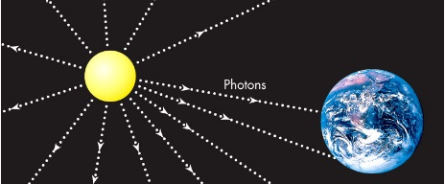

Light and Color

Visible Light Spectrum

Frequency

Electromagnetic Spectrum

Infrared

Ultraviolet

X-rays

Gamma Rays

Energy Carried by EM

Different Wavelength Different Science

Matter and Heat

Kelvin Scale

Wien’s Law

Radiation and Temperature

Ideal Blackbodies

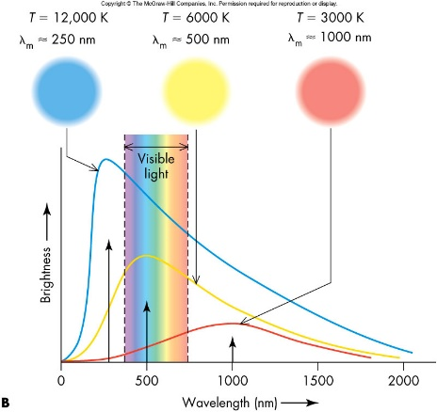

The Chemical Elements

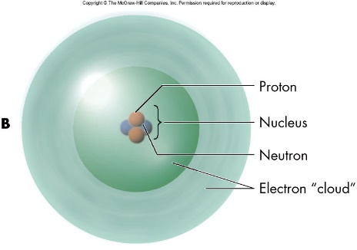

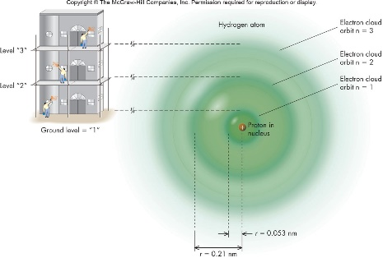

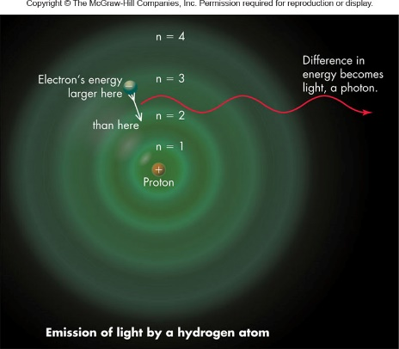

Conservation of Energy

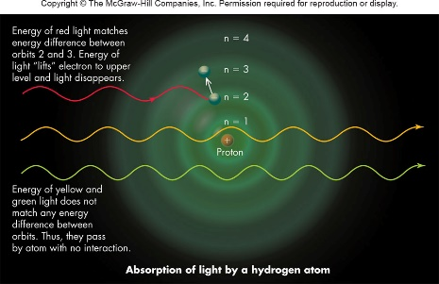

Spectroscopy

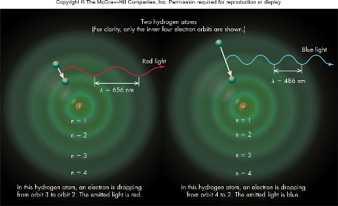

Types of Spectroscopy

Helium Emission

Continuous and Absorption Spectrum

Astronomical Spectrum

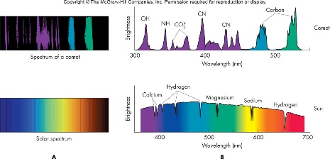

Absorption in the Atmosphere
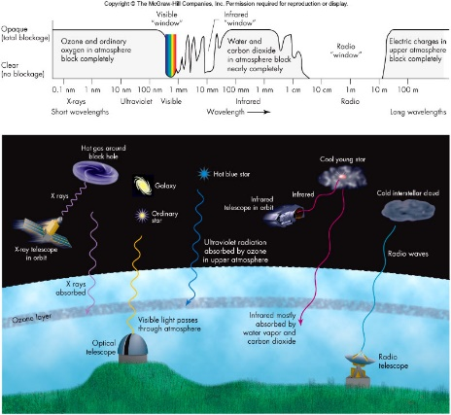

Doppler Shift of Sound
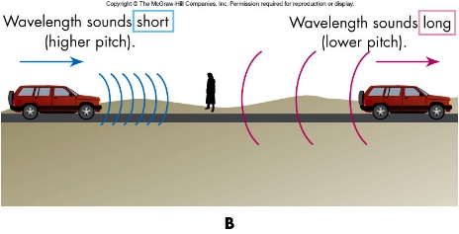

Doppler Shift of Light
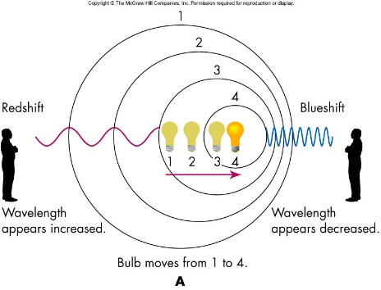

Red Shift and Blue Shift

Summary:

