Cornell Notes  Topic: Jovian Planets (Outer Planets)  Essential Question: What are the similarities and differences of the Jovian planets?  How do the Jovian Planets compare to the Terrestrial planets?  Questions/Main Ideas: | Name: ___________________________________Block: ________  Date: ____________________________  Notes:
The Outer Worlds | 1.
 | 2.
 | 3.
 | 4.
 | 5.
Jupiter Draw/Label | 1.  2.  3.
Cloud Tops | 1.
 | 2.
 | 3.
Jupiter’s Interior  1.  2.  3.  4. | 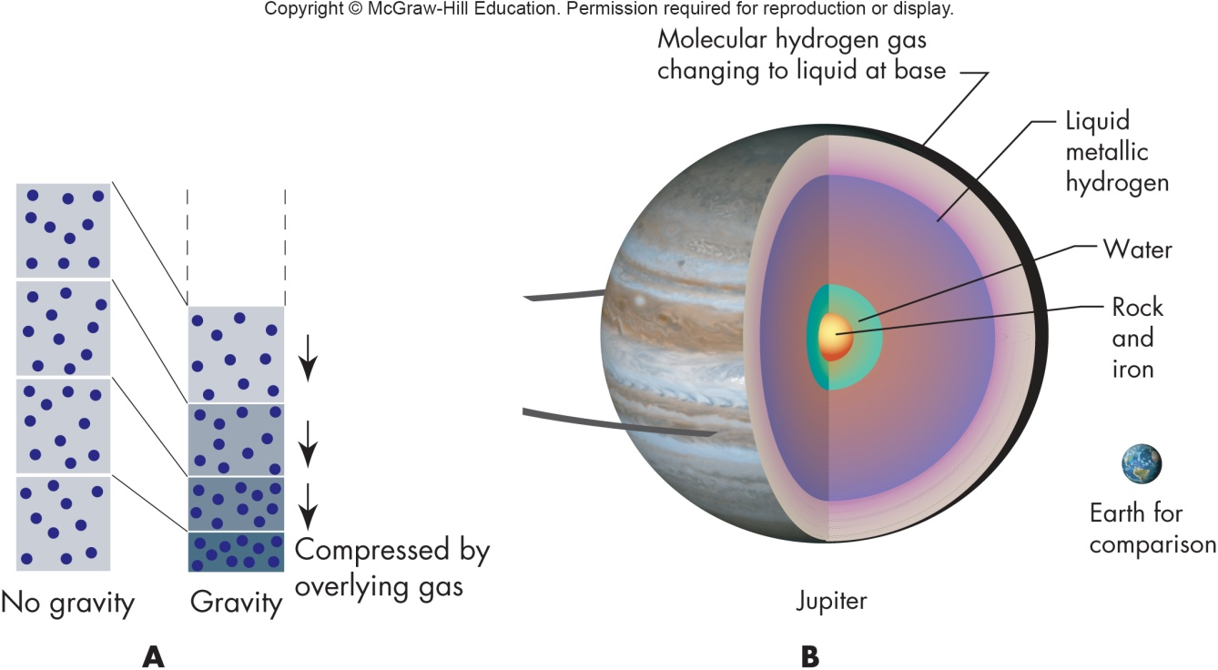
Jupiter’s Interior | 1.
 | 2.
 | 3.
Jupiter’s Atmosphere  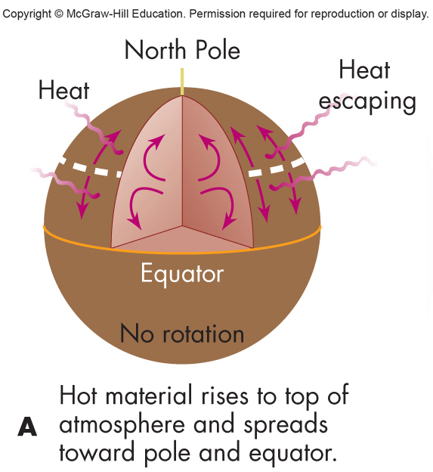 | 1.  2.
Jupiter’s Jetstream | 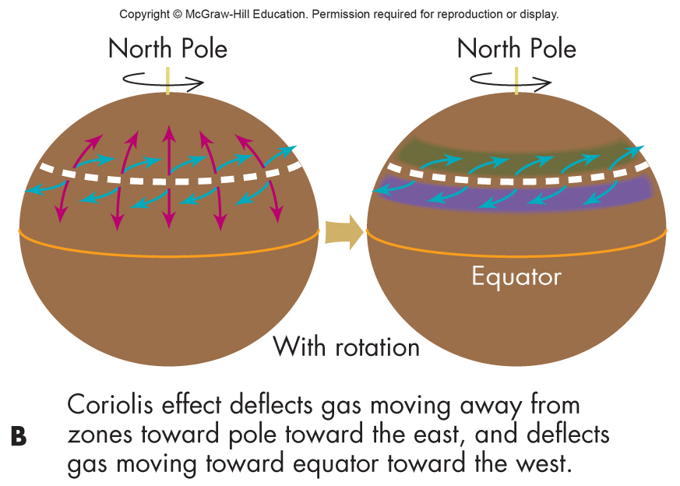
Jupiter’s Wind
The Giant Red Spot
Jupiter’s Magnetic Field | 1.
 | 2.
 | 3.
Aurora and Lightning | 1.
 | 2.
Jupiter’s Rings | 1.
 | 2.
 | 3.
Moons of Jupiter | 1.
 | 2.
 | 3.
Planets in Miniature | 1.
 | 2.
Io | 1.
 | 2.
Europa | 1.
 | 2.
 | 3.
Europa’s Water | 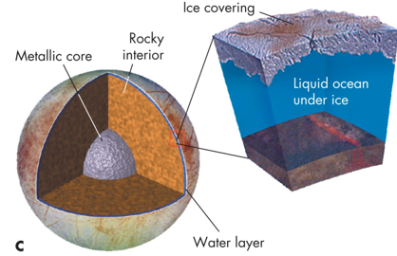
Ganymede and Callisto | 1.
 | 2.
 | 3.
 | 4.
Other Observations | 1.
 | 2.
 | 3.
 | 4.
Saturn Draw / Label  Interior of Saturn | 1.  2.  3.  4.  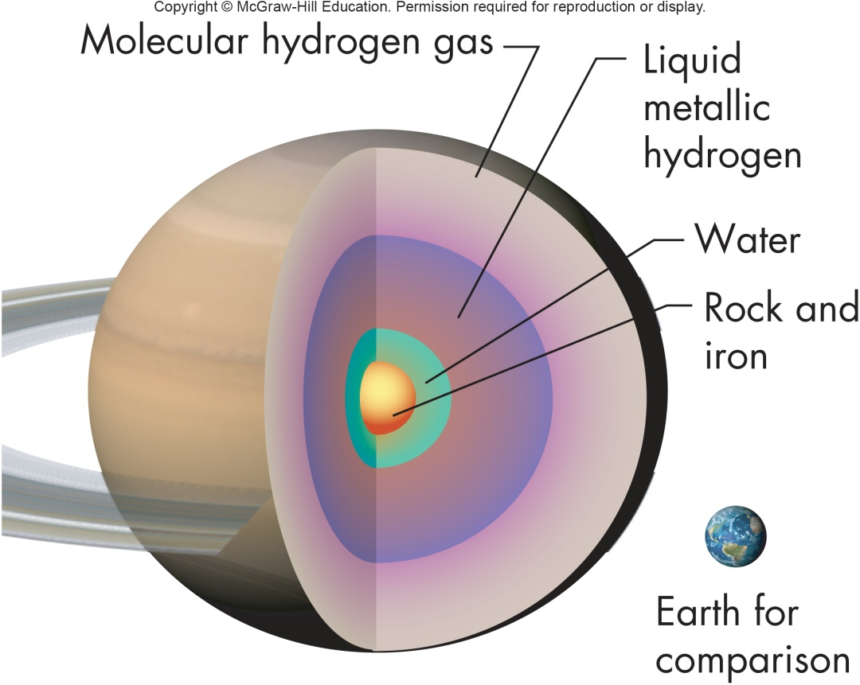
Storms on Saturn | 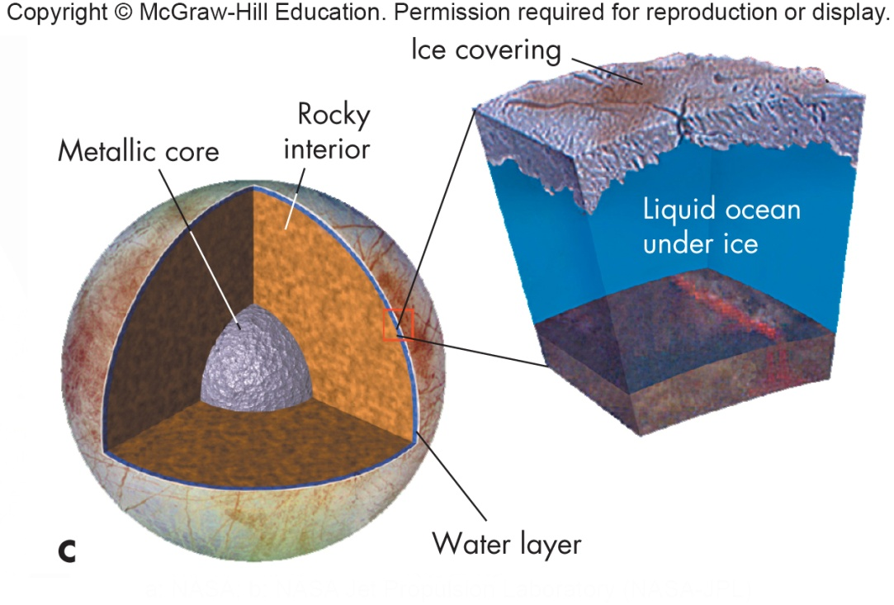
Rings of Saturn | 1.
 | 2.
 | 3.
 | 4.
 | 5.
Ring Structure | 1.
 | 2.
 | 3.
 | 4.
 | 5.
Ring Gaps | 1.
 | 2.
 | 3.
Destructive Tidal Forces | 1.
 | 2.
 | 3.
 | 4.
 | 5.
The Roche Limit | 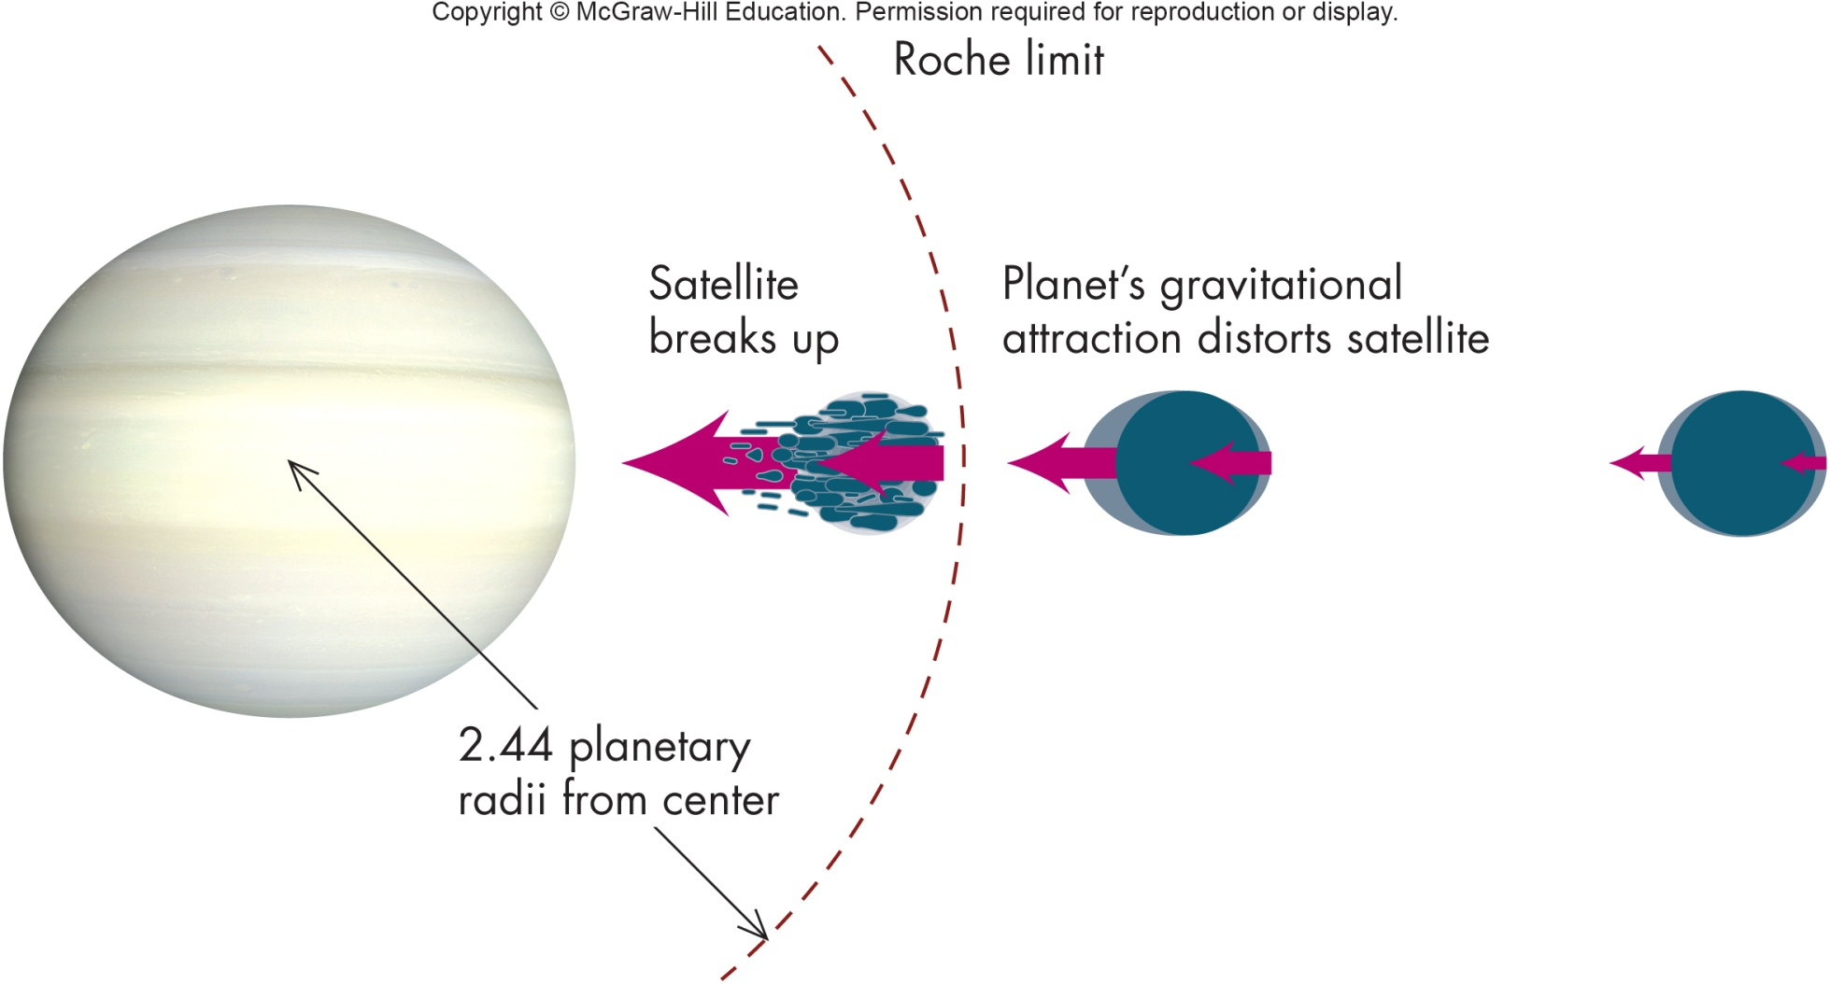
Saturn’s Moon | 1.
 | 2.
 | 3.
 | 4.
 | 5.
Ice World’s
Titan | 1.
 | 2.
 | 3.
 | 4.
 | 5.
Iapetus | 1.
 | 2.
Enceladus | 1.
Uranus | 1.
 | 2.
 | 3.
Uranus Atmosphere | 1.
 | 2.
Uranus Composition | 1.
 | 2.
 | 3.
 | 4.
 | 5.
Interior of Uranus | 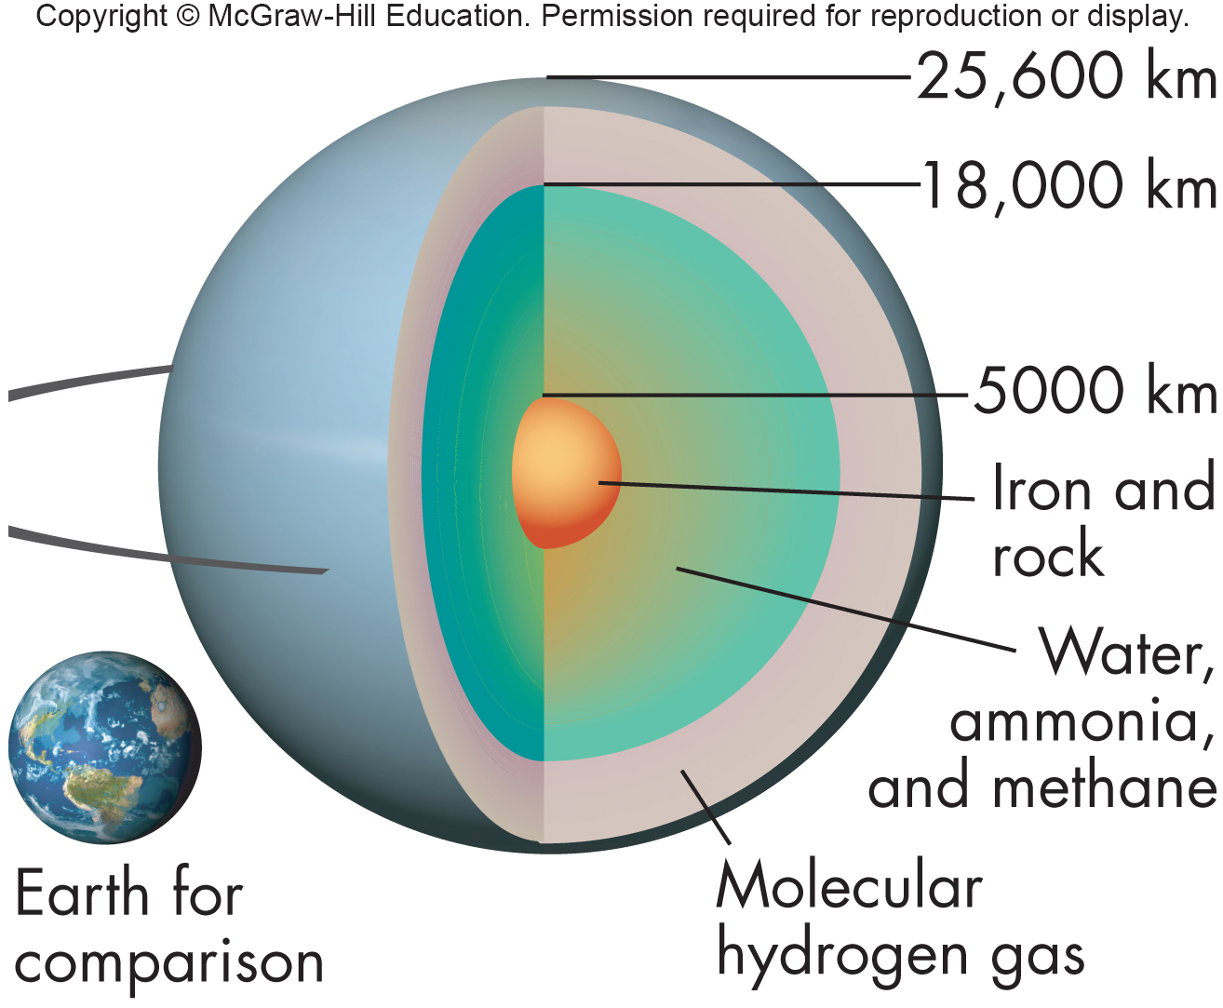
Uranus’s Odd Tilt | 1.
 | 2.
 | 3.
Rings of Uranus | 1.
 | 2.
 | 3.
Moons of Uranus | 1.
 | 2.
 | 3.
Neptune Draw/Label | 1.  2.  3.
Interior of Neptune | 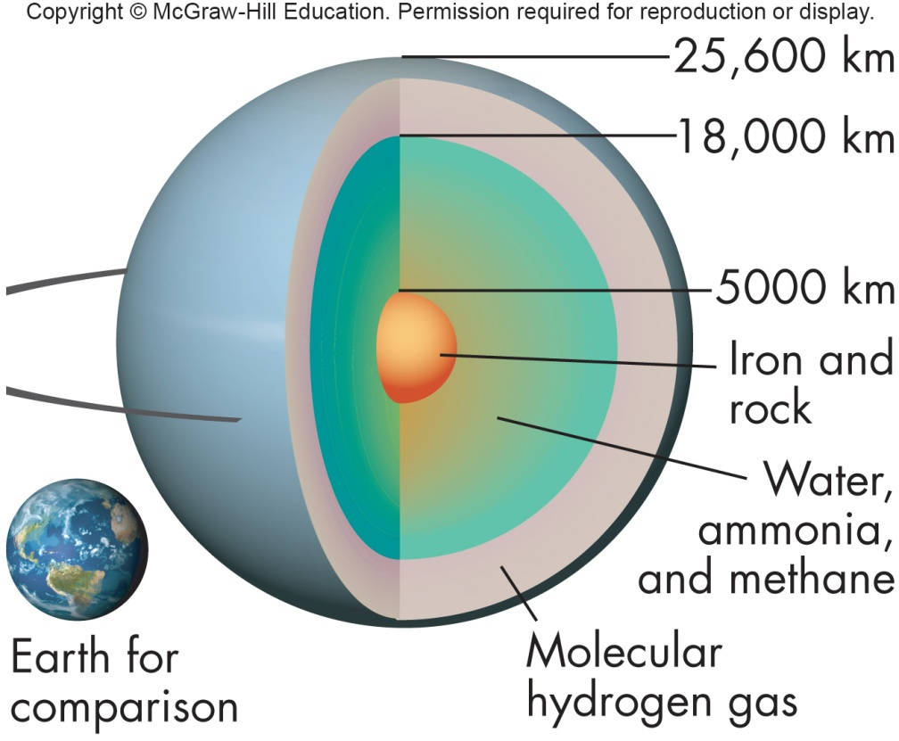
Neptune’s Atmosphere | 1.
 | 2.
 | 3.
 | 4.
Rings of Neptune | 1.
 | 2.
 | 3.
 | 4.
Triton | 1.
 | 2.
 | 3.
 | 4.
Summary:

