Cornell Notes  Topic: Other Objects in Our Solar System  Essential Question: What are the similarities and differences of the other objects of our solar system?  Questions/Main Ideas: | Name: ___________________________________Block: ________  Date: _____________  Notes:
Asteroids and Comets | 1.
 | 2.
 | 3.
Leftovers of the Solar System  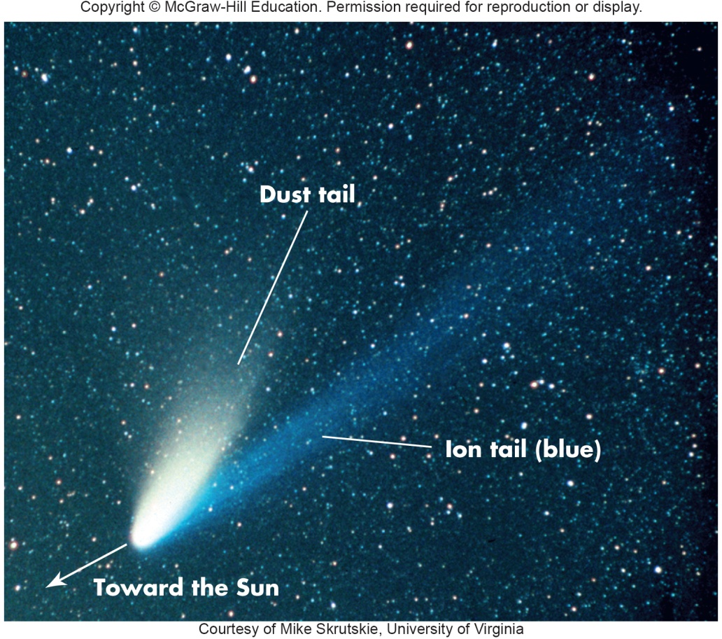 | 1.  2.  3.  4.
Meteors and Meteorites | 1.
 | 2.
 | 3.
Heating of Meteors | 1.
 | 2.
Meteroites | 1.
 | 2.
 | 3.
 | 4.
3 Flavors of Meteorites | 1.
 | 2.
 | 3.
Classification | 1.
 | 2.
Chondrules | 1.
 | 2.
 | 3.
Carbonaceous Chondrites | 1.  2.
Asteroids | 1.
 | 2.
 | 3.
 | 4.
Asteroid Belt | 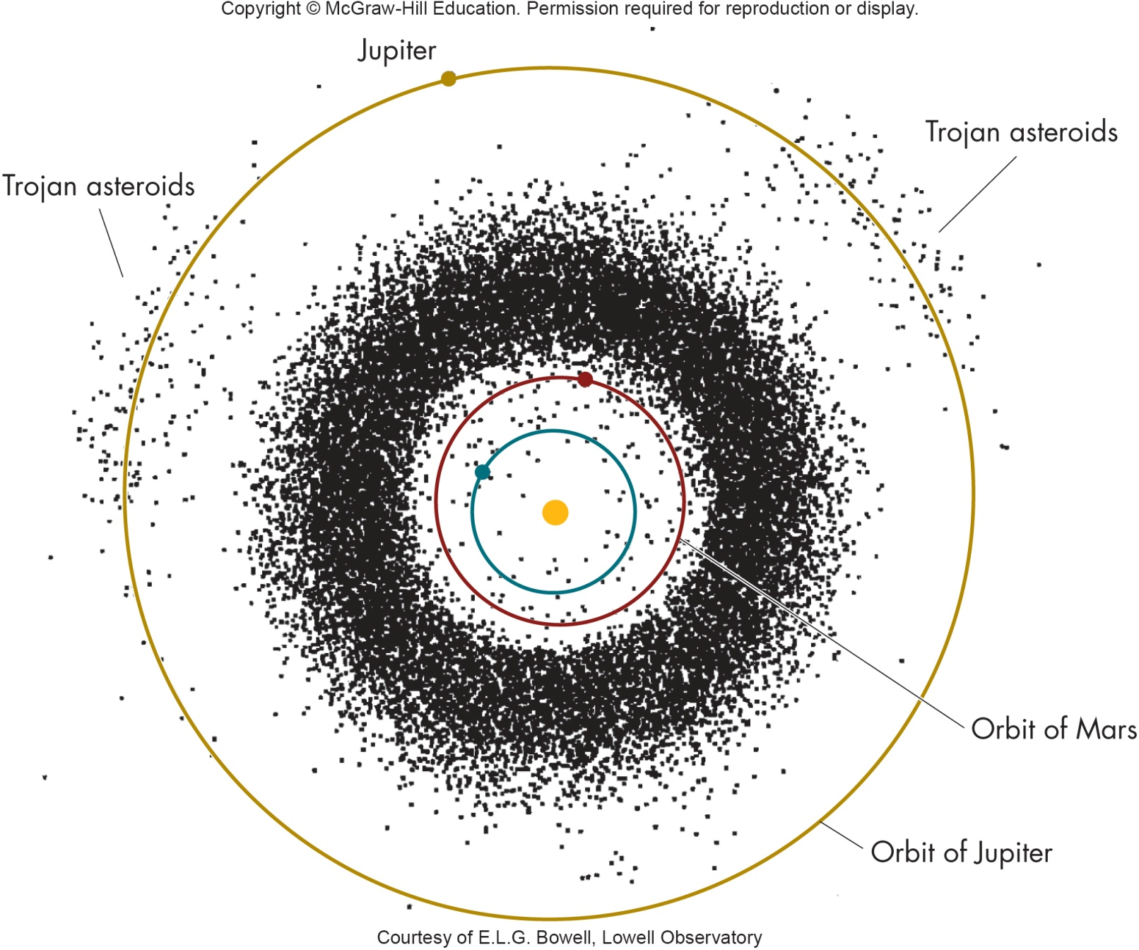
Size of Asteroids | 1.
 | 2.
Shape of Asteroids
Ceres | 1.
 | 2.
 | 3.
Asteroid Composition | 1.
 | 2.
 | 3.
Origin of Asteroids | 1.
 | 2.
 | 3.
 | 4.
Origins of Asteroids and Meteoroids | A  B
Asteroid Belt | 1.
 | 2.
Near Earth Objects | 1.
 | 2.
 | 3.
Pluto | 1.
 | 2.
 | 3.
 | 4.
Pluto and Charon | 1.
 | 2.
 | 3.
 | 4.
Size of Pluto and Charon | 1.
 | 2.
 | 3.
 | 4.
New Horizons | 1.
 | 2.
 | 3.
Dwarf Planets
Comets | 1.
 | 2.
 | 3.
Parts of a Comet | 1.
 | 2.
 | 3.
Structure of Comet | 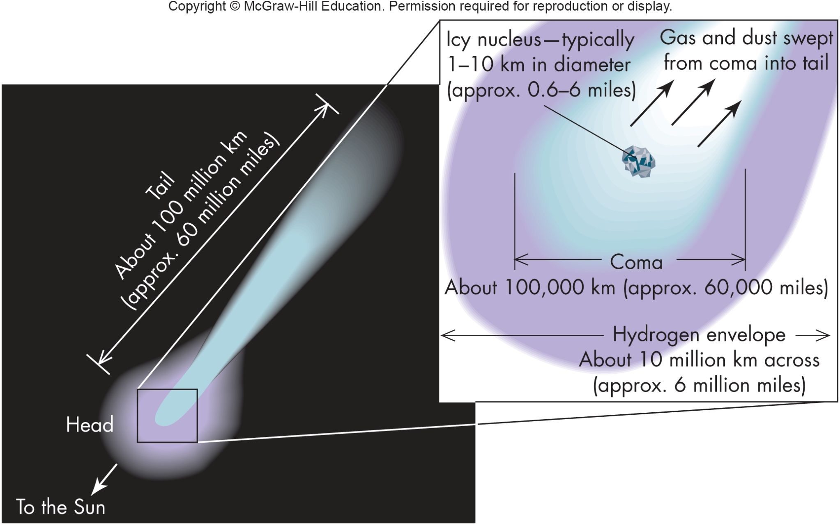
The Comet’s Tail | 1.
 | 2.
Two Tails
Tail Evolution | 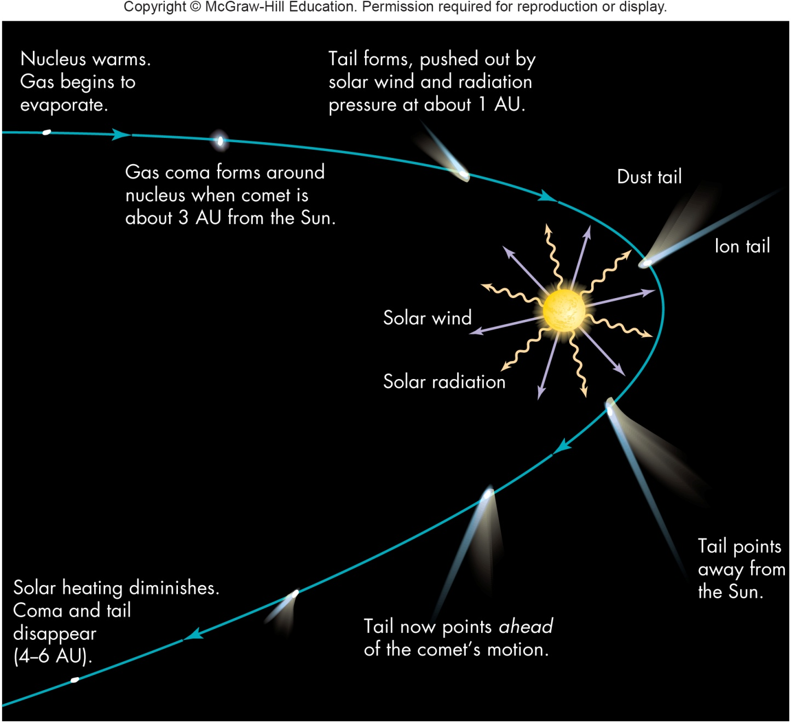
Composition of Comet | 1.
 | 2.
 | 3.
 | 4.
Spacecraft Exploration | 1.
 | 2.
Comet Tempel 1 | 1.
 | 2.
Churymov-Gerosimenko | 1.
 | 2.
Origins of Comets
The Oort Cloud | 1.
 | 2.
 | 3.
 | 4.
Incoming Comet

Short Period Comets | 1.
 | 2.
 | 3.
Short Per. Comet Origin | 1.
 | 2.
 | 3.
Shooting Stars
Comet Meteor Showers | 1.
 | 2.
Debris from Comets
Names of Meteor Showers

Giant Impacts | 1.
 | 2.
 | 3.
Giant Meteor Craters | 1.
 | 2.
Russian Meteor Explosion | 1.  2.  3.
Other Meteor Craters | 1.
 | 2.
 | 3.
Mass Extinctions | 1.
 | 2.
 | 3.
Extinction Level Impact | 1.
 | 2.
 | 3.
 | 4.
 | 5.
Summary:

