Biodiversity Fill-In-Notes NAME_______________________________
Biodiversity is:
--the ______________________ of organisms in a given area
--the _______________________________ within a population
--the variety of _______________ in a community
--the variety of _________________________ in an ecosystem.
__________________________ is the ____________________ on Earth and the ______________________________________________________________________________.

- Scientists have identified appx ____________ species on Earth --- Est ________________ more remain unknown
- The tremendous variety of life on Earth is made possible by complex interactions among all living things including micro-organisms.

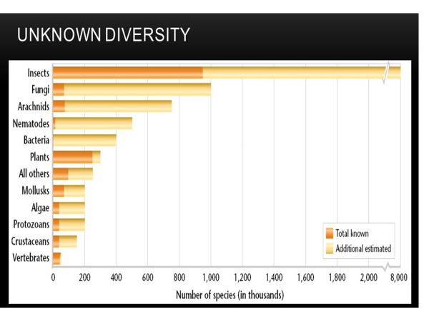
LEVELS OF BIODIVERSITY
- Biodiversity can be studied and described at three levels:
  - ____________________________________________
  - ____________________________________________
  - ____________________________________________

Species vs Population
- Diversity of number of species
the _________________________ between populations of species, as well as between different species.

- Variety of ecosystems

-- _________________ of habitats, communities, & ecological processes within and between ecosystems.

- Genetic Diversity

- all the ___________________________________ contained within all members of a population.
___________- a segment of DNA that is located in a chromosome –it codes for a specific hereditary trait.

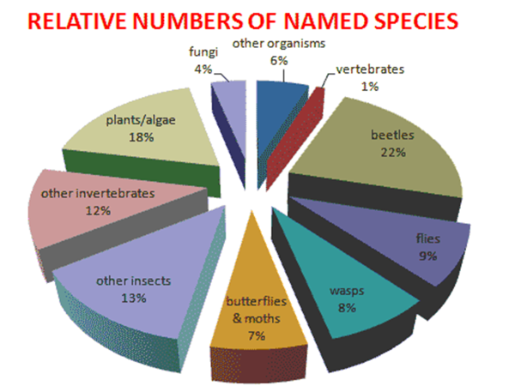
Benefits of Biodiversity
_______________________________________________________ = Something that has value naturally

Biodiversity can affect the _____________ of ecosystems and the ___________________ of populations.
Healthy ecosystems ensure a healthy biosphere It has balanced cycles of energy and nutrients.

Biodiversity has Utilitarian Value
___________________________________ = the value something has as a means to another’s end. Something that is functional

Utilitarian values include:
  - Goods like sustainable timber
  - Services like eco-tourism
  - Information -- National Park Wardens

BIOMASS PYRAMID

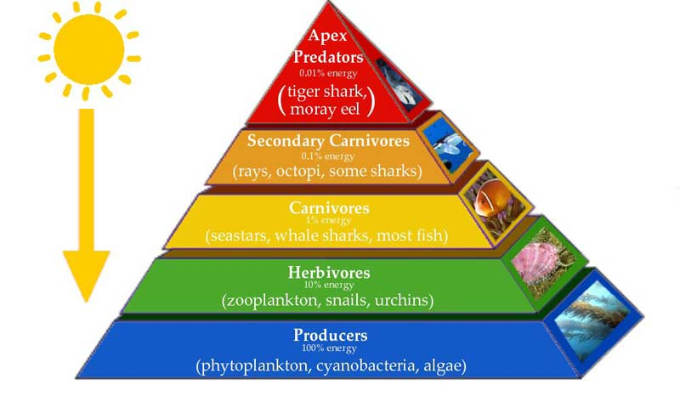

COMPLETE THE BIOMASS ACTIVITY

CLOSING:
WATCH THE VIDEO FROM THE LINK IN THE PRESENTATION
https://www.youtube.com/watch?v=hRGg5it5FMI

COMPLETE THE TICKET OUT THE DOOR QUESTIONS
- What determines how many species live in a given place?
- How many individuals of the species can live somewhere?
- Briefly explain how biodiversity is important to ecosystems

