This is a fill-in-form. Click in the spaces below to enter your answers. SAVE your worksheet with your answers and upload it to CTLS.

Name: Click or tap here to enter text.
Amoeba Sisters Video Recap: Autotrophs and Heterotrophs

Complete the below examples and statements about herbivores, carnivores, and omnivores.  - Herbivore  One example: Click or tap here to enter text.  Generally, herbivores eat: ____________________________________________.  - Carnivore  One example: _____________________________________________________  Generally, carnivores eat: ____________________________________________.  - Omnivore  One example: _____________________________________________________  Generally, omnivores eat: ____________________________________________.  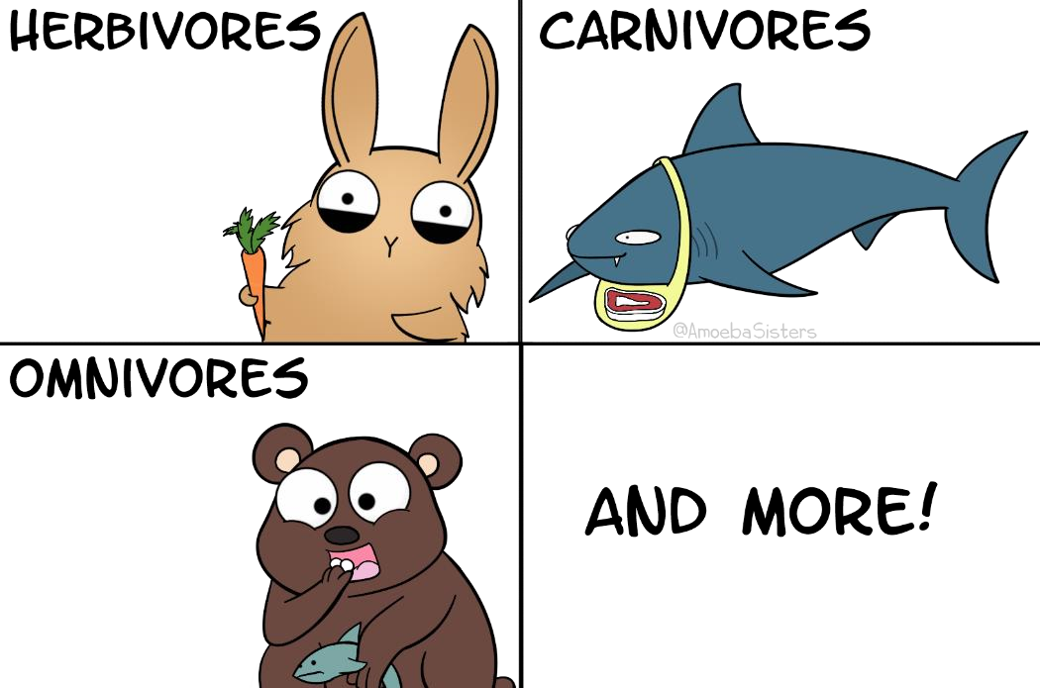 | Define the general difference between an autotroph and a heterotroph.  ____________________________  - Herbivores are generally considered autotrophs or heterotrophs?  Click or tap her to enter text.  - Carnivores are generally considered autotrophs or heterotrophs?  Click or tap her to enter text.  - Omnivores are generally considered autotrophs or heterotrophs?  Click or tap her to enter text.
For the following organisms, please write whether they are generally an example of a heterotroph (H), autotroph (A), or a strong example of either one (both). While these responses are general, please keep in mind biology is full of fascinating exceptions!

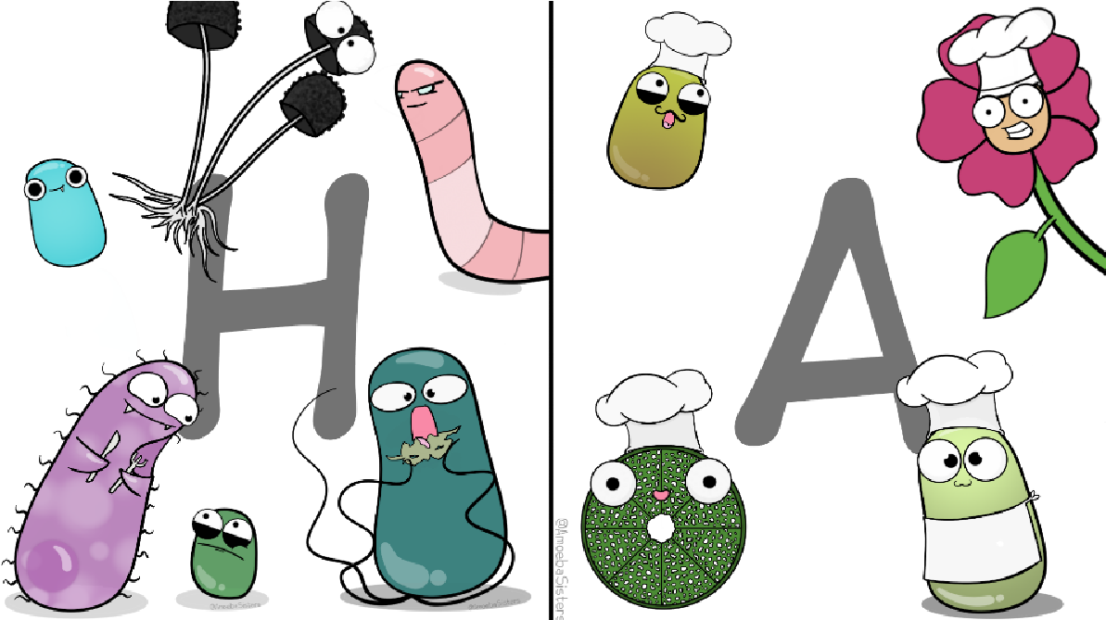
- Bacteria: Choose an item.

- Fungi: Choose an item.

- Archaea: Choose an item.

- Protists: Choose an item.

- Animals: Choose an item.

- Plants: Choose an item.

Amoeba Sisters Video Recap: Autotrophs and Heterotrophs

- The image at right is called a food web. Arrows point in the direction of energy flow. On the food web at right, please write “autotroph” or “heterotroph” by each organism.  How many autotrophs did you count?  _______________________________  - View the organisms that you labeled heterotrophs. Are these heterotrophs considered producers or consumers?  Choose an item.  - View the organisms that you labeled autotrophs. Are these autotrophs considered producers or consumers?  Choose an item. | 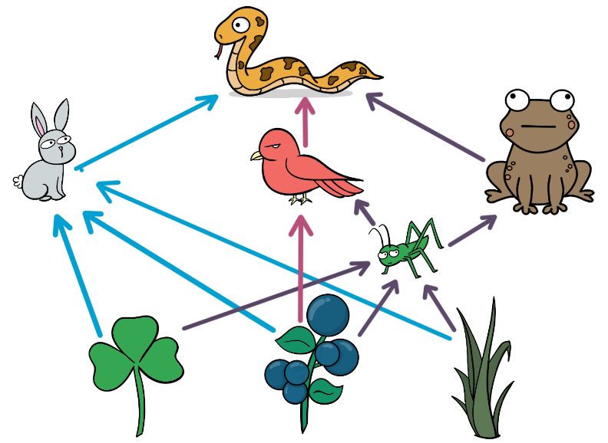
17. Plants can use sunlight energy in producing their own food and are examples of autotrophs. Do all autotrophs use sunlight energy to produce their own food? Choose an item.

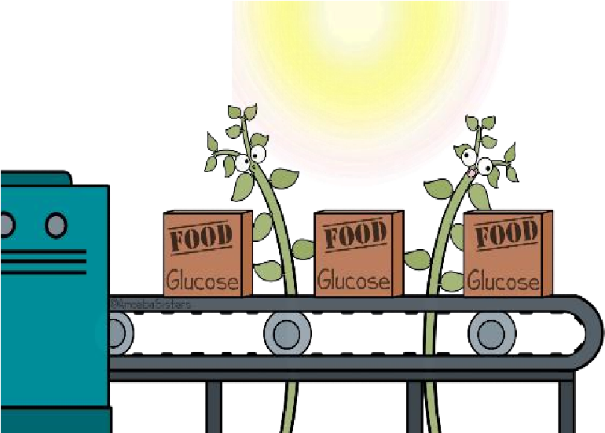
Explain why or why not.

______________________________________________________________

______________________________________________________________

______________________________________________________________

