SOIL  Objectives:  - Describe how soil forms.  - Recognize soil horizons in a soil profile.  - Differentiate among the factors of soil formation. | NAME:_________  Date: ______ Block: ______
Key Terms  - __________: the loose covering of weathered rock particles and decaying organic matter, called _______, overlying the bedrock on Earth’s surface, and serves as a medium for the growth of plants  - ______________: a soil whose parent material is the local bedrock  - _________________: soil that develops from parent material that has been moved far from its original location, usually by agents of erosion  - ___________________: source rock for soil  - ______________: a vertical sequence of soil layers  - Mature soils have several distinct layers that take tens of thousands of years to develop; new soils (known as ___________________) do not have these layers  - ____________: a distinct layer within a soil profile  - Typically 4 major soil horizons in mature soils: O, A, B, and C  How Soil Develops  - Soils begin to develop when weathering breaks down _______ into smaller pieces, which continue to undergo weathering and break down further.  - _________ and ___________________ break down organic matter and add nutrients to the soil and create passages for air and water.  What is helping to break up the soil in this image?  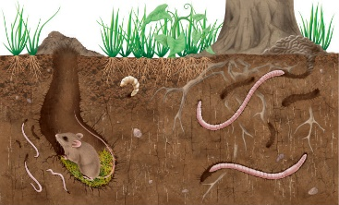  Soil Layers and Soil Profiles  - Through the processes of weathering, erosion, and deposition of parent material, soil will develop layers.  - Residual soil has parent material that is the local bedrock; transported soil is transported from somewhere else usually through erosion.  - The vertical sequence of layers make up a __________________.  NOTE: the layer below the C-horizon is bedrock. It is sometimes referred to as the  D-horizon or the R-horizon. For the purposes of this class, know that below the  C-horizon is solid rock.  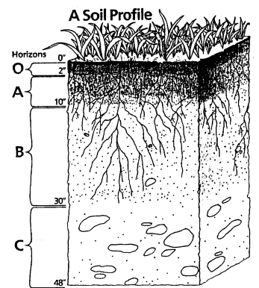  Soil Profiles  ________________: top layer of organic material; composed of humus and leaf litter  _______________: layer of weathered rock combined with a rich concentration of dark brown organic material  _________________: known as the __________________, is a red or brown layer enriched over time by clay and minerals deposited by water flowing from above, or percolating upward from below  ________________: little or no organic matter; often made of broken-down bedrock (known as __________)  SOIL FORMATION  Five factors:  - _______________  - Most significant factor because it impacts ________________________________  - _______________  - Affects the ___________________ that forms  - _____________ slopes will have more vegetation  - ____________________  - Residual soils have ____________ chemical compound as local bedrock; transported soils likely ___________  - _________________________  - __________________ interact with the soil  - Different types of biological organisms can lead to different soil orders  - ____________________  - Determines the characteristics of a soil  - The longer weathering occurs, the greater the chance original minerals are changed or washed away  SOIL TEXTURE  - Simply put, it’s the ________________ of soil particles and impacts a soil’s capacity to __________________ and ability to ___________ _______________.  - Soil texture triangle determines a soil’s texture.  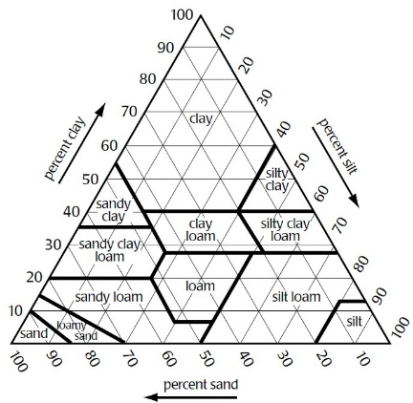 | REVIEW QUESTIONS  (questions should line up with the location of the answer in your notes to the left)
SUMMARY: Read through your notes and use the new vocabulary you learned to summarize the concepts you saw today in class. HIGHLIGHT EACH key vocabulary word when you use it.

______________________________________________________________________________________________________________________________________________________________________________________________________________________________________________________________________________

