Density Practice! Name: ___________________________ Period: ____
Use the density equation at right to solve the following
problems. Don’t forget to show full GUESS for each problem.
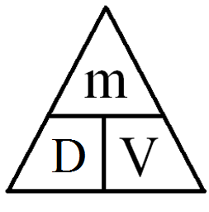
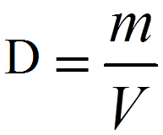
FYI:
- Water has a density of about 1 g/mL and if something floats in water it must have a density of less than 1 g/mL. If something has a density greater than that, it will sink.
- The eraser on the end of your pencil is about 1 cm³.
- 1 cm³ = 1 mL so 1 g/cm³ = 1 g/mL

Example Problem:
A gas tank holds 50 L. If the density of gasoline is 0.7 g/mL, how much mass will the tank of gas have?
Givens | Unknown | Equation | Substitute | Solve

- A 150 g piece of ice falls off an icicle and falls into a lake. If the icicle has a volume of 163 cm³, will the ice sink or float?
Givens | Unknown | Equation | Substitute | Solve

- Sometimes new kittens have to be given milk from a dropper if they are away from their mother. What is the mass of 10 mL of milk if the density of milk is 1.03 g/mL?
Givens | Unknown | Equation | Substitute | Solve

- A blacksmith was making a horseshoe when a 100 cm³ piece of iron flew off. If the density of iron is 7.8 g/cm³ then what is the mass of that piece of iron?
Givens | Unknown | Equation | Substitute | Solve

- You have a piece of jewelry that you were told was pure gold. You decide to check. You know that the density of pure gold is 19.3g/cm³. You measure the volume of the piece of jewelry to be 3.6cm³, and the mass to be 53g. Is the jewelry pure gold? Why or why not?

Givens | Unknown | Equation | Substitute | Solve

- Platinum is a very popular metal for jewelry and has a density of 21.4 g/cm³. A platinum ring has a mass of 15 g. What is its volume?
Givens | Unknown | Equation | Substitute | Solve

- From #4 you learned the density of gold. If you had a gold ring that had the same mass as the platinum ring in #5, what would its volume be?
Givens | Unknown | Equation | Substitute | Solve

- An aluminum block has a mass of 45 g and takes up 16.7 cm³ of space. Will this block of aluminum float in water?
Givens | Unknown | Equation | Substitute | Solve

- The aluminum block above is hallowed out into a boat shape so that is takes up the same amount of space but only has a mass of 10 g. Will the hollowed out aluminum block float in water now?
Givens | Unknown | Equation | Substitute | Solve

- Osmium is the densest material with a mass of 22.5 g per cm³. If you had a piece of Osmium about the volume of your text book (2400 cm³), how much mass would it have?
Givens | Unknown | Equation | Substitute | Solve

