Virtual Mineral Lab - 1
http://www.wiley.com/college/strahler/0471669695/interactivities/flash/mineralogy/mineralogy.htm
- Read the first paragraph.
- Click on “Introduction to Rocks and Minerals”
- Start at #1 and work your way to # 7.
- Color and Streak
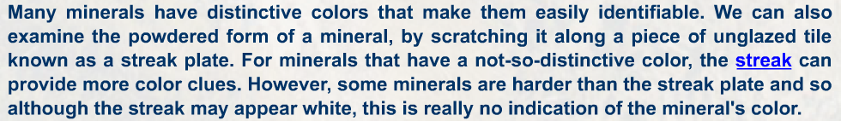
Streak color for Hematite - __________________
Streak color for Pyrite - _________________
Streak color for Galena - _________________
Streak color for Olivine - ___________________

- Luster
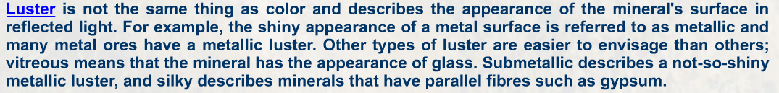
Talc - ________________
Quartz - ________________
Pyrite - ___________________

- Cleavage
Muscovite - ________________
Galena - ___________________
Calcite - ______________________

- Fracture
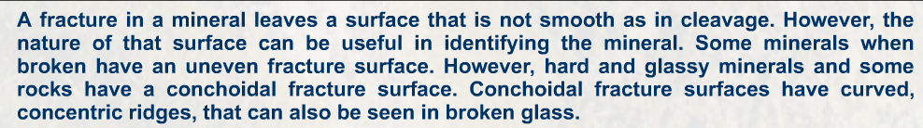
Quartz - ___________________________
Hematite - _______________________________

- Crystal

Quartz - ___________________________
Pyrite - _______________________________
Olivine - _________________________

- Hardness

Quartz - ______________________________________
Talc – ___________________________________
Feldspar – ___________________________________
Hematite - _______________________________
Calcite - ______________________________

- Specific Gravity
Quartz 2.65 - _________________________
Galena 7.4-7.6 - ____________________________
Pyrite 4.9-5.2 - ________________________________

- Go back to the main screen and click on “Virtual Minerals Drawer”. Complete the activity for each mineral.
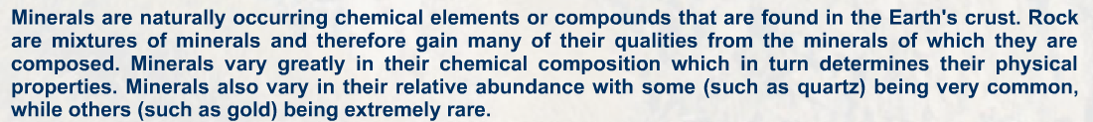
Identification for mineral 1 - ________________________________
Identification for mineral 2 - ________________________________
Identification for mineral 3 - ________________________________
Identification for mineral 4- ________________________________
Identification for mineral 5- ________________________________
Identification for mineral 6- ________________________________
Identification for mineral 7- ________________________________
Identification for mineral 8- ________________________________
Identification for mineral 9 - ________________________________

