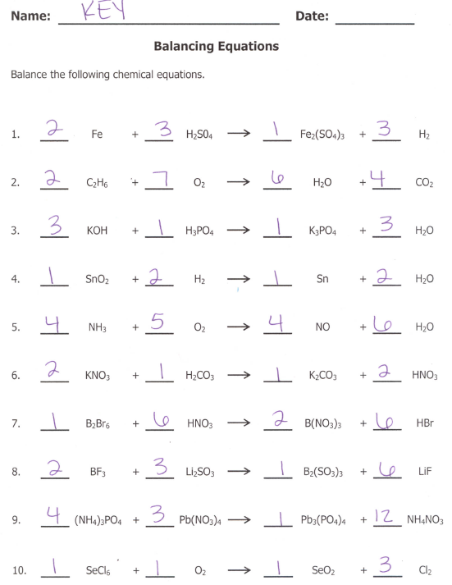
REACTION TYPES
- Single Replacement 6. Double Replacement
- Combustion 7. Double Replacement
- Double Replacement 8. Double Replacement
- Single Replacement 9. Double Replacement
- Combustion 10. Combustion

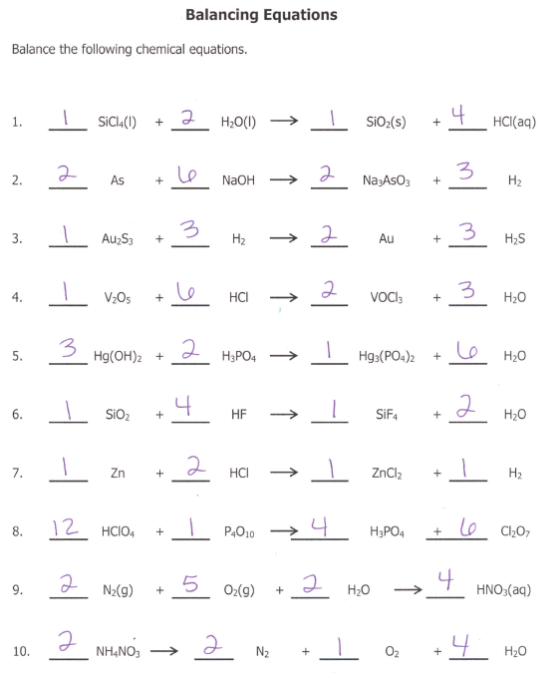
REACTION TYPE
- Double Replacement 6. Double Replacement
- Single Replacement 7. Single Replacement
- Single Replacement 8. Double Replacement
- Double Replacement 9. Synthesis
- Double Replacement 10. Decomposition

