Name: _________________________________________ Block: _________________ Date: ___________ Unit 1 Lesson 1

Four major parts of Earth work together as a complex system. On a global scale, each part can be thought of as a sphere, roughly the same size and shape as the planet. The four parts are called the geosphere, hydrosphere, atmosphere, and biosphere.

 | What you think this means... | What it actually means… | Examples
Geo-sphere
Hydro-sphere
Atmo-sphere
Bio-sphere | .

Do you think clouds should be classified as part of the atmosphere, or part of the hydrosphere? Explain why. ______________________________________________________________________________________________________
_____________________________________________________________________________________________________________________
_____________________________________________________________________________________________________________________
Directions: In the photograph below, label and describe each of Earth's four spheres.

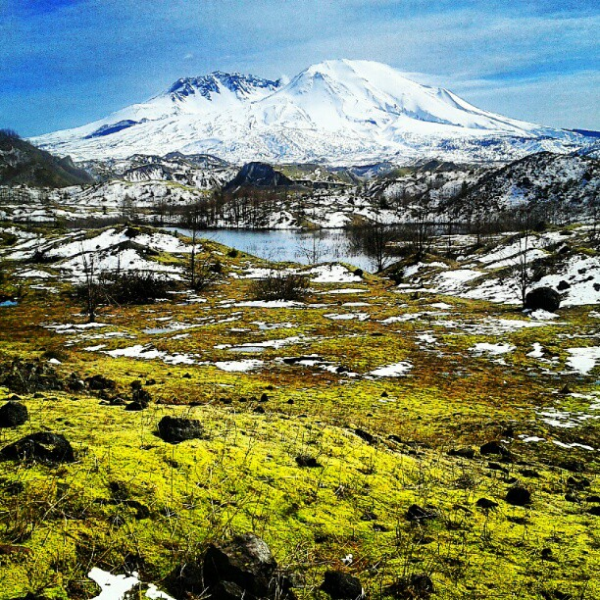

Directions: In the photograph below, label and describe each of Earth's four spheres.

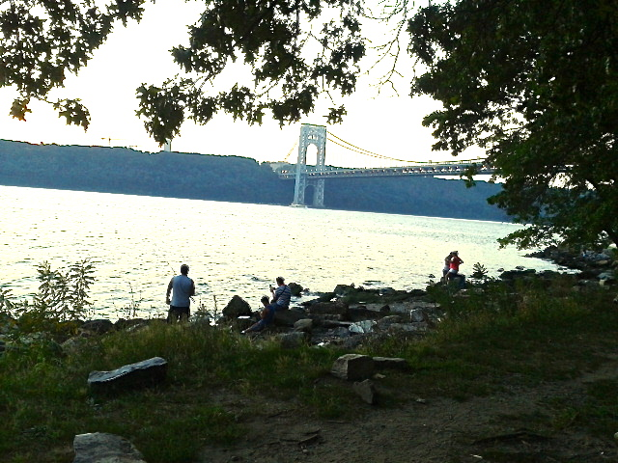

Directions: In the photograph below, label and describe each of Earth's four spheres.

