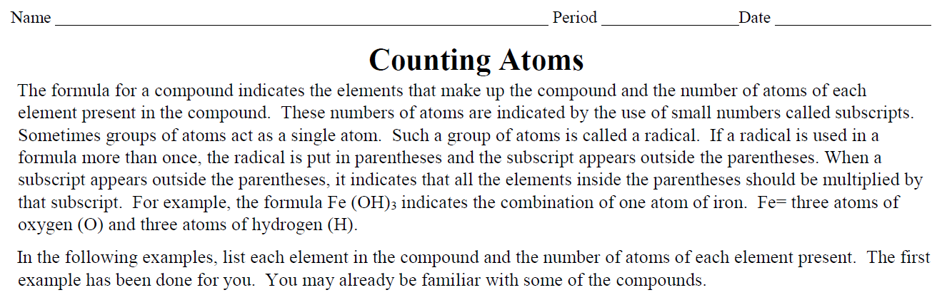
NAME | USE | FORMULA | ATOMS IN FORMULA
Calcium Carbonate | Limestone | CaCO₃
Aspirin | Pain Reliever | C₉H₈O₄
Magnesium Hydroxide | Found in Milk of Magnesia | Mg(OH)₂
Paradichlorobenzene | Moth Balls | C₆H₄Cl₂
Acidic Acid | Found in vinegar | C₂H₄O₂
Trinitrotoluene  (TNT) | Explosives | C₇H₅(NO₂)₃
Calcium dihydrogen phosphate | Fertilizer | Ca(H₂PO₄)₂
Pyrite | Fool’s Gold | FeS₂
Sucrose | Sugar | C₁₂H₂₂O₁₁
Cellulose | Found in pencil and paper, wood fibers | C₆H₇O₂(OH)₃

Section B: Write the name of the elements in order as they appear in the formula from left to right. If the element appears more than once, only write it once, then add its atoms together.
3Na₂SO₄ # of molecules______  # of elements ______  Name of element: # of atoms:  ____________________ ______  ____________________ ______  ____________________ ______  Total # of atoms ______  The #3 is a _________________________  (coefficient or subscript) |  | 2ZnSO₄ # of molecules______  # of elements ______  Name of element: # of atoms:  ____________________ ______  ____________________ ______  ____________________ ______  Total # of atoms ______  The #4 is a _________________________  (coefficient or subscript)
K₂SO₄ # of molecules______  # of elements ______  Name of element: # of atoms:  ____________________ ______  ____________________ ______  ____________________ ______  Total # of atoms ______  The #2 is a _________________________  (coefficient or subscript) |  | Ba₃(PO₄)₂ # of molecules______  # of elements ______  Name of element: # of atoms:  ____________________ ______  ____________________ ______  ____________________ ______  Total # of atoms ______  The #2 is a _________________________  (coefficient or subscript)
Na₂CrO₄ # of molecules______  # of elements ______  Name of element: # of atoms:  ____________________ ______  ____________________ ______  ____________________ ______  Total # of atoms ______  The #4 is a _________________________  (coefficient or subscript) |  | 4Al₂(CO₃)₃ # of molecules______  # of elements ______  Name of element: # of atoms:  ____________________ ______  ____________________ ______  ____________________ ______  Total # of atoms ______  The #4 is a _________________________  (coefficient or subscript)
Pb(NO₃)₂ # of molecules______  # of elements ______  Name of element: # of atoms:  ____________________ ______  ____________________ ______  ____________________ ______  Total # of atoms ______  The #3 is a _________________________  (coefficient or subscript) |  | 4Au(IO₃)₃ # of molecules______  # of elements ______  Name of element: # of atoms:  ____________________ ______  ____________________ ______  ____________________ ______  Total # of atoms ______  The #4 is a _________________________  (coefficient or subscript)
CO₂ # of molecules______  # of elements ______  Name of element: # of atoms:  ____________________ ______  ____________________ ______  Total # of atoms ______  The #2 is a _________________________  (coefficient or subscript) |  | 3CaCl₂ # of molecules______  # of elements ______  Name of element: # of atoms:  ____________________ ______  ____________________ ______  Total # of atoms ______  The #3 is a _________________________  (coefficient or subscript)
Cr(NH₃)₆(NO₃)₃ # of molecules______  # of elements ______  Name of element: # of atoms:  ____________________ ______  ____________________ ______  ____________________ ______  ____________________ ______  Total # of atoms ______  The #6 is a _________________________  (coefficient or subscript) |  | 5Al(C₂H₃O₂)₂ # of molecules______  # of elements ______  Name of element: # of atoms:  ____________________ ______  ____________________ ______  ____________________ ______  ____________________ ______  Total # of atoms ______  The #3 is a _________________________  (coefficient or subscript)
C₄H₈FCOOH # of molecules______  # of elements ______  Name of element: # of atoms:  ____________________ ______  ____________________ ______  ____________________ ______  ____________________ ______  Total # of atoms ______  The #8 is a _________________________  (coefficient or subscript) |  | 2(NH₄)₃PO₄ # of molecules______  # of elements ______  Name of element: # of atoms:  ____________________ ______  ____________________ ______  ____________________ ______  ____________________ ______  Total # of atoms ______  The #2 is a _________________________  (coefficient or subscript)

