Name ______________________________ Date _______________ Period ________

# Got Energy? Food Web Activity

1. Read through the activity. Select **TWO** ecosystems. Cut- out each organism and create a food web with the organisms present in your ecosystem. If you cannot print, then you must draw out the species given. Make sure that you spread the pictures out on your paper whether you are cut and pasting or drawing.
2. Make sure to draw arrows to show the movement of energy.
3. Label each organism as a producer, herbivore, omnivore, carnivore, or decomposer.
4. When you are done, complete the analysis questions below and turn in to the teacher.

**Analysis**

1. In which biome is this food web most likely to be found?

1. List some of the biotic and abiotic factors that exist in your ecosystem? Biotic:

Abiotic:

1. What is the ultimate energy for your food web?

1. Identify one example of a food chain within your food web with at least 4 organisms and write it below.

1. The 1st organism in a food chain must always be what type of organism?

1. Place the names of your organisms into this energy pyramid. On the arrows, label producer,

primary consumer, secondary

consumer, and tertiary consumer,

Quante

r

nary

consumer (if any)

AND label the Trophic Levels (T1,

T2, etc.)

. Predict how a change in a

7

n

abiotic

factor such as sunlight

would affect

your ecosystem?

## Shrubland Food Web

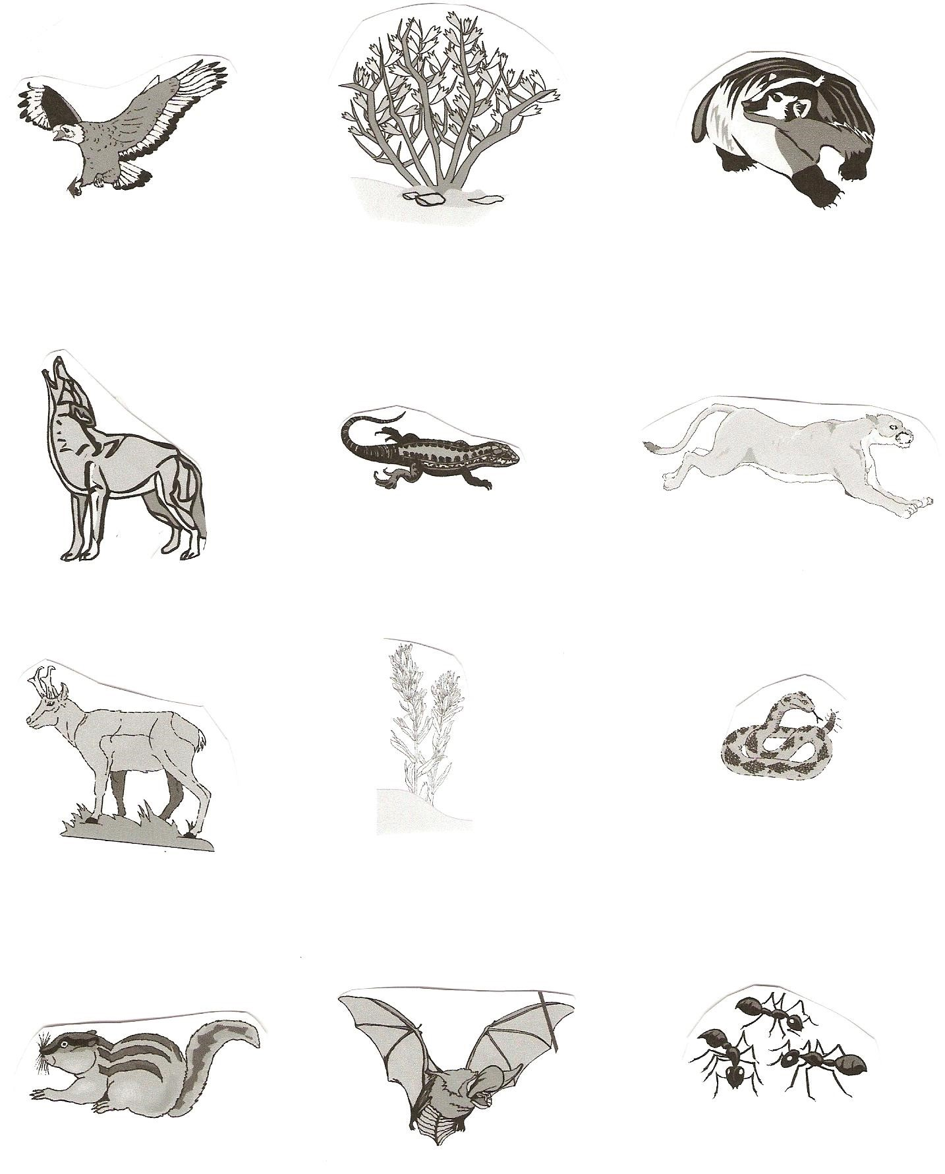

Raptor

Coyote

Squirrel

Badger

Sagebrush

Bat

Insects

Desert Wildflower

Pronghorn

Snakes

Small reptiles

Mountain Lion

**Marine Ecosystem Food Web**

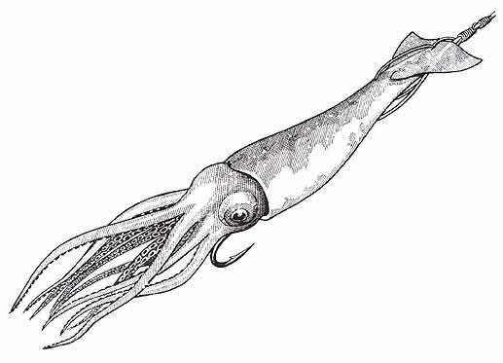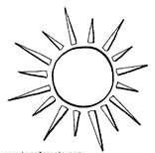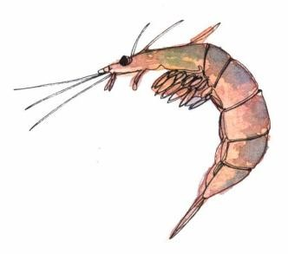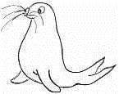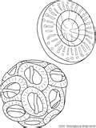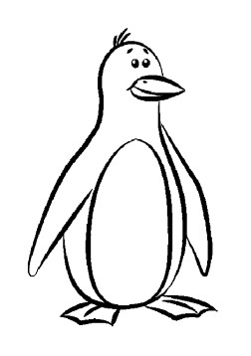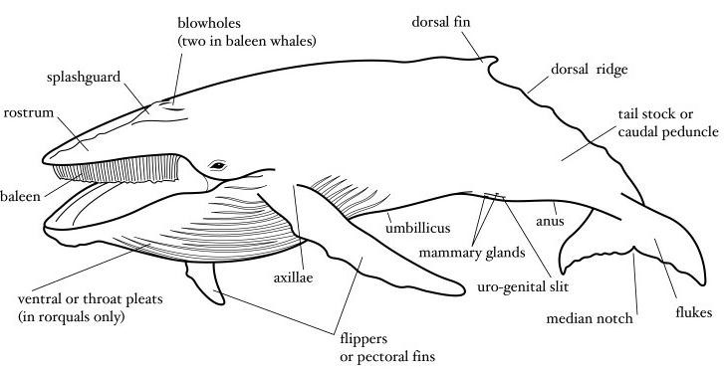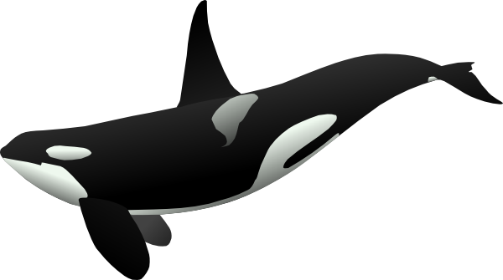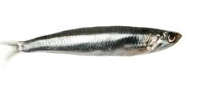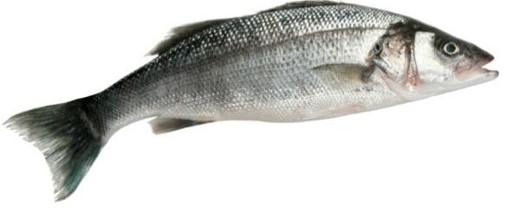

Sunlight Krill

Seal

Phytoplankton Penguin

Small Squid

[Small Fis](http://danamccauley.files.wordpress.com/2009/01/istock_000002987518small.jpg)

[h](http://danamccauley.files.wordpress.com/2009/01/istock_000002987518small.jpg)

Baleen Whale

[e](http://www.clker.com/cliparts/9/2/0/6/1194983736860056937orca_matthew_gates_r.svg.hi.png)

[Orca Whal](http://www.clker.com/cliparts/9/2/0/6/1194983736860056937orca_matthew_gates_r.svg.hi.png)

[Large Fis](http://danamccauley.files.wordpress.com/2009/01/istock_000002987518small.jpg)

[h](http://danamccauley.files.wordpress.com/2009/01/istock_000002987518small.jpg)

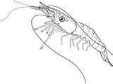

[p](http://www.coloring-pictures.net/drawings/shellfish/shrimp.gif)

[Shrim](http://www.coloring-pictures.net/drawings/shellfish/shrimp.gif)

## Savanna Ecosystem Food Web

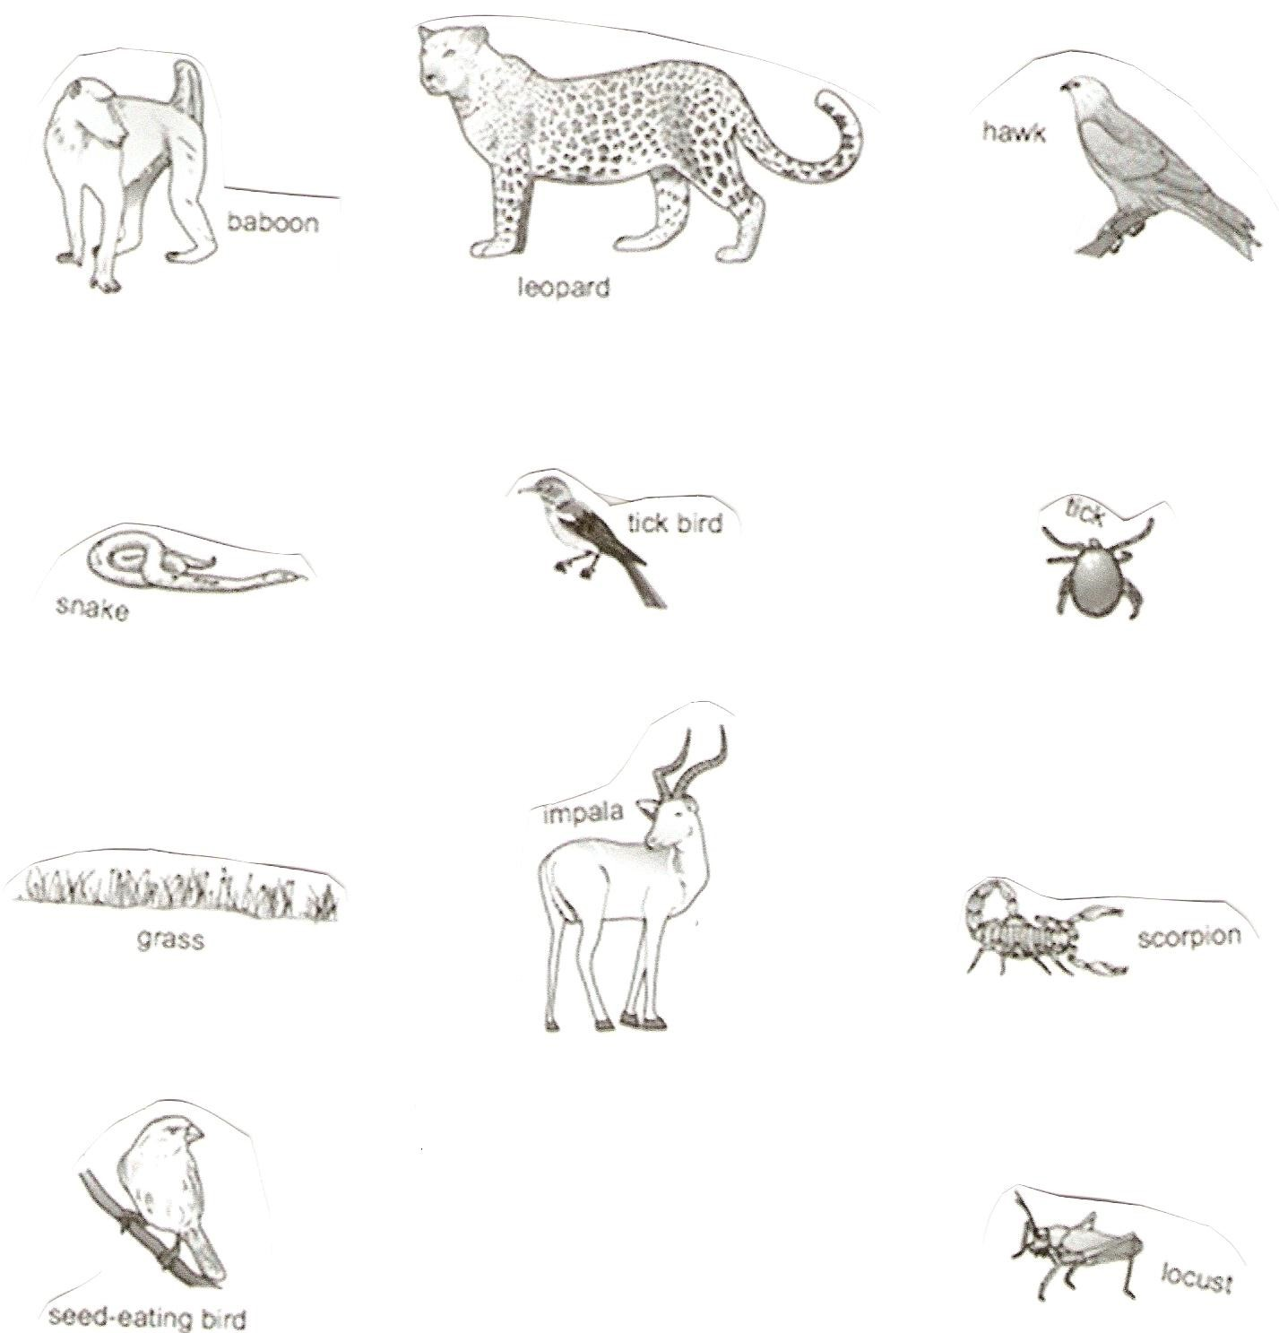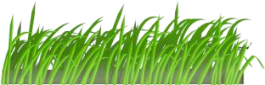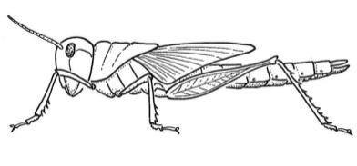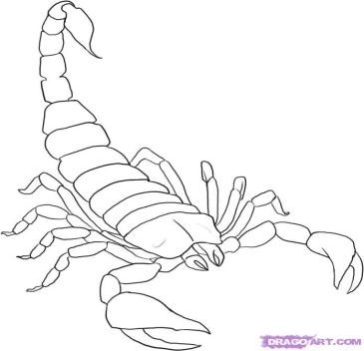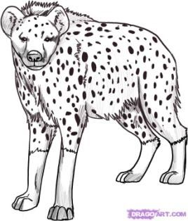

Hyena

Locust

Scorpion

Leopard

**Baboon**

Hawk

Snake

Seed

-

eating Bird

Tick Bird

Tick

Impala

Grass

**Grassland Food Web**

|  |  |  |
| --- | --- | --- |
| Grass | Dragonfly | Frog |
| Bean Plant | Rabbit | Snake |
|  | Trout | Human |
| Hawk |  |  |
| Fox | Bacteria | Deer |

**Deciduous Forest Ecosystem Food Web**

|  |  |  |  |  |  |  |
| --- | --- | --- | --- | --- | --- | --- |
| Owls |  | Cougar | | Fox | | Bear |
| Deer |  | Skunk | | |  | Deciduous Trees |
| Fungi |  | Small Rodents | | |  | Nematodes |
| Birds | Insects | | Flowers/ Berry  Bushes | | | Sunlight |